Home Biology Chemistry About Me

Caribbean Summer

Log of the Summer of ‘92
To see all photos of trip: http://community.webshots.com/album/549603815hyTFxD

Let me begin by saying, I met Ed, my mother’s cousin, in August of 1989 when he had just bought his 43-foot Erwin sailboat in Mattapoisset, MA. He and his brother, Bob, were planning to sail it to the Caribbean shortly after we met. Ed called and introduced himself, suggested I come meet him and his brother. I did and they invited me to come back the following week for a sail. I had previously owned a sailboat, so was glad to take him up on the offer. I brought local lobster and corn with me and we had a great sail and lunch on the boat. I wished them well on their long voyage and was glad to have met them.

Then, out of the blue, almost three years later, I got a message on my answering machine from Ed. He was in St. Thomas and had heard from my mother that I had the summer off. He asked if I would like to be his crew for the summer. I called and left him a message at the yacht harbor in Charlotte Amalie saying I would be happy to join him. He suggested I meet him at Union Island, but after talking to my travel agent, I found that I couldn’t reach the island in one day. My agent suggested Carriacou as it was close to Union Island—thus began the saga of my Caribbean summer. (Unfortunately, I quit keeping a journal in the middle of July, so, for the rest of this account I will have to rely on my memory and photos of that summer.)

Tuesday, 6/23/92
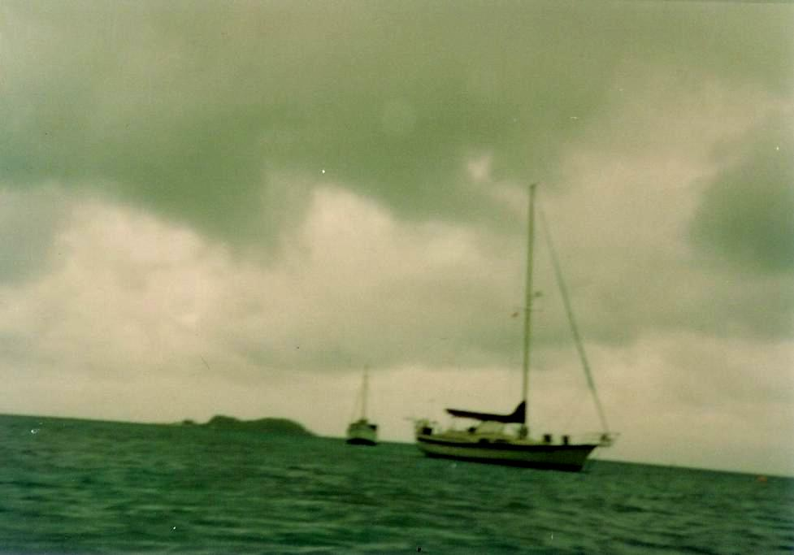
Diane and I arrived at Logan airport at 7:00 a.m., 15 minutes before my plane boarded. Arrived in San Juan on time, boarded flight to Grenada, also on time. Arrived in Grenada on schedule. Had difficulty at customs because I didn’t know what harbor the boat was in. Customs agent finally let me go, but had to stand in line behind woman with 4 suitcases, all of which were searched—didn’t even ask me to open mine (must have had an honest face). Had about a half hour wait for flight to Carriacou. Flew with 7 other passengers in an 8-seater to Carriacou, while being chased by a storm. Arrived in rain. Ed was there to greet me, but my luggage wasn’t. A man at the tiny Carriacou airport (terminal about the size of my shed) called Grenada—said luggage would be on next flight about 2 hours later. (One note about Carriacou airport: It had one short runway, which was also the main road. Gates were closed when the plane landed or took off.) So we went to the boat, which was anchored in Hillsboro Bay. The boat was named “Baby Cakes” for Ed’s deceased wife (nickname, of course). My bags did safely arrive on the next flight. Ed went back to the airport to pick them up while I unpacked my carry-on bags on the boat and got generally settled in. The weather cleared up and we ate charbroiled chicken, coleslaw and potato salad for dinner that Ed had prepared. The stars came out and then all of a sudden, just as we were getting ready to turn in for the night, the rains came again. It was a real stormy night, even had some thunder and lightening.
“Baby Cakes” in Hillsboro Bay

Wednesday, 6/24/92
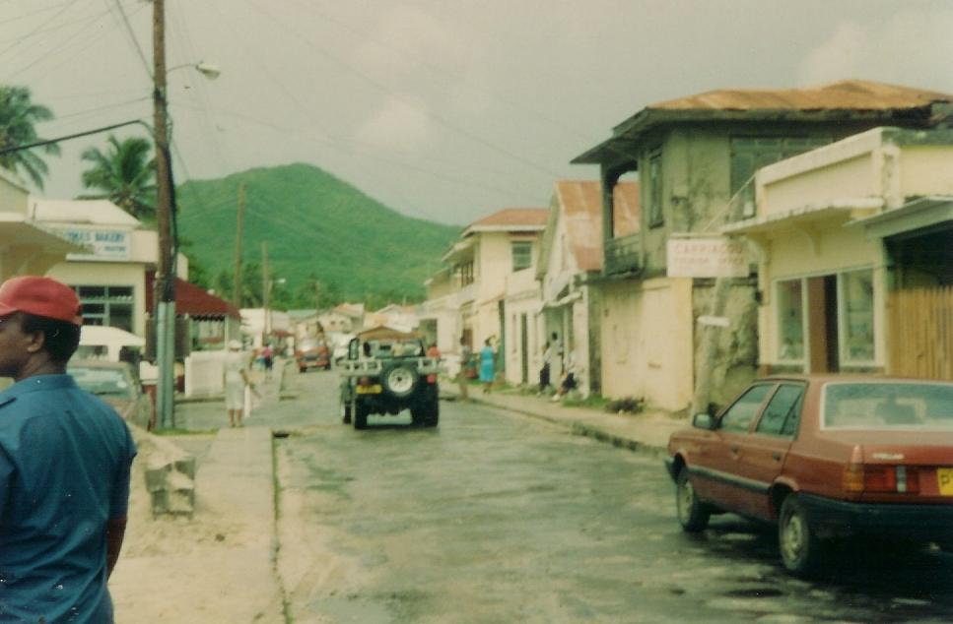
It was still raining this morning but cleared around 11:00 a.m. We went to town to clear me at customs for the boat and to eat lunch, shop, and go to the bank. I was cleared through customs first, and then we ate lunch at the Roof Garden Restaurant. I ate my first roti with a Carib Beer. A roti is a meat (mine was chicken) and potato filled fried dough affair, spiced with curry and some kind of hot sauce. Then, after several aborted attempts, I reached Mom on a pay phone using my Master Card. Mom didn’t recognize my voice and almost refused to believe it was me—thought she was going to hang up. The supermarket was closed until 1:00, so we went to the Carriacou Museum. It was small, but very interesting and it had a nice shop. I bought post cards and a Batik dress (real neat at $24 U.S.) with the E.C. money I had just exchanged at the bank--$2.67 E.C. (Eastern Caribbean) for each $1.00 U.S. We then bought supplies at the market and stopped at the bakery to write post cards. The bakery has delectable odor and outside tables. We mailed cards at the post office and picked up fish (tuna) for supper on the way back to the boat at a fish market/ice cream parlor.
The town of Hillsboro in Carriacou

When we got back to the boat, we ate a fresh coconut and I made Ed save the coconut water to cook the cabbage (one of the few fresh vegetables available) for supper. It started raining again, so Ed pan-fried the tuna while I prepared my gourmet cabbage dish (cabbage and onions sautéed in margarine with curry, garlic, parsley, pepper, and Creole seasoning and then steamed in coconut water and banana soda—delicious). It cleared briefly and then poured again. So, we went to bed (separately, of course) early—around 9:00 p.m.

Thursday, 6/25/92
It was a gorgeous sunny day when I got up at 8:30 a.m. I woke up in the middle of the night, though, because I was suffocating and saw that the stars were out. So, I opened the hatch for some air—explains why I got up so late. We went to town (Hillsboro) for veggies, ice, and breakfast. We bought some tiny, not too rip, tomatoes and mangos. Then we ate some kind of raisin bread at the bakery where it proceeded to rain again briefly. We picked up ice at the Silver Beach Resort where we had docked the dingy. When we got all that ice back to the boat (not easy, but Ed said we might not be able to get any for 2 or 3 days) we prepared to take off for Mayreau (pronounced my’-roe).

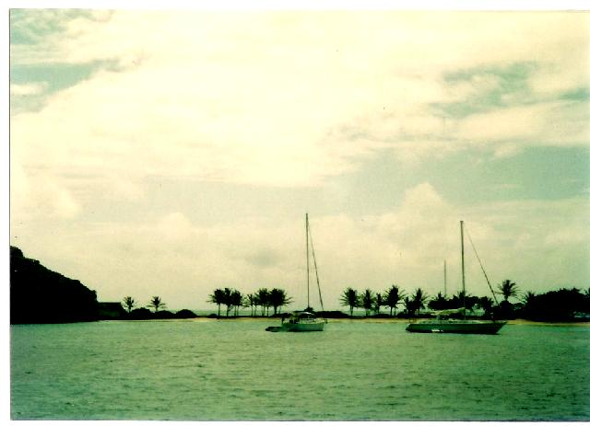
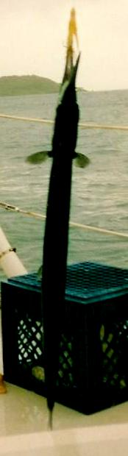
The trip to Mayreau was not uneventful. It was bright and sunny when we left Carriacou, but that only lasted about a half hour. We could see the black clouds approaching. Fortunately, we hadn’t put up the sails. We went through one rainsquall after another with me at the helm and Ed navigating. Finally, we reached Salt Whistle Bay on Mayreau and dropped anchor in the rain. We ate lunch about 2:00 p.m. and it’s still blowing and raining. While we were motoring here, Ed had a fishing line and lure put out. When he pulled it in, it had a fish, about 4 feet long, on it. Neither of us had ever seen one like it, so we looked it up in his “Guide to Corals and Fishes of Florida, the Bahamas, and the Caribbean.” The fish turned out to be a Houndfish. We recognized it for certain by its green teeth and bones. The book said it was edible, so we cut it up into steaks and put it in the freezer (Took the above picture too).
Salt Whistle Bay in Mayreau
Our Houndfish

I cooked up the rest of our chicken for supper and Ed pan-fried potatoes and onions. We completed the meal with left over coleslaw and sliced tomatoes. Diane would love our diet—chicken, fish, and veggies. The rain stopped long enough to eat in the cockpit and then the stars came out. The generator wasn’t working on the way over to Mayreau (wires got shaken loose in Tuesday’s storm), so we conserved on electricity by going to bed early.

Friday, 6/26/92
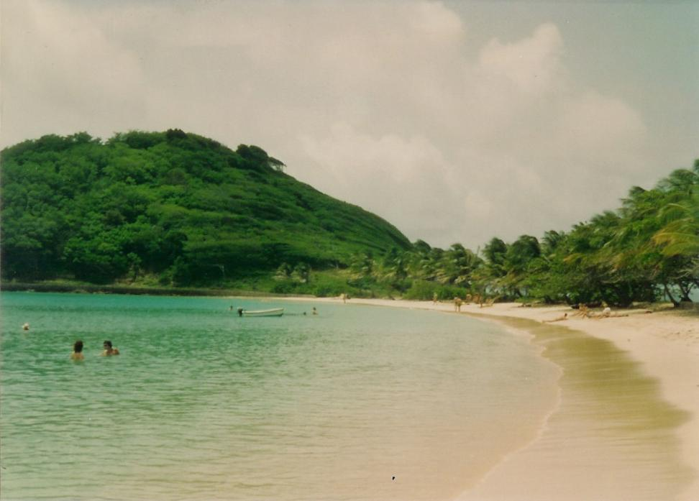
We got up around 7:30 a.m. I woke up during the night to close my hatch as it was raining again. Today, though, is gorgeous with only a few cumulous clouds. Salt Whistle Bay is beautiful. There is a resort that is so hidden in the trees that you only know it is there by the colored lights at night. There’s a beautiful white sand beach circling it with palms in the background.

Ed fixed the wiring on the generator this morning and we even have the refrigerator on to conserve ice. I’ve been trying to be helpful wherever possible because Ed would do everything (cooking, dishes, the work) if I let him. It is bad enough that he refuses to let me pay for anything.
The beach at Salt Whistle Bay

After lunch we went ashore to the beach. The beach is great and virtually deserted and the water is incredible—perfect temperature, not too warm like the Gulf of Mexico in June. After swimming, we went to the Mayreau resort souvenir shop and I bought myself a pair of earrings made from coconut shells, I think. But the beachside shop was much more reasonable, so got a couple of gifts there too.

When we got back to the boat, I mostly vegged and read on the deck while Ed ran the generator and did crossword puzzles—must run in the Page family—I just didn’t inherit the gene. Also, I finally washed my hair (rain has been washing it) and rinsed off with one of the giant sun showers.

For supper we had tuna (not canned) and some of the Houndfish. Houndfish has a delicate flavor—all white meat and delicious. It’s easy to pick out the bones too since they are green. I saved part of a backbone just to prove that it did have green bones to the folks back home. I also smoked my last cigarette tonight!

Saturday, 6/27/92
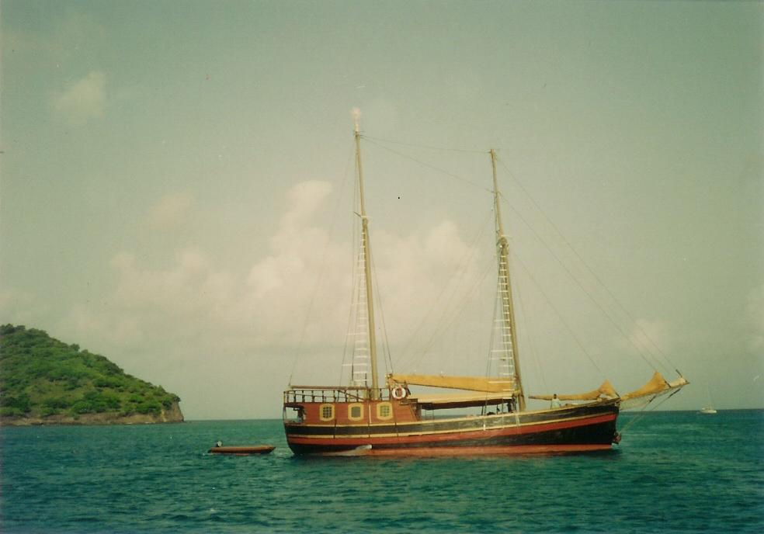
Today we sailed back to Carriacou, but this time to Tyrrel Bay. Tyrrel Bay is a very sheltered anchorage. The mangrove swamp on Tyrrel Bay is considered a hurricane hole. Ed’s friend Dennis, whom he talked to on the radio this morning, says we’re in the midst of a perpetual hurricane. Of course, he’s referring to the frequent little squalls we’ve had. The bay is nice and calm though.
Interesting boat in Tyrrel Bay

We went ashore to visit the two stores on this part of the island. Alexi’s supermarket was definitely the best stocked of the two. Neither store, however, had fresh fruits or vegetables. When we got back to the boat, we swam and took a salt-water bath (soaped up on the deck and swam again). Then we rinsed off using the sun showers.

For supper we finished off the Houndfish and had cabbage and stewed tomatoes. I made them rather spicy. After super I had rum with grapefruit juice and peach nectar—not a bad combination—and watched the stars. Then it was time to turn in.

Sunday, 6/28/92
We finished off the mangos yesterday, so had a banana for breakfast and V-8 juice (We discovered the V-8 at Alexis.). I spent most of the day reading Cape Cod, a pretty good book. We went ashore again to the supermarkets and got a huge block of ice along with other incidentals. Ed spent most of the day fixing the windlass that lets out and picks up the anchor chain and finally got it fixed. We plan to stay another day, so he can patch the dinghy, as it has a slow leak.

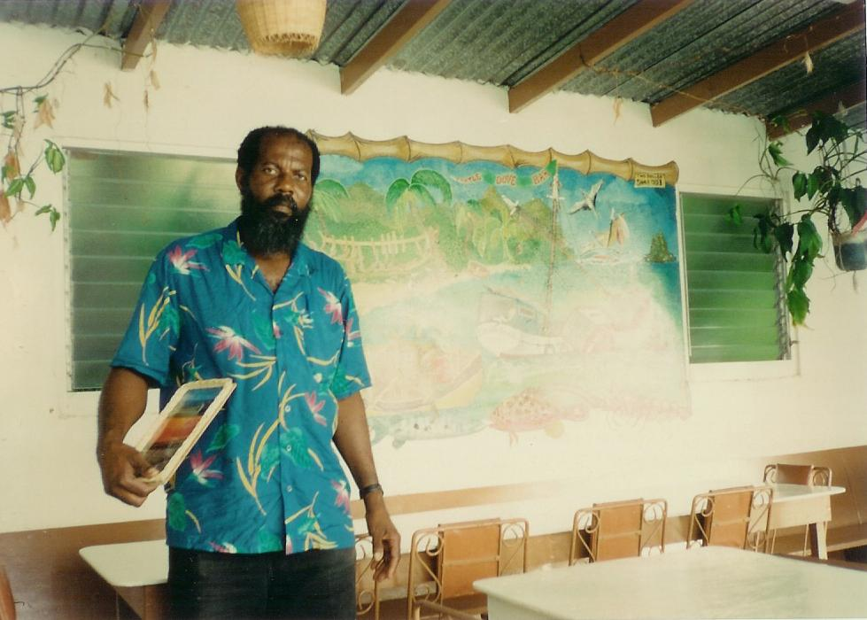
We decided to go ashore for supper. We ate at the Turtle Dove and watched the sunset from its deck. We ate curried lambi (conch) with coconut-flavored rice, coleslaw, and a huge loaf of garlic bread—delicious. Ed didn’t like the coconut-flavored rice, but I did.

The Turtle Dove owner

Monday, 6/29/92
We’re still in Tyrell Bay. Ed patched the dingy and varnished its transom. I continued to read Cape Cod. The book is pretty engrossing.

We went ashore to the markets again and, this time got a whole chicken. Ed managed to thaw it enough (they only had frozen chickens) to cut it in half. I took my usual afternoon swim and fresh water rinse and washed my hair again. (It’s gotten where I need to write this down so I’ll remember.)

We barbecued the chicken (charbroiled anyway) and I sautéed potatoes, onions, and cabbage. That’s become our staple.

Tuesday, 6/30/92
This morning we had fresh baked rolls for breakfast. A woman in one of the boats in the harbor bakes it and her husband sells it from boat to boat by dinghy. We ordinarily discourage the local kids who are constantly rowing from boat to boat selling mangrove oysters (tiny) and limes, but this guy is from the U.S (Boston, actually) and they are now living on their boat and the kids are even going to school here. We had met the husband at a local open-air bar the day before.

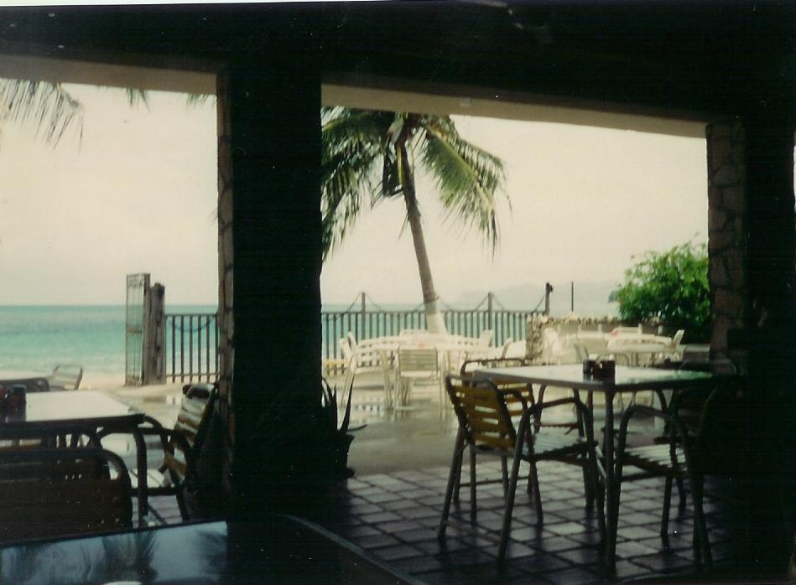
After breakfast we took off for Hillsboro Bay, my original port in Carriacou. Hillsboro has the advantage of having a bank, post office, telephones, and a great bakery. We headed for the bakery first where I wrote a couple more post cards while drinking a soda. Ed went looking for gasoline for the dinghy motor and for the generator. He couldn’t get gas—closed for inventory till 2:00 p.m. Also, the bank and stores were closed for the daily siesta, so decided to walk to Silver Beach resort for lunch—great idea. We had lambi rotis and I had a rum punch while Ed had a Carib beer. We even got fresh salads with the rotis (a real treat). I found out that rum punch is pretty potent stuff. The recipe for rum punch in Ed’s Windward Island Guide is: Mix the juice of 3 limes, ¼ C of Grenadine syrup, and 1 C of brown rum with 1 liter of juice (orange, pineapple, or passion fruit); serve with a lot of ice and liberally grate some fresh nutmeg on top—just thought I’d add that for posterity. Anyway, the cost of the meal including drinks for Ed and me was $27 E.C., which is $10 U.S. or $5 each (cheap).
Restaurant at Silver Beach Resort

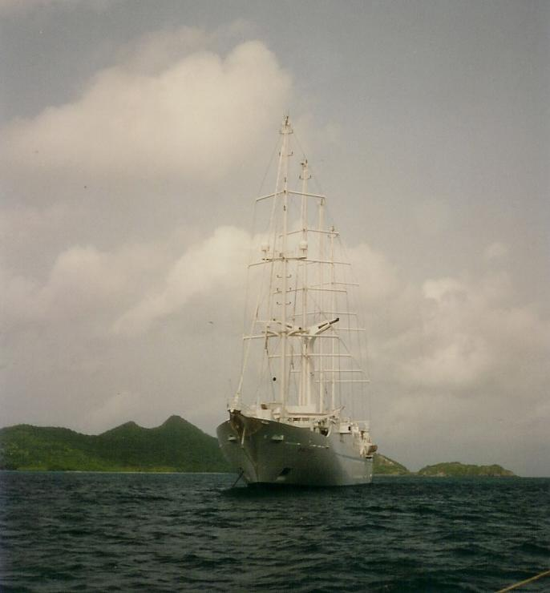
After our sumptuous lunch, we went to the bank, post office (to mail cards), but still couldn’t get gas. So, we went back to the boat and Ed came back later for gas. He had two six-gallon cans, so it took him two trips. On the second trip, a guy told him that he had heard that a tropical storm was on its way. For that reason, we headed back to Tyrell Bay. Too bad—Silver Beach Resort offers free showers to boaters. I was looking forward to that.

I almost didn’t mention that there was a cruise ship (mini) anchored at Hillsboro. It was a strange looking vessel—looked like a small cruise ship but with sails. It wasn’t a windjammer. Ed said computers controlled all the sails on the ship. I took a picture of it anyway.

We went back to Tyrell Bay and showered on deck with the sun shower (better than nothing). Then we had sandwiches for supper because we were still stuffed from lunch. I’ve just about finished reading Cape Cod and Ed did finish The Boat Who Wouldn’t Float by Farley Mowat (one I brought).
Strange sailing cruise ship

Wednesday, 7/1/92
One advantage of being back in Tyrrel Bay is that we got more fresh baked rolls this morning from the boat vendor.

After breakfast we headed out with the intention of going to Petite St. Vincent or the Tobago Cays. However, Ed sighted some black clouds when we were barely clear of Carriacou. So, we turned back to Tyrrel Bay. Every time we try to leave this place, something brings us back. It’s a good thing it’s a real nice harbor.

There was no storm, so we spent the afternoon exploring in the dinghy. We found the entrance to the mangrove swamp and its lagoon. It’s large—can see why it’s a good hurricane hole.

We finished our chicken for supper and I cooked rice while Ed made cold slaw. I don’t think Ed likes rice a lot—one of those potato people—I liked having it for a change. Before bed I finally finished Cape Cod.

Thursday, 7/2/92
After fresh raisin cinnamon rolls from our boat vendor, we finally left Tyrrel Bay (I think for good) and headed for Grenada. The guy who sells rolls told us a tropical wave was headed our way so that we should stay in Grenada a few days.

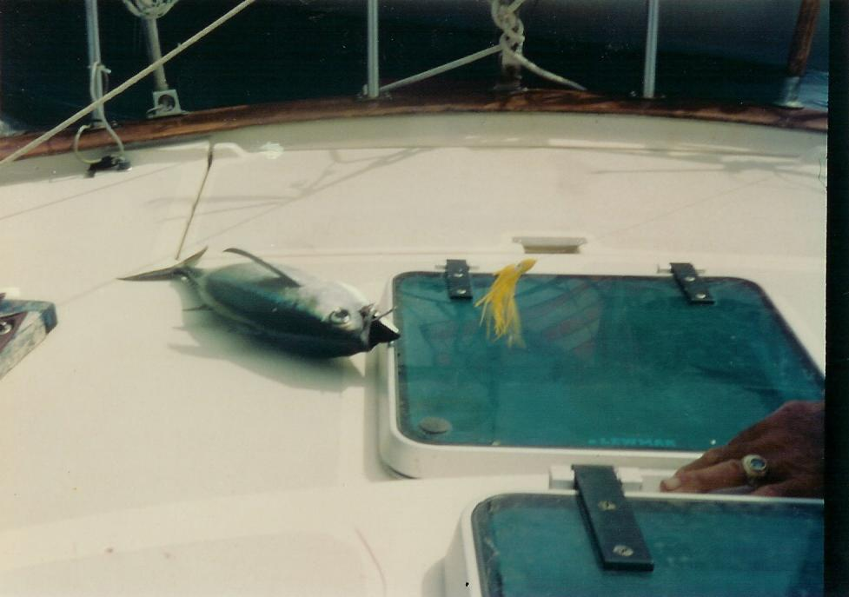
The seas were really rough until we passed Kick ‘em Jenny Island. Ed’s book said the seas would calm down after that island and they did, shortly after passing it. We caught a Bonita that was about 10 pounds—a couple of dinners anyway. Ed poured rum in its gills to kill it (what a way to go), then filleted it and washed the deck—what a mess.
Our Bonita

We arrived in St. George’s inner harbor at the lagoon for small boats at around 3:30 p.m. There is a real narrow channel going into the lagoon, so Ed took us through that. I had already been at the helm for about five hours, hence I was happy to let him take over.

We went to customs as soon as we anchored to check in. We are seeing a lot of the same boats that were with us in Tyrrel Bay. We talked on the dock to a group from Guernsey, England who had this big dog. It climbs their swim ladder to get on the boat from the dinghy—pretty clever.

We also went to Foodland, which is right across the street from our anchorage. The store had a dinghy dock and the bag boys cart your groceries over to the dinghy for you. I bought a whole case of Diet Coke. We got fresh apples too, which we proceeded to eat right away.

You can tell by the legibility of my writing (this, of course, applies to my original journal) that this is a very calm anchorage. The water is practically like glass. I took a shower, washed my hair, and shaved my legs in preparation for going to town tomorrow. Then it was time for the usual cocktail hour (something I haven’t mentioned before, but an evening tradition). This time I tried rum with strawberry nectar and fresh squeezed limejuice—another hit. Ed usually just drinks rum and water (ugh!). In the last week and a half we’ve probably gone through a gallon and a half of rum and, believe it or not, I really haven’t done my share. Of course, we do feed rum to the fish we catch too! Ed cooked one of the Bonita filets. He coats them with a green pepper sauce that is found locally. I heated up left over rice, potatoes, and cabbage. The fish was delicious, but we didn’t eat half of it—guess we’ll eat Bonita (like tuna) for three more meals. We also have the steak that we bought in Carriacou.

Being in this harbor at night is very different. There are so many lights and we can hear music from the shore. We’ll have to explore some of those places tomorrow.

Friday, 7/3/92
We woke up this morning to roosters crowing—there must be hundreds of them on the island! I had mango and coffee and was ready to go to town. St. Georges is a good-sized town with just about anything you need. I even managed to find a place where I could photocopy the first 18 pages (of the original journal) of this log. There are even a lot of air-conditioned shops—nice because it is hot. Maybe in another week or so I’ll get used to the heat.

We ate lunch at a place called The Nutmeg. It’s an upstairs café with a nice view of the harbor. Then, I made my second trip to the post office to
mail my logs. The post office is in a real out of the way place that I probably would have never found, but, of course, Ed’s been here before. We met a taxi driver where our dinghy was docked who wanted to take us on a tour of the island (for a fee, of course). We may take him up on it Sunday since everything is supposed to be closed.
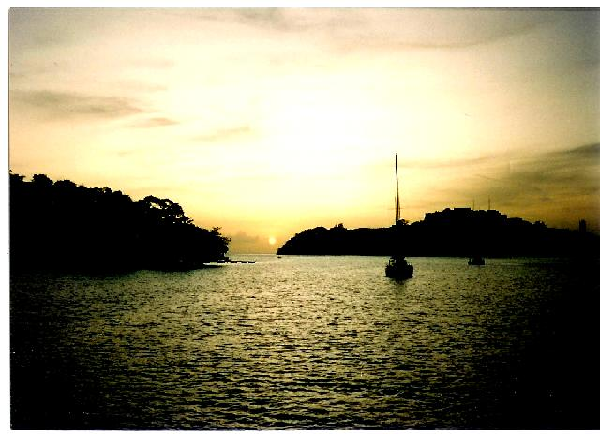
The steak we bought in Carriacou turned out to be stew meat, so Ed made a delicious stew out of that with our leftovers and a lot of spices. We saw a beautiful sunset tonight. The weather has been gorgeous ever since we got to Grenada—hope it continues. The tropical wave that was traveling our way must have gone north.
Sunset in St. Georges small boat harbor

Saturday, 7/4/92
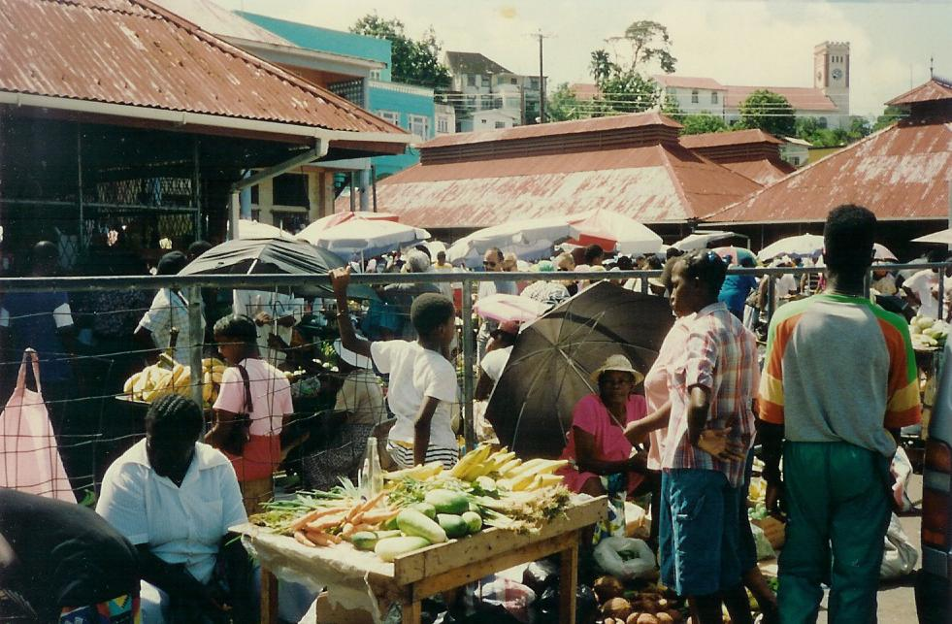
Today we went to town to the big Saturday market. I bought some spice baskets and took pictures. I also got my picture made for a Venezuelan visa. But since the Embassy isn’t open until Monday, we decided to stay in St. Georges until then.

Saturday market in St. Georges
When we got back to the boat, we decided to go to Grand Anse beach and rode a local bus (really a van). That was quite an experience as they play reggae music from loud speakers. The beach was beautiful—gorgeous turquoise water and white sand. We got to it by going through the Ramada Renaissance Hotel area. I bought a couple of T-shirts at the beach and had a few braids put in my hair, beads and all. After the beach, we came back to the boat and cooked more of the Bonita and made a salad with lettuce and tomatoes. This was the first lettuce we had found on the islands. It was a busy day, but enjoyable.

Sunday, 7/5/92
We spent half the night getting up to close hatches because of the rain. Also, a place on the shore played Reggae music all night on very loud speakers, so didn’t get much sleep. It was probably good that it was cloudy and rainy all day—it was a day of rest. I started reading Tom Clancy’s The Sum of All Fears, a book that Ed had onboard.

I made a breakfast of cheese omelets, home fries, and French bread toast—good, if I do say so myself. It was a very uneventful day. We just stayed on the boat and vegged. We ate chicken (Ed always coats the chicken liberally with curry powder before grilling) and salad for supper and retired early.

Monday, 7/6/92
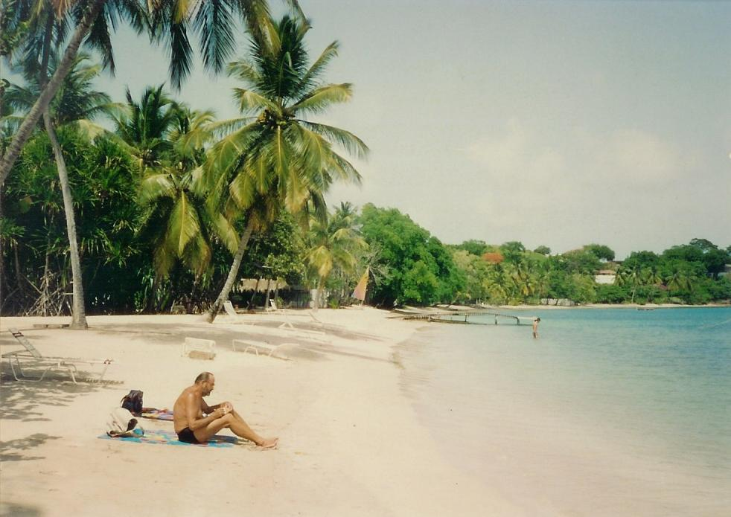
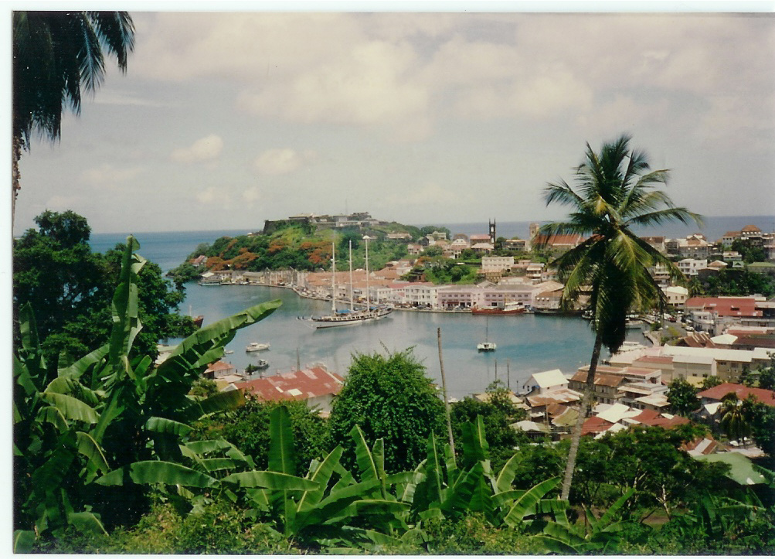
It started out somewhat sunny today. We went to town and walked (all uphill and I mean uphill!) to the Venezuelan Embassy. Ed didn’t have any blank pages in his passport, so we were told that we would have to go to the American Embassy to get more pages. We started walking down the hill to find a bus stop and it proceeded to pour. We took shelter in a Texaco station and a local there offered to drive us to the embassy and back for $45 E.C. Considering the weather, we took him up on it. The U.S. Embassy, unlike the Venezuelan one, had very tight security. We had to stay at the gate while a woman with a distinctly British accent took Ed’s passport to add pages. Fortunately, this only took about 15 minutes. We got back to the Venezuelan Embassy and filled out our visa applications. Just to make matters more difficult, we couldn’t pay for the visas there, but had to go into town and pay at the bank. It had stopped raining, so we walked to town and, since it was past lunchtime, we went to The Nutmeg for another roti. This time I got a shrimp roti—yummy.
Ed on Grande Anse beach
View of St. Georges from Venezuelan Embassy

When we got back to the boat, we decided to go to Grand Anse beach again—what a beautiful spot! Afterwards, we finished off the day with chicken and salad for supper.

Tuesday, 7/7/92
Today we had to go back to the Venezuelan Embassy to get our passports and visas. Fortunately, we discovered that it was much easier (less uphill) to walk from the boat lagoon. Predictably though, it started to pour again when we were half way there. This time we braved it and just got soaked. We walked into the embassy-dripping wet, but we got our visas.

Since we’d mainly stayed in St. Georges to get our visas, we decided to motor on over to Prickly Bay, the next harbor over in Grenada. Prickly Bay is very pretty and has lots of sailboats. We are anchored between a Swiss boat, Canadian boat, and Swedish boat—very cosmopolitan. We got here too late to check into customs but just in time for happy hour (our own) and supper. We charbroiled the lamb chops acquired at Foodland, had salad again, and I made rice.

I almost forgot. On our trip to Prickly Bay, we caught a tuna—about 12 pounds or four more dinners.

Wednesday, 7/8/92
We checked into customs at around quarter past nine and while there, met George, an island tour guide and driver. We decided to let him take us on a tour of the island.

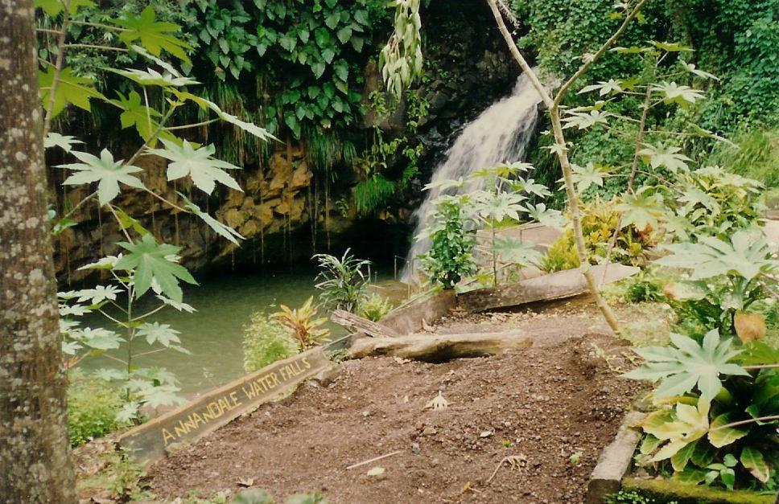
First we went to a fort, way up in the hills of St. Georges. There was a good view of the Caribbean on one side of the fort and the Atlantic on the other. Also, a steel band greeted us when we arrived. Next we entered the Grand Etang National Forest. Our first stop in the forest was a 15-minute hike (mostly uphill) to Annandale Water Falls. A guide took us to the falls and one thing we noticed in Grenada is that there is no charge for most attractions. You are just expected to tip the guides. Then we drove to an overlook where we could see a crater lake and the Atlantic.
Annandale Water Fall

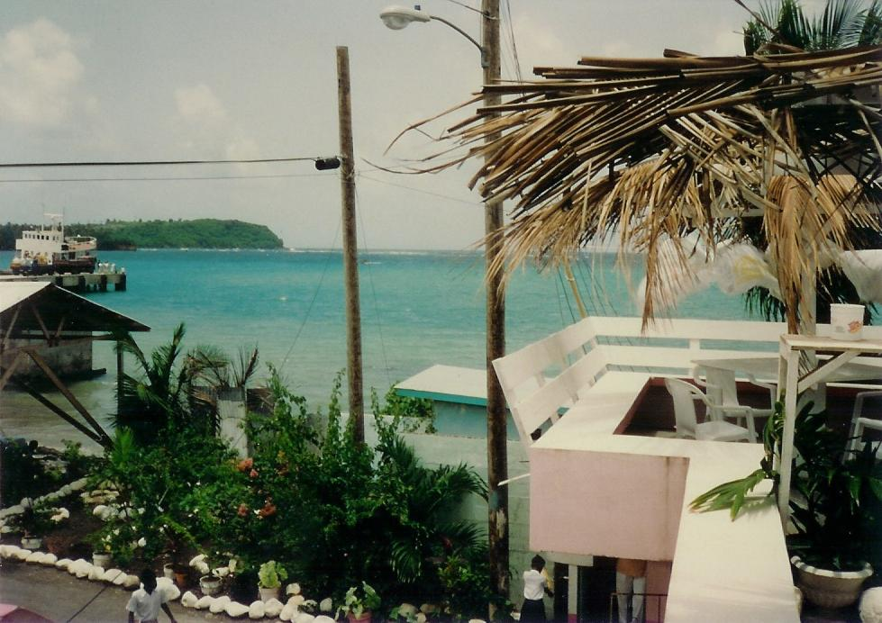
From there we went to the town of Grenville on the eastern side of the island. We had a lunch of lambi stew, rice, salad, fried potato, mango, passion fruit, and oranges (quite a meal) at a restaurant overlooking the water. George said it was the Atlantic on this side and the harbor was surrounded by coral reefs.
View from restaurant in Grenville

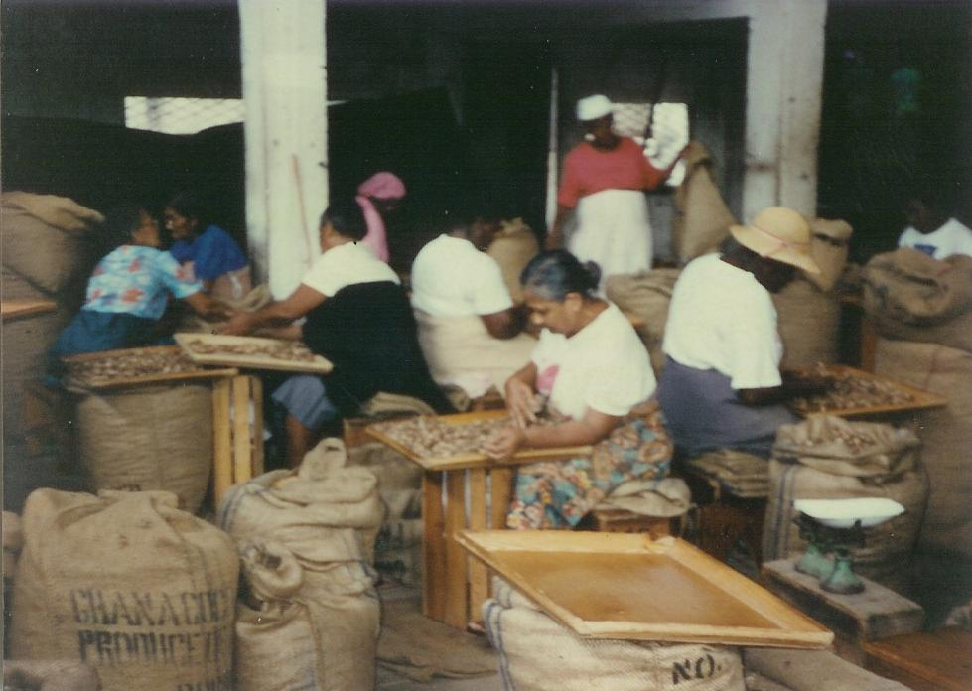
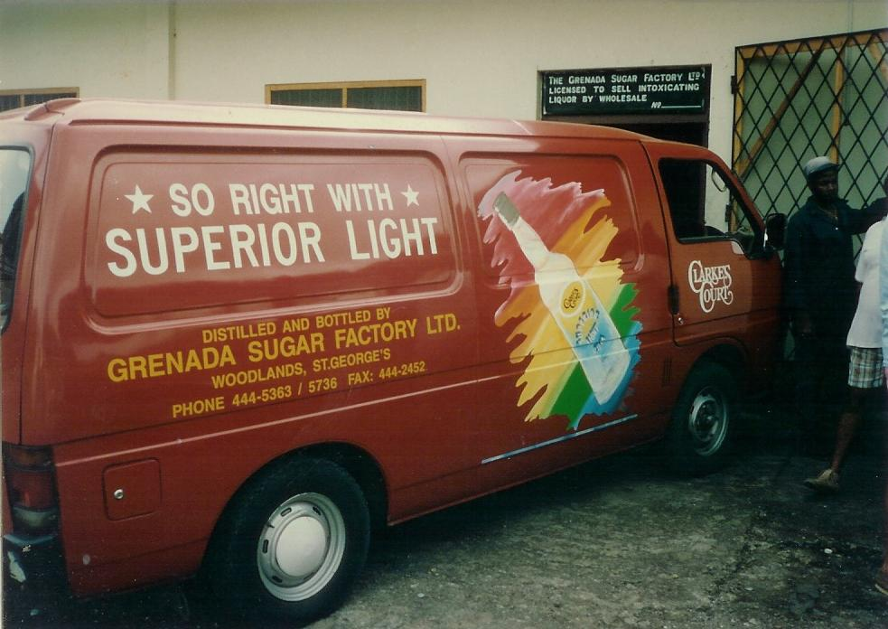
After lunch we went to the nutmeg factory in town. Everything but the cracking of the shells is done by hand—very labor intensive. There, they explained how mace is the thin, bright red, lace-like covering over the shell of the nutmeg. I found the whole process fascinating. Next, after driving down the coast road for miles, we made our last stop—the Clark’s Court rum distillery. A guide described the whole process to us as he took us around. The rum was in the fermentation stage in a huge vat. The sugar cane had already been crushed and the molasses made for the season. We were finally taken to the office and shown the final product. We had already bought a bottle of their rum while in St. Georges. We ended up in Prickly Bay again around 3:30. It was a nice tour and we thanked George and gave him the $60 U.S. he had specified.
The Nutmeg Factory in Grenville
Clark’s Court rum truck at the factory
The nutmeg factory in Grenville

Back on the boat, we had our tuna (caught yesterday) and tomato and onions (ran out of lettuce). However, we were still full from lunch.

Thursday, 7/9/92
Today was a fairly quiet day. I read most of the day. Then we went to the beach by dinghy for a swim. The beach belongs to the Calabash Resort, but they don’t seem to mind visitors from the boats (or yachts as they call them). The security guard from the resort came over and talked to us and picked some sea grapes for us to try—not bad.

We ate the pork chops that we had bought at Foodland for supper. They were a nice change.

Friday, 7/10/92
Today we decided to go back to St. Georges to do a little shopping, so I first wrote post cards to mail in town. It was quite hot and we walked a mile and a half or so to the bus stop.

In town we went to the National Museum and to several shops. The museum had many photos of the U.S. invasion of Grenada, but the locals didn’t seem to have any hard feelings towards us. We stopped at Food Fair for supplies and found a little sidewalk restaurant in time for lunch. Ed had a hamburger and I had a chicken roti. The roti was huge and very good.

We got back to the boat in plenty of time for supper, but before, I swam off the boat and rinsed with the sun shower. We cooked the other tuna filet and got to listen to the steel band that was playing at the marina. Unfortunately, that got cut a little short because we had a little rain squall around 9:00 p.m.

Saturday, 7/11/92
Today I mostly stayed on the boat and finished reading Sum of All Fears—a good book. Ed suggested we go to the marina for Happy Hour. It was from 5:30 to 6:30 and drinks are half price. It was a good idea because we met other people there. One of the people we met, Bruce, from the boat Deliberate, joined us at our table. He is from New York City (rather a young kid to have his own boat). Anyway, he told us that he and several other boats were planning on going to Trinidad together on Wednesday night. We will probably join them since Trinidad is an overnight trip. After happy hour, we went back to the boat and ate leftover tuna and salad.

Sunday, 7/12/92
Today started out to be a fairly nice day. We went into shore to use the telephone fairly early. Ed called Jodi, his daughter, but no one was home—so decided to come back later. We bought stuff to make macaroni salad and chicken because we were planning on going to a cookout at Hog Island this afternoon. Hog Island is about 45 minutes away by boat. We came back to shore a couple of hours later, but Jodi still wasn’t home. However, I reached Mom and Dad. Then we went back to the boat and made macaroni salad.

We didn’t make it to the cookout though because the weather looked iffy. Good thing we didn’t go. A huge squall blew up and this huge Swedish boat that was dragging its anchor in the 40-knot or more winds almost hit us. Two guys on that boat were holding it off while they got the motor started. It’s a good thing someone was onboard. The Swedish boat did push us down a few yards, but other boats in the harbor were madly backing out of our way, so a possible disaster was averted.

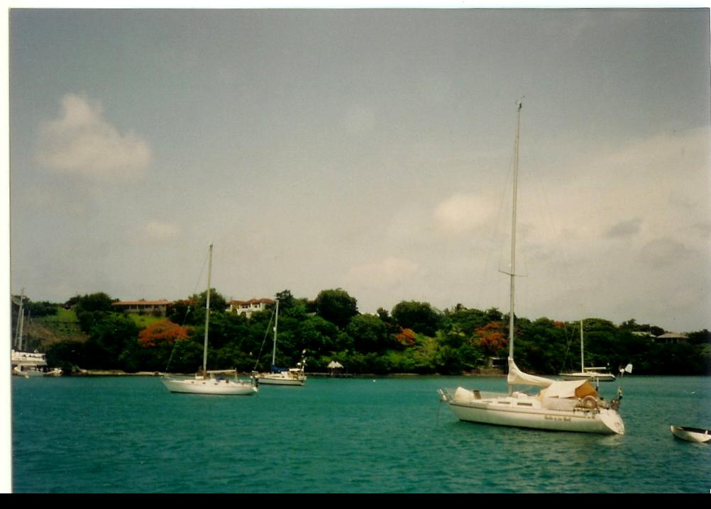
Bruce, from Deliberate, joined us for cocktail hour onboard. It turns out that he’s a 31 year-old stockbroker on Wall Street who is laid off right now. So, he bought this 37-foot Pearson and decided to sail south. His girlfriend sailed part of the way with him and then flew home from Grenada and is planning on joining him again in Trinidad. Right now he has a guy, Andrew, crewing with him whom he met in St. Johns. Andrew graduated a year ago from college and was supposed to start law school last fall. However, he decided to take a vacation to St. Johns—liked it so much that he hasn’t made it out of the Caribbean yet.
Prickly Bay, Grenada (I think)

After Bruce left we ate our pan-fried chicken and macaroni salad.

Monday, 7/13/92
We decided to go back into St. Georges today, so we took the 9:30 bus in. It leaves from the marina and brings you back whatever time the group agrees on.

We did a little shopping and then I went to The Nutmeg restaurant for a soda and to write this log while Ed went to telephone Jodi again. At The Nutmeg I met Harry, the guy in the boat called Wemicus, next to us in the bay. He is a retired schoolteacher from Toronto. He was able to retire on full retirement at 55—wish we could do that.

Ed eventually met me at The Nutmeg and we had shrimp rotis for lunch. It rained while we were there so that they had to lower their big windows.

The bus met us at The Nutmeg at 1:30 to take us back to Prickly Bay. We had the rest of the chicken (cooked on the grill this time) and more macaroni salad.

Tuesday, 7/14/92
We went into the marina this morning to check mail. Ed has been waiting all week for a package and it still wasn’t in. I purchased one of John McDonald’s Travis McGee books at the mini-mart called Essentials and ended up reading that all day. Much of the action in the book takes place in Grenada. It’s called A Tan and Sandy Silence. I didn’t quite finish the book before we went into shore for Happy Hour. This time Harry from Wemicus joined us.

After 4 rum punches (hope I didn’t drink all those) we returned to Baby Cakes and cooked hamburgers on the grill and had salad with it.

Wednesday, 7/15/92
Last night was a wild night. It rained almost all night with thunder and lightening at one point. But shortly after 8:00 a.m., it cleared and the sun was shining brightly again.

We went ashore about 1:00 p.m. to clear out of customs—I finally got my passport stamped! We got ice and prepared to leave for Hog Island. The dinghy motor quit for some reason and Ed had to row to shore and back. We left for Hog Island about 2:30 or 3:00. It’s only supposed to be a 45-mile trip, but I ran us aground on a shoal outside the island. It was really poorly marked and Ed didn’t see the buoys in time. We were lucky though. A launch from Seabreaze Charters came and pulled us off. So we made it to Hog Island around 4:30. We stayed only an hour—just long enough to make a big pot of spaghetti for the crossing to Trinidad and to shower and wash my hair.

We left Hog Island at 5:30, just in time to rendezvous with Deliberate outside The Porpoises (a group of rocks off the coast). Bruce and Andrew on Deliberate turned out to be the only other boat going to Trinidad. Fortunately, Bruce had GPS (global positioning system) on his boat. There is a strong westerly current, so we couldn’t strictly go by compass headings. Bruce has it set up to tell how far we’ve been, how far we have to go, what heading to take, and even what our speed is.

I had the 6:00 p.m. to 9:00 p.m. shift at the wheel. We had good wind, 10-13 knots, and were moving right along. Bruce or Andrew called us every hour on the hour with an update on our position. Ed took over from 9:00 till midnight. I ate some spaghetti, but only managed to get about a half hour of sleep.

Thursday, 7/16/92
I had the midnight to 3:00 a.m. shift. It was pretty uneventful—just tiring. There was a nearly full moon (it was full Tuesday night) to sail by which was nice. We did see an oilrig being towed to another location. Then Ed took over from 3:00 a.m. till 6:00 a.m. I slept for a couple of hours and woke up just in time for the sunrise, which was gorgeous! Everything seemed to turn gold just as the sun rose. And, right after the sunrise, a school of porpoises swam along side for a while (wish I’d had my camera ready).

I took over the helm from 6:00 a.m. to 9:00 a.m. The wind had just about completely died, so we mostly motored. Ed took over at 9:00 a.m., just in time for our passage between two islands outside of Trinidad. The islands were mostly uninhabited and had lots of caves in them along the shore. One of them was the home of the lighthouse we had seen since about half way across. We only passed four freighters during the night and arrived at Chaguaramas Bay at about 11:45 a.m. That’s where we had to go to clear customs.

The customs agent was the friendliest we had met so far. He was quite a character, joking with us, etc. Deliberate had to give up the shotgun they had on board for the time they are in Trinidad or Tobago anyway. They were carrying it because of the piracy that still exists on the open seas (also one of the reasons we didn’t want to make the trip alone). After clearing customs and immigration, we motored to the Trinidad and Tobago Yacht Club in Carenage Bay. We anchored there since there were no slips available.

When we went into the yacht club, Ed found that his friends, Frank and Pat, on Fore Wind were there. We had a couple of drinks at the yacht club. Prices are unbelievable—beer and mixed drinks are both $0.94 U.S. or $4:00 TT (Trinidad and Tobago dollars).

Back on Baby Cakes, we charbroiled pork chops for supper and I made rice. We were both exhausted and turned in right after supper.

Friday, 7/17/92
Today we took a route taxi as they are called ($0.47 U.S. or $2.00 TT) to Peake Marine. Bruce from Deliberate wanted to check on some stuff for his boat. The stores here are very impressive after Grenada. After Peake Marine, we walked past the fruit markets to the West Mall—like our malls. It even had one of those big food courts and we ate lunch there. I had Chinese pepper shrimp—good.

After lunch we checked out the mall. There is even a grocery store here called Hi-Lo. We then took a route taxi back to the yacht club. They even have 6-lane highways here.

This is where my journal ends. There were so many more things to do in Trinidad that I must have gotten lazy about recording events. So the rest of this log will have to depend on my memory of that summer. Since I won’t be able to recall the exact events by day, I’ll just divided it up into locations.

Trinidad
Ed and I spent 3 weeks altogether in Trinidad with a 2-week side trip to Tobago in between.

One of the things Ed and I first noticed on approaching Trinidad was the flying fish that were sailing onto our deck. We later went to a restaurant where we feasted on this delicacy. Unfortunately, I can’t remember what restaurant.

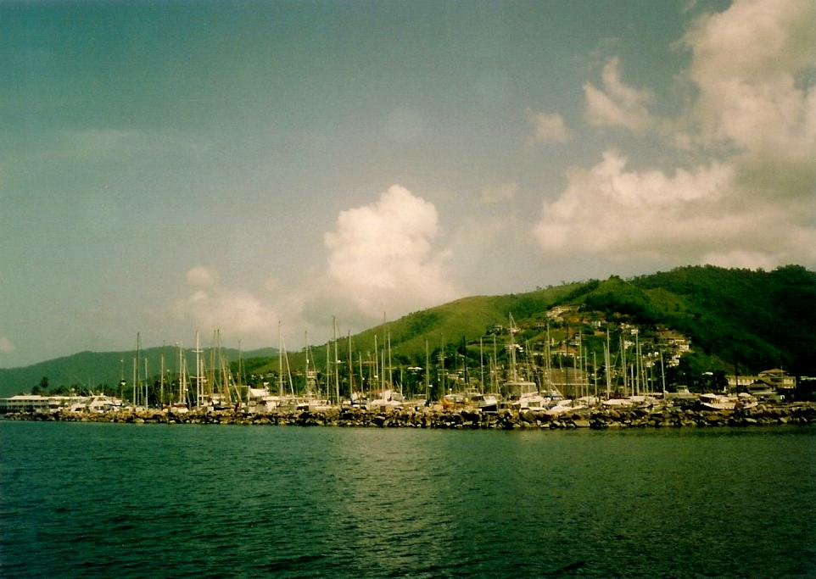
The Trinidad and Tobago Yacht Club has a huge number of boats in its harbor as can be seen from the photo. The club also had delicious food and, unlike the rest of our trip, we ate quite a few meals there.

One of my favorite features of the club was the shower—what a luxury. The water was heated by the sun, which meant it wasn’t that warm, but certainly better than nothing. Because the Orinoco River in Venezuela (Venezuela is only 7 miles from Trinidad) emptied into the Caribbean across from Trinidad, the water is not good for swimming. It’s full of trash. However, there are plenty of fish and I even saw a manta ray swimming around the boat one afternoon.
Boats at Trinidad and Tobago Yacht Club

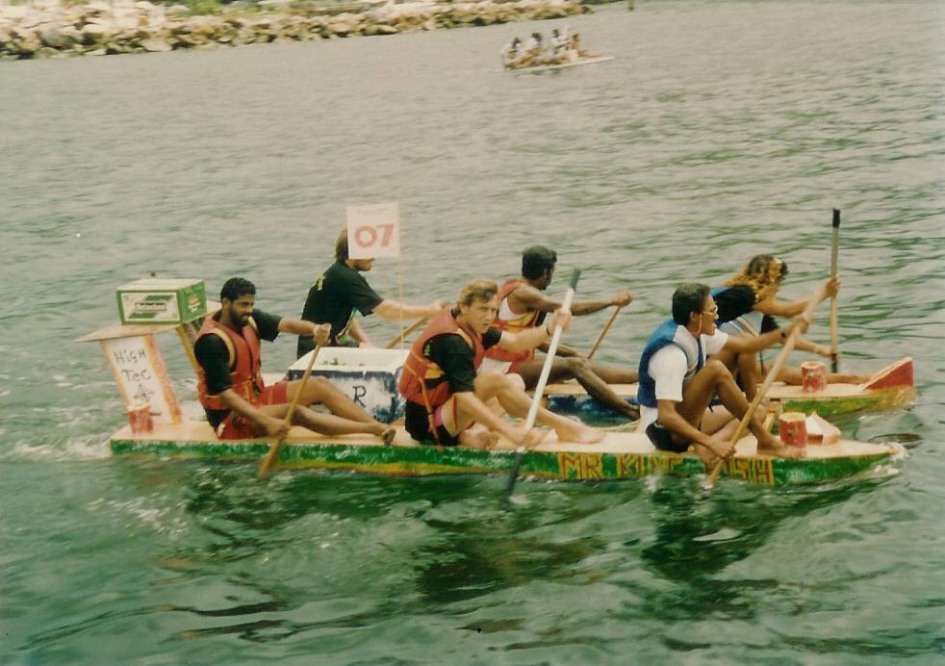
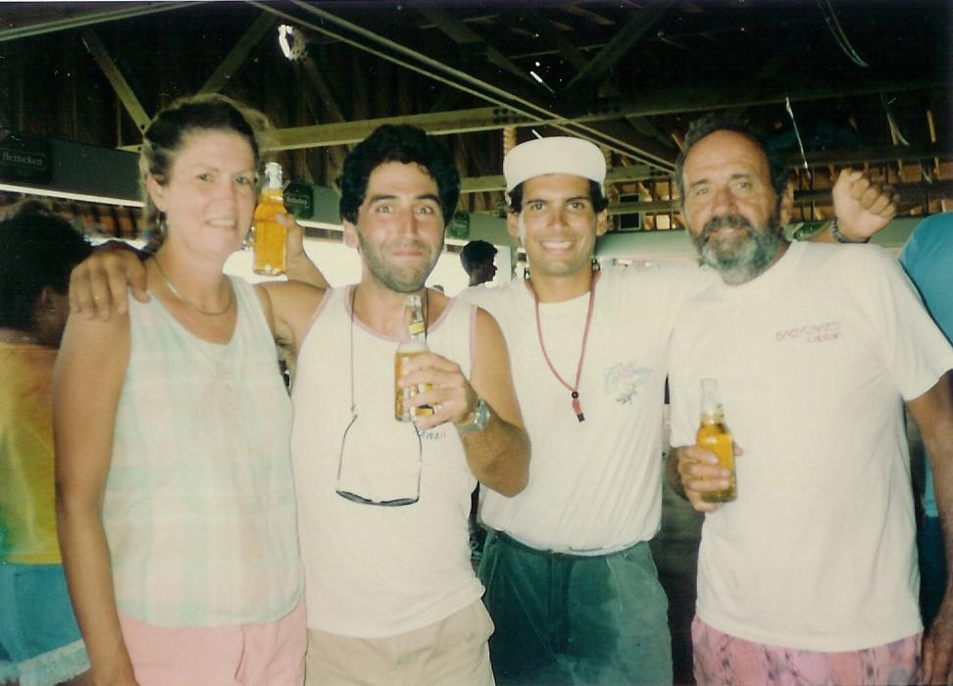
Another highlight was The Great Crate Race. Heineken put on this race and contestants were required to build their own rafts from crates that included a Heineken case somewhere on the craft. The event also included a bathing suit contest that local girls competed in. We watched much of the race from Baby Cakes, but went to the club for the other festivities. Someone (don’t remember who) was nice enough to take a picture of me, Bruce, Andrew, and Ed. After getting my pictures back, I discovered that this was the only picture of me for the whole summer.
One craft in The Great Crate Race

One afternoon, Bruce, Andrew, and I went to Port of Spain, the capital of Trinidad, to a movie theater. We walked since it wasn’t that far but got there a little early since we didn’t know the movie times. While waiting for the theater to open, I met a real nice Trinidadian woman. She and I chatted about her country and mine until it was show time. We saw “My Cousin Vinnie” and “White Men Can’t Jump,” a real cheap double feature. I think we paid $8 TT’s for the movies or approximately 2 U.S. dollars. One note: movies are censored in Trinidad and all the curse words are just blanked out. “White Men Can’t Jump” had lots of blank spots but I much preferred “My Cousin Vinnie”--hilarious.
Me, Bruce, Andrew, and Ed
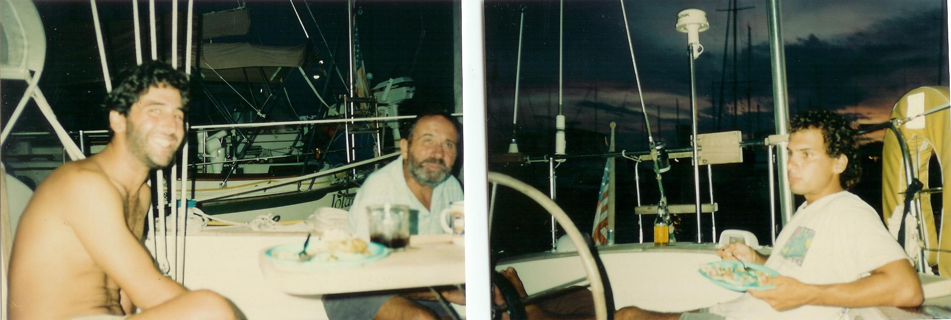
Port of Spain seemed to have a high crime rate. Most of the houses had barred windows and walls around them with broken glass embedded in the wall tops. And many of the stores showed products behind bars with a space to the hand money and products through. Even the supermarket had an armed guard at the door. Also, Bruce, Andrew, and I noticed police walking the streets with machine guns—didn’t make us feel all that safe.
Bruce and Ed
Andrew

While anchored at the yacht club (which was a gated community) we visited often with Bruce and Andrew and with Ed’s friends, Frank and Pat on Fore Wind. Bruce was having new covers made for the cushions on Deliberate and Andrew didn’t feel like hanging around Trinidad all of the time this would take. So, he decided to accompany us to Tobago.

After two weeks in Trinidad Ed, Andrew, and I took off for Tobago, but since we were on the opposite side of Trinidad from Tobago, we first circled the island and spent a night in a harbor on the other side. It was there that we invented a meal we called “Poor-man’s Surf ‘n Turf.” It consisted of burgers (which we discovered were ground goat) and flounder that Andrew caught using leftover chicken for bait. On the entire trip Ed had refused to eat goat, but I knew the ground meat that we had been eating couldn’t have been beef (didn’t have enough fat). So, I asked the butcher at the supermarket in Trinidad what was in the ground meat. He informed me that it was goat—Ed had been eating goat for three years and didn’t know it!

Tobago

The highlight of our sail to Tobago was seeing a whole flock of Scarlet Ibis, the national bird of Trinidad, fly overhead. They are beautiful birds and I would have liked to have taken a guided boat tour into the Caroni Bird Sanctuary where, at sunset, hundreds of the birds fly in from neighboring lagoons to roost for the night. Unfortunately, time didn’t permit.

I don’t remember for sure where we first dropped anchor in Tobago, but I think it may have been Castara Bay. I do remember that we had to walk a good distance to find a phone in order to check into customs (I’m sure we must have checked out at customs before we left Trinidad and you have to check into customs on each island even though Trinidad and Tobago are one country). I also remember that we heard a steel band playing on the island that night, so we must have been close to a town.

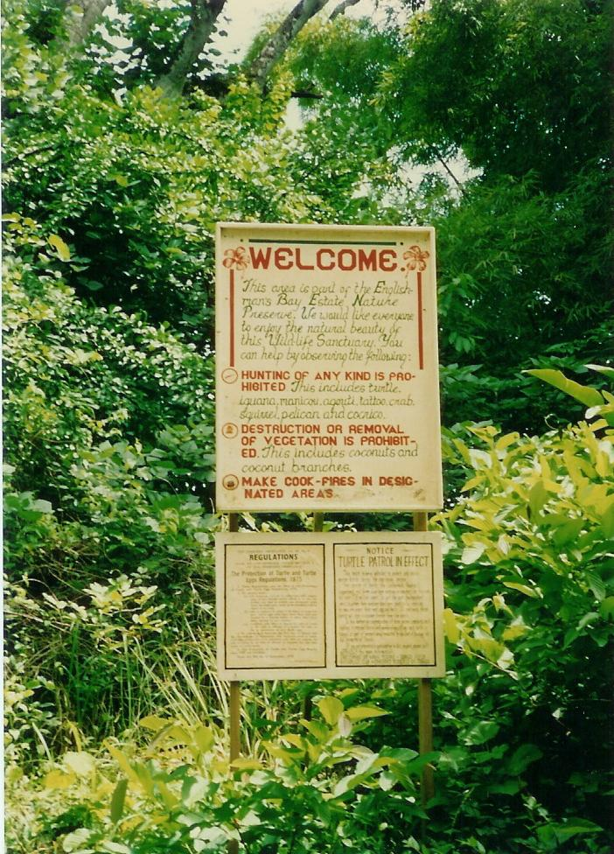
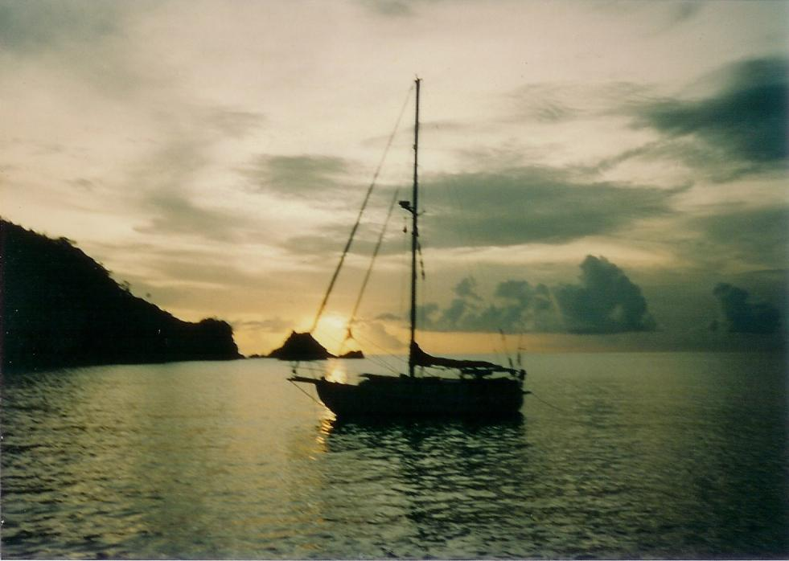
One of the highlights of the trip, though, was Englishman’s Bay—what a gorgeous place! It had a beautiful white sand beach and clear turquoise water with coral reefs on either side. Frank and Pat from Fore Wind joined us there and before we realized the area was a nature pressure, Frank speared a lobster on one of the reefs. We shared that as an appetizer before supper. We spent a couple of idyllic days there, swimming, snorkeling and just enjoying the quiet. The only down side to the bay was the waves we experienced one night. Evidently, the wind was coming from the wrong direction and the boat rocked from side to side so fiercely that I had to brace myself to stay in my bunk in the V-birth. None of us were too hungry for breakfast the next morning. Each morning the locals brought in the large fishing net that had been laid out the night before. Ed helped them haul it in one morning and even though he was entitled to a share of the catch for helping, he declined. Before we left this wonderful site, we walked to the road behind the beach that was hidden by the trees. That is where we discovered the sign telling us that we were in a nature preserve and that it was unlawful to take anything off the reef. (A note: Just this past year, I was appalled to see Englishman’s Bay listed on The Travel Channel as one of world’s top 10 beaches—doubt if it will stay as unspoiled as it was when we visited!)
Baby Cakes at sunset in Englishman’s Bay in Tobago
Sign welcoming visitors to Englishman’s Bay

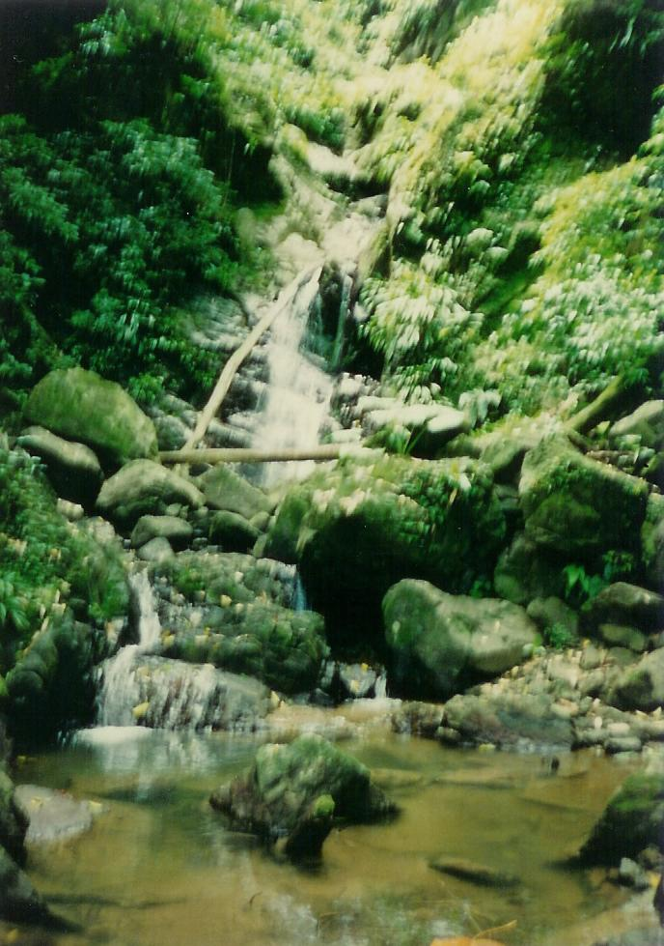
Our next stop on Tobago was a visit to an out of the way waterfall. Ed found it mentioned in his guidebook, but I haven’t been able to find a mention of it on the Internet. We had to walk about a mile and a half through jungle with no real path to get to the falls. We simply followed the stream that it flowed into and found it necessary to cross the stream many times on the way. Ed gave up about half way but Andrew and I continued on to the falls. Andrew actually climbed to the top of the falls so I could take a picture. However, he looked so small as not even to show up—afraid I didn’t have a telephoto lens. After this little adventure, we continued on to Charlottesville.
Unknown Waterfall

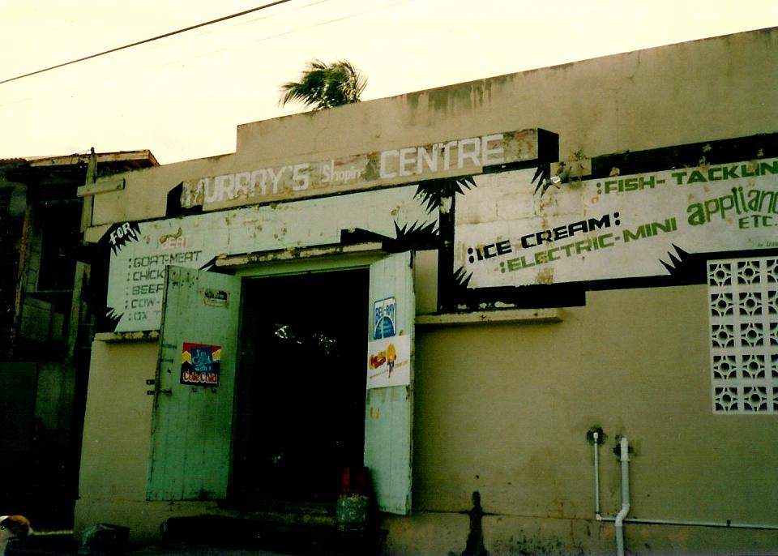
Charlottesville is a small town at the northern tip of Tobago. It lies on Man ‘O War Bay, another nice bay. We found a few more boats there, but not for long. We had a bit of a scare when a coast guard boat came up to us with their machine guns aimed to ask if we had checked into customs. Thank goodness we had! Two of the boats in the harbor evidently hadn’t checked in. The coast guard boarded them, searched them, and then made them leave the harbor. While we were in Trinidad, we had heard the news of an Englishman and his daughter getting arrested when drugs were found on their boat. We supposed the Trinidadian Coast Guard was so cautious because of Trinidad’s close proximity to South American countries. We spent several days here because there was a “Shopping Center” (you’ll see why this is in quotes if you look at the picture of Murry’s) for supplies and a nice peaceful harbor. Ed and Andrew did a lot of fishing; Andrew did some windsurfing; and I mostly read Ed’s copy of Jimmy Buffett’s Tales From Margaritaville. (Speaking of Jimmy Buffett reminded me that Ed had tapes of almost every album Jimmy Buffett ever produced—listened to a lot of his songs during the summer.)Then, Ed started making homemade bread in Baby Cakes’ oven. Andrew and I liked it so much that we had him teach us how to make it so we could have fresh homemade bread every day. We had pretty much been unable to buy fresh bread in the stores most of the summer.
“Murry’s Shopping Center” in Charlottesville, Tobago

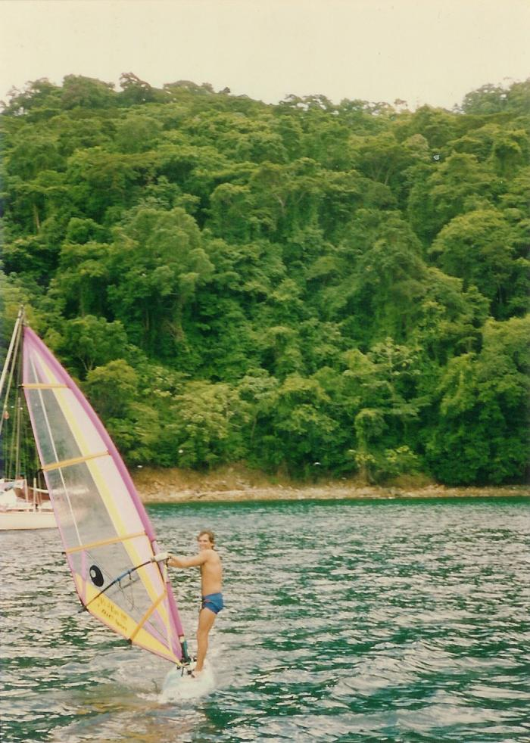
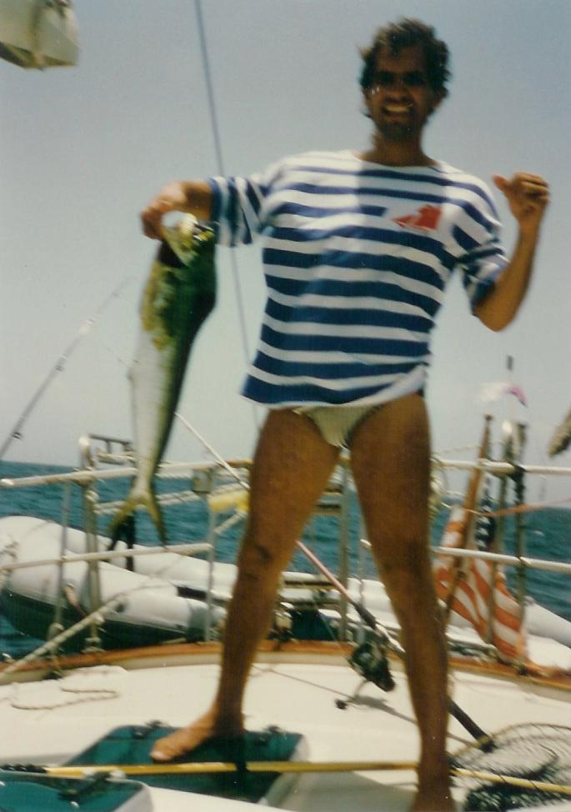
Our last stop in Tobago was Bucco Bay. We only spent one night there, but met Frank and Pat from Fore Wind again and went out to dinner with them. I’m afraid I don’t remember the name of the restaurant, but I had very good Dorado, the Trinidadian name for the Dolphin Fish (not to be confused with Flipper). The next day, after preparing our bread to rise, we all went snorkeling on Bucco Reef, which was the main reason we stopped here to begin with. We didn’t do the real touristy thing—going on a glass bottom boat ride. The reef was very impressive, but because it was a cloudy day, the colors weren’t as brilliant as those in Englishman’s Bay. Besides all the colorful fish and coral, we did see a rather large grouper—too bad Bucco is another nature preserve; he would have made a tasty treat.
Andrew windsurfing

The next morning it was time to return to Trinidad. Ed and I had originally planned to go to Margarita Island in Venezuela—thus the Venezuelan visas. However, we heard they were having a cholera outbreak there and a tropical wave was predicted (This turned out to be the beginnings of Hurricane Andrew!). So we settled for another week in Trinidad. On the trip back Frank and Pat from Fore Wind followed us. Both boats had fishing lines out and we almost simultaneously caught Doradoes—some good eating for my last week in Trinidad.
Andrew with our Dorado

Trinidad, Again

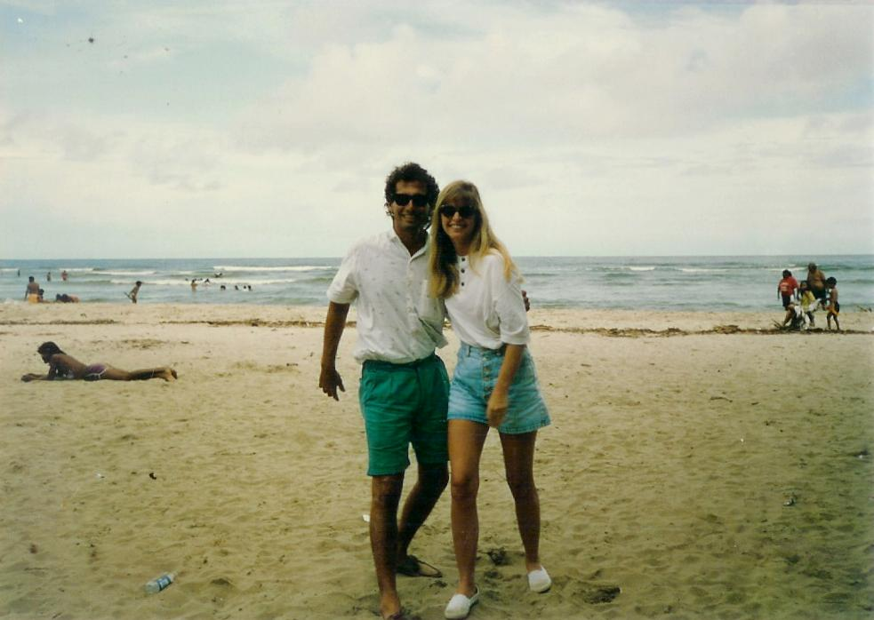
We arrived back at the Trinidad and Tobago Yacht Club in time for happy hour and I particularly remember the meal of oxtail stew; it contained plantains and breadfruit along with the meat and a scrumptious base. Andrew rejoined Bruce there and Bruce’s girlfriend had flown in to join them as well. Bruce rented a car and took me, Ed, Andrew, and the girlfriend (can’t remember her name) to a beach on the other side of the island for a day.
Andrew with Bruce’s girlfriend

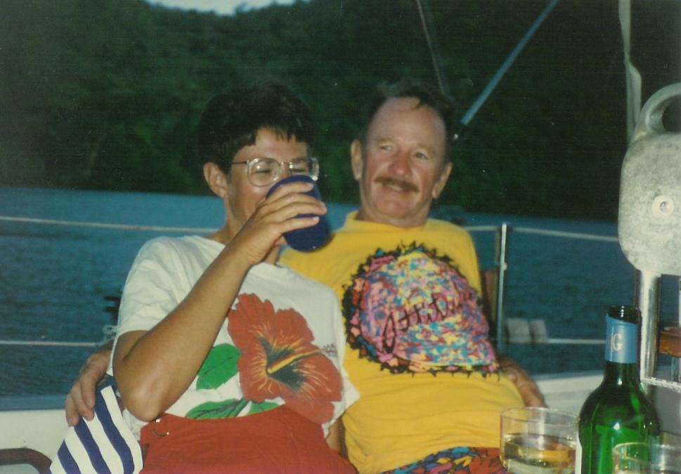
We spent the rest of my stay socializing with Frank and Pat from Fore Wind and Bruce, his girlfriend, and Andrew from Deliberate—some of the time on each other’s boats and the rest of the time in the yacht club. We took the usual shopping trips, but I don’t remember any other significant adventures.

It was time for me to plan my flight back home. Ed and I found a travel agent at the mall and I arranged to leave Sunday, August 23rd early in the morning. I had a connecting flight in San Juan with a 6-hour layover—the best she could do. Ed arranged for a taxi to pick me up in the wee hours of the morning on the 23rd and I made it to the airport in plenty of time. Because I had stayed on the boat the whole time, I didn’t have to pay the departure tax that Trinidad collects from most tourists (Don’t ask me why.)
Pat and Frank from Fore Wind

I lucked out in San Juan. As soon as I got there, I put my name in for standby on the next flight to Boston. Probably because Hurricane Andrew was out in the ocean at the time, I was able to get on the flight. (On the flight they showed “My Cousin Vinnie,” this time with the curse words changed to things like “darn”—didn’t actually see the real movie till years later.) However, my luggage didn’t make it and my friend Diane wasn’t prepared to pick me up 5 hours early. (The hurricane made the trip and hour longer as we had to fly around it.) Since the flight was to arrive late at night, she had made plans for Bill, a friend of ours, to pick me up. But when I arrived, he was working. Diane was with another friend of ours, Frank, having a few cocktails where Bill bartended. So, instead, she went to Frank’s Goodtime Lounge (one of our favorite hangouts) and asked Louise to pick me up. It ended up that Louise, Mary, and Diane drove in to get me. We had a little of a communication mix-up about where to meet, but I eventually found them in the bar nearest my arrival gate.

Whew, it was nice to finally get home! Another friend, Maureen, had been house sitting all summer and taking care of my two cats. (I picked up my luggage at Logan the next day.)

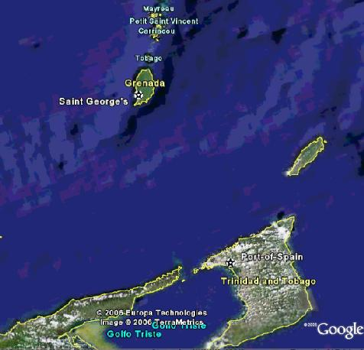
I had a marvelous summer—one to tell the grandkids about if I had any (guess my nephews will have to do). I have to thank Ed for asking me to crew for him and provide me with the experience of my lifetime! (One sad note: I found out later that Andrew’s parents lived in Homestead, Fl and their home was destroyed in Hurricane Andrew—a coincidence in the name?)

Path of My Amazing Trip

