Titration of sodium hydroxide from http://www.chemsoc.org/networks/learnnet/Word_files/Kev1-10.doc
with hydrochloric acid

Introduction
In this experiment sodium hydroxide is neutralized with hydrochloric acid to produce the soluble salt sodium chloride. This is then concentrated and crystallized in a crystallizing dish.

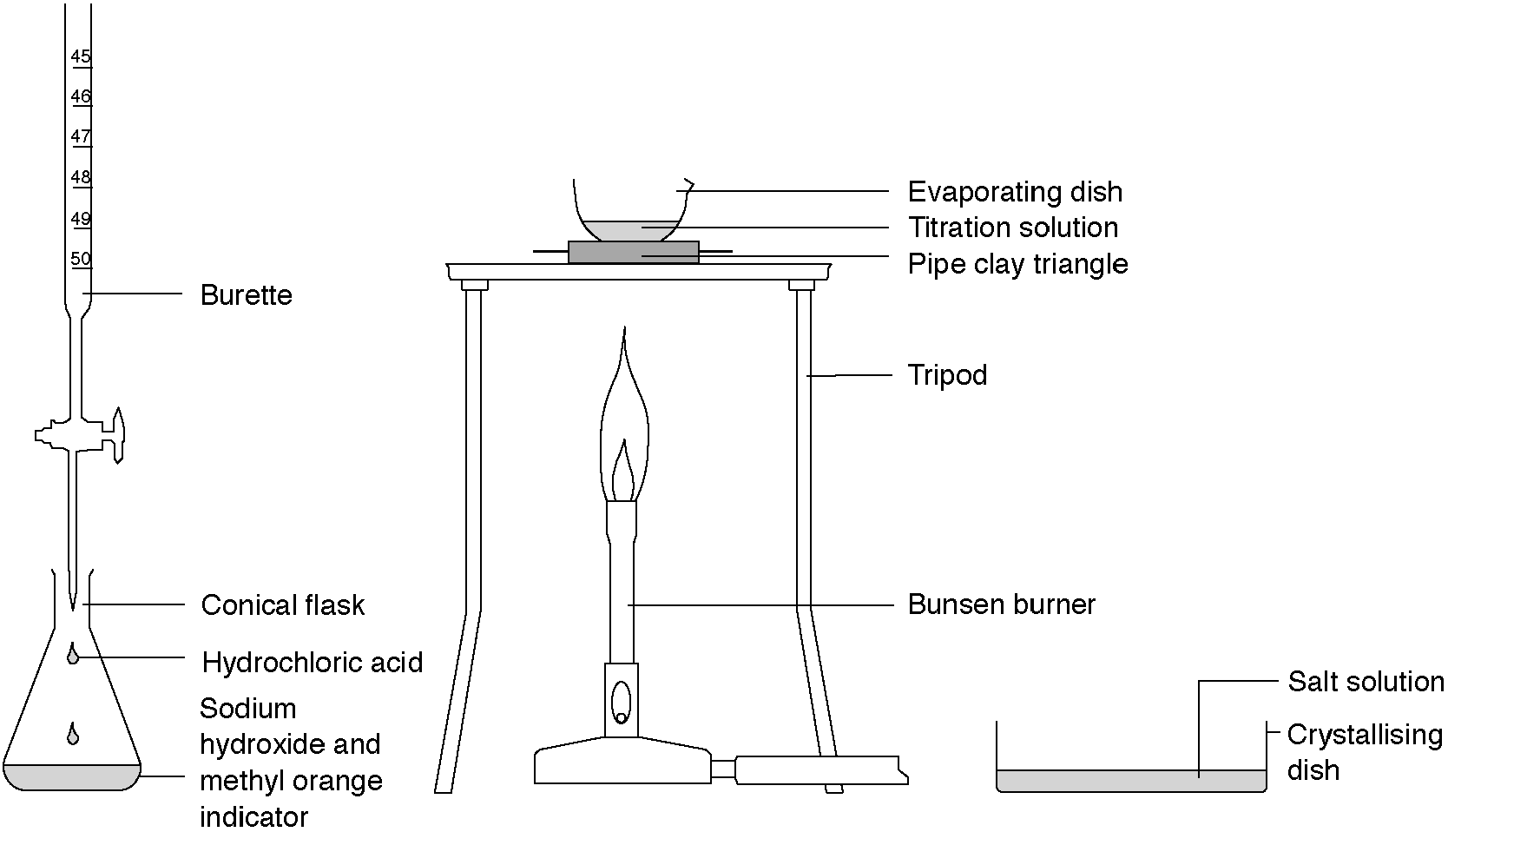What to record
What was done and what was observed.

What to do
1. Add 25 cm³ of sodium hydroxide solution (Corrosive) to a conical flask using a measuring cylinder and add a couple of drops of methyl orange indicator.
2. Fill the burette with hydrochloric acid and run through to the zero mark (use a funnel to fill the burette and a beaker to collect the excess acid).
3. Add the hydrochloric acid to the sodium hydroxide solution in small volumes swirling after each addition. Continue until the solution turns red and record this reading on the burette.
4. Carefully add this volume of fresh hydrochloric acid to another 25 cm³ of sodium hydroxide solution to produce a neutral solution.
5. Reduce to about half the volume using an evaporating dish on a gauze over a Bunsen burner flame.
6. Leave to evaporate in a crystallizing dish to produce a white crystalline solid.

Safety
Wear eye protection.

Questions
1. What is the everyday name for sodium chloride?

2. This reaction is a specific example of the general reaction: Acid + alkali → salt + water.
Write a word equation for this specific reaction.

3. Write a formula equation for this reaction.

4. Why must you use another 25 cm³ of sodium hydroxide solution to make pure sodium chloride?

Home

