
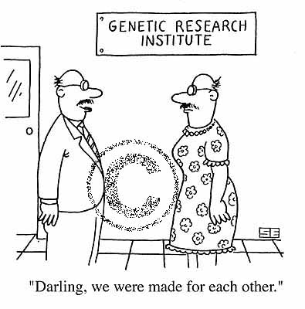
Biotechnology
A Multimedia Journey
In the day and age that we live, biotechnology is a very hot subject. Topics such as stem cells, genetically modified food and designer babies are things that people used to only be able to read about in science fiction novels. In 2007 most of these “farfetched ideas” are an actual reality. It is almost impossible to read the newspaper or watch TV without hearing about one of these topics. The range of biotechnology is astounding and unfortunately we do not have enough time in class to really delve into them. Your project will do just that.

Here is what your project entails:
- Prepare a team of individuals between 1-3 people.
- Pick a topic either from the supplied list or something else approved by me.
  - Genetic engineering
  - DNA fingerprinting
  - Gene Therapy
  - Cloning
  - Genetically Modified Food
  - Stem Cells
  - Transgenic Animals
  - Reproductive Technologies
- Inform me of your topic and team on or before ___________________.
- Obtain relevant information about your topic (1997-present)

Be sure to include:
  - The topic that you picked
  - What is it?
  - How does it/can it affect human life?
  - Is it dangerous?
  - Miscellaneous interesting information that you find
  - NONE OF YOUR OWN OPINION
- Prepare one of the following using your research:
  - A colored printed 3-fold brochure that details the above criteria in a creative and interesting way.
OR
  - A poster that details the above criteria in a creative and interesting way.
OR
  - A radio announcement that demonstrates the above criteria in a creative and interesting way. (Minimum of 2 minutes, maximum of 5 minutes)
OR
  - A television public service announcement that demonstrates the above criteria in a creative and interesting way. (Minimum of 2 minutes, maximum of 5 minutes)
- The brochure/poster must be professional looking. (Color, typed, neat, includes pictures etc.)
- The radio or television announcement must be previously recorded.
- Be prepared to show and present your research to the class
- You must also hand in a journal entry that explains your topic and your OPINION
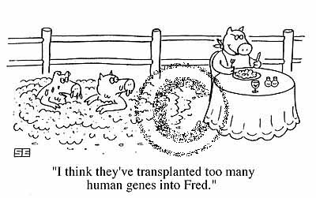
- Every day late will receive 10 points off.

Due _____________
This project will count as 1 TEST GRADE

Evaluation Rubric will include the following

- The project must contain each of the 6 required parts including accurate and complete information
- WORKS CITED
  - Include your works cited page separate from your project.
  - You do not need to cite the information on your poster or brochure BUT make sure that you paraphrase. If anything looks like it was copied and pasted straight from a source your project will receive a zero.
- Presentation
  - Everyone in your group needs to be able to field answer questions.
  - Everyone also needs to participate in the explanation of your research.
  - If you do a radio or television announcement all members of the group will need to have an active role.

Poster/Brochure
- Creativity – How does it look? Is it neat and professional looking? Does it indicate an effort?
- Readability – Does it make sense? Can the average person understand your information? Does it flow? Is too much information crammed into a little space?

Radio or Television Announcement
- Creativity – Did you take an interesting approach? Does your approach indicate an effort from all participants?
- Attention grabbing – Does your announcement make me want to find out more about your topic? Does your announcement make me want to use your technology?

See me if you have an problems or questions

