HONORS CHEMISTRY I
How to use and adjust a Bunsen burner

Purpose: To learn how to use and adjust the Bunsen burner and to find the hottest part of the flame.

Materials: Bunsen burner 3 X 5 Index card
Rubber tubing Match
Striker Straight pin

Procedure:

PART ONE: Adjusting the Bunsen burner
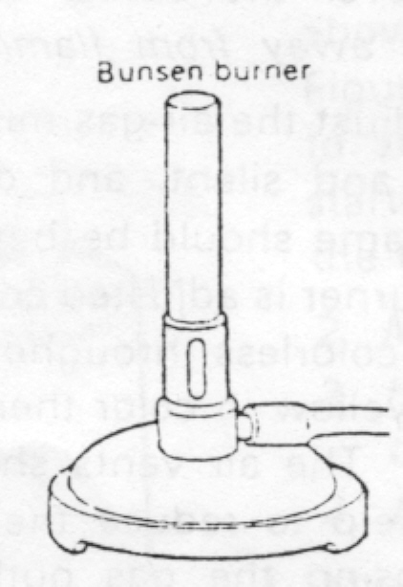
- Examine your Bunsen burner. Look for the short metal gas inlet at the base of the burner. The gas inlet is connected to the gas outlet on your lab table by means of sturdy rubber tubing. Do not use old, rotten, or porous rubber tubing.

- Locate the air vents. The barrel has an adjustable sleeve that rotates around it, permitting you to adjust the air-gas mixture. The purpose of the barrel is to permit the mixing of gas and air as they both pass upward through the barrel. This produces a combustible mixture at the top of the burner.
Air Vents→

- Use a suitable length of rubber tubing to connect the burner to the gas outlet on your lab table. Rotate the sleeve so that the air vents are about half-way open. Too much air makes the burner difficult to light.
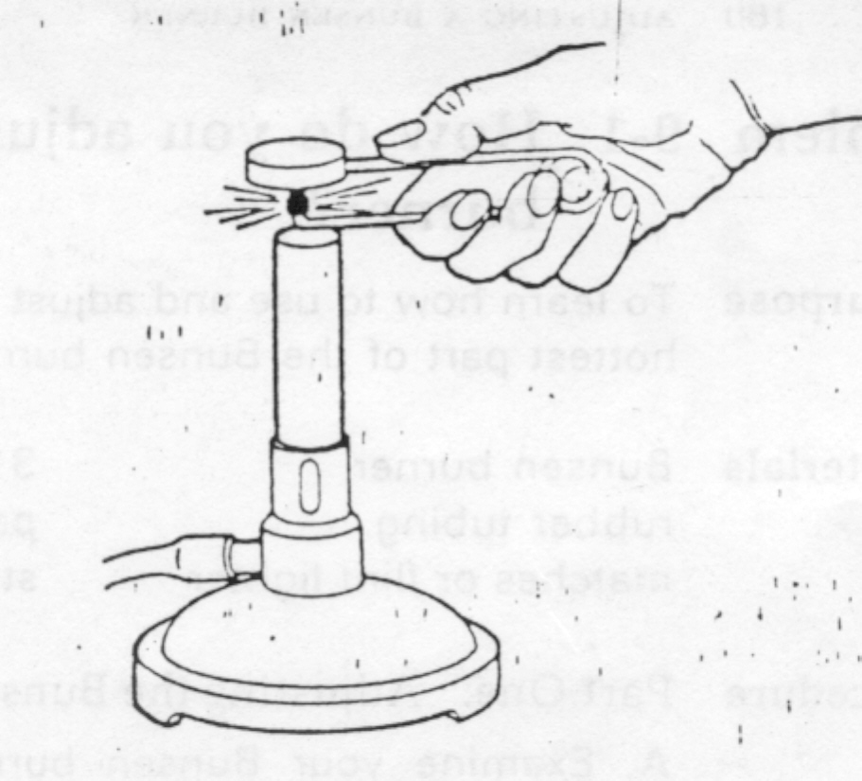
- When you turn on the gas, you should hear a slight hissing sound as the gas escapes. Turn on the gas, hold the flint lighter over the barrel in the gas-air mixture stream and squeeze the handle on the lighter to produce a spark.

Caution: Do not lean over the burner when lighting it. Keep the lighted burner away from flammable materials.

- When the burner is lit, adjust the gas outlet till the flame is about two inches tall. Close the vent and describe what happens; draw a picture in your lab book. Carefully lable the color regions observed in the flame. Open the vent all the way, and describe what happens; draw a picture in your lab book.

Caution: If the flame goes out at any time, turn the gas off.

- Adjust the air-gas mixture so that the flame produced is blue and silent, and does not flicker. There should be a two part blue flame. Describe and draw a picture in your lab book.

- Extinguish the burner by closing the gas outlet on your lab table.

- Repeat the lighting procedure (repeat for all lab partners) several times until you can do it without difficulty.

PART TWO—Finding the Hottest Part of the Flame
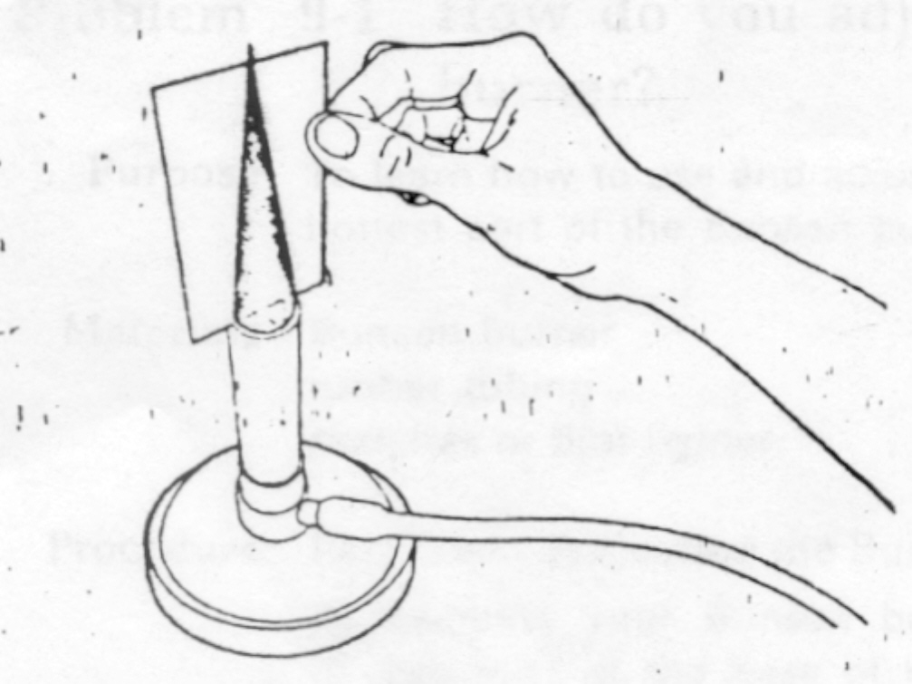
- You will now find if the flame is equally hot throughout. Hold an index card in the flam, in a vertical position just above the top of the barrel for one to two seconds. Remove the card immediately when it starts to scorch. (If it catches on fire, throw it in the sink, and try again. Do not hold the card in the flame as long). Closely examine the scorched pattern on the card, describe in your lab book and glue the card to your book. (Repeat for each lab partner)
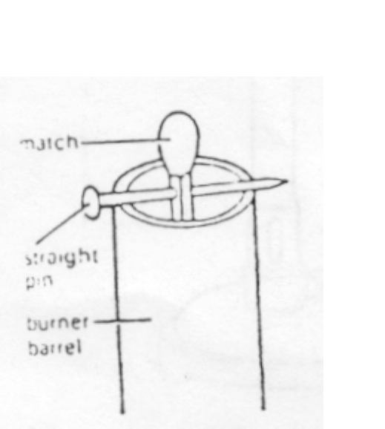

- Stick a straight pin through a match one-half centimeter below the head of the match. Suspend the match in the barrel of an UNLIT burner. Turn on the gas and carefully light the burner.

QUESTIONS:

- What happened to the match?

- Is the inner portion of the flame hot? How do you know?

- What region of the flame is the hottest? (Look closely at your card)

- If you wish to heat an object strongly, what should you do?

Note: A wire screen is usually used when heating an object on a ring stand. The ring should be adjusted so that the hottest part of the flame hits the very bottom of the wire screen. The screen serves two purposes. First, it spreads the heat evenly over a larger area. In this way the flame is not concentrated on a small area of the object. Second, is to help support the object being heated.

