CARTOON CHEMISTRY

Types of Chemical Reactions Name: _______________________

Describe the chemical reaction illustrated below each diagram:

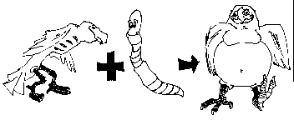
___________________________________________________________________________ ______________________________________________________________________________________________________________________________________________________
Type of reaction: ________________________________

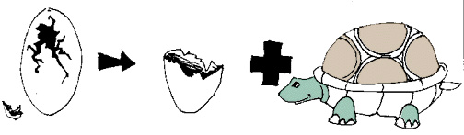
___________________________________________________________________________ ______________________________________________________________________________________________________________________________________________________
Type of reaction: ________________________________

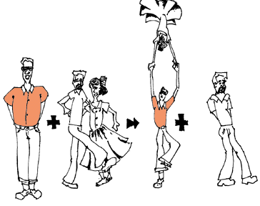

___________________________________________________________________________ ______________________________________________________________________________________________________________________________________________________
Type of reaction: ________________________________

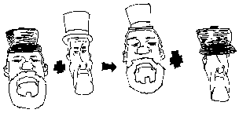

___________________________________________________________________________ ______________________________________________________________________________________________________________________________________________________
Type of reaction: ________________________________

Home

