Castle Mendeleev

Place the symbol and name of the element in the room where it belongs.

Castle Mendeleev
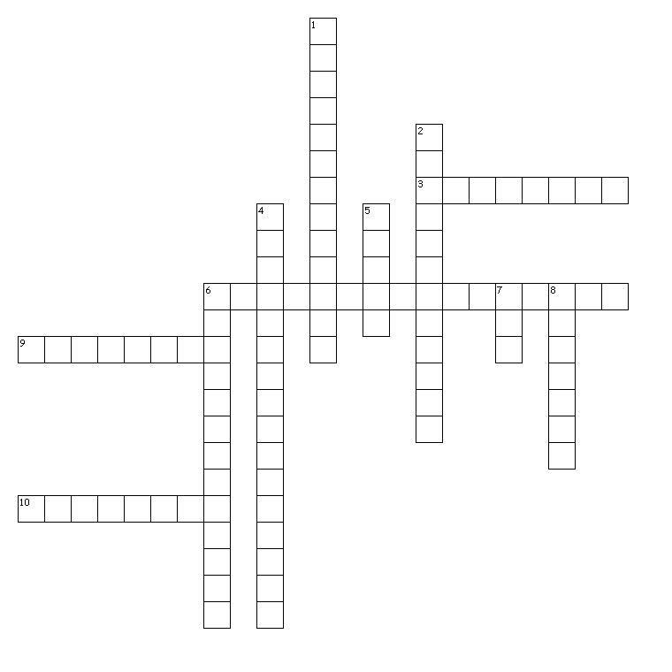
Across
3. Compound consisting of two atoms of the same element. (ex: O₂, H₂)
6. Force that attracts chemical elements to other elements and keeps them joined (bonded) together.
9. Smallest part of a compound.
10. Inactive; ex. He,Ne; do not actively combine with other elements.
Down
1. Easily transfer the flow of electrons (electricity).
2. Compounds consisting of the elements carbon and hydrogen.
4. Electron(s)in the outer orbit of an atom that will either be gained, lost, or shared when combining with another atom to form a compound.
5. A metal made by mixing two or more metals; ex. copper + zinc ----> brass
6. Orbit of electrons around the nucleus of an atom.
7. A charged particle; the result of an atom either gaining or losing electrons.
8. Atoms of an element that have a different than normal number of electrons.

