Chapter 10: Mendel’s Laws of Heredity

Heredity
- The passing on of characteristics from parents to offspring

Traits
- Characteristics that are inherited

Genetics
- The branch of biology that studies heredity

Gregor Mendel
- Austrian monk that first developed the study of genetics
- Experimented with pea plants to discover the general laws of genetics
- A pea plant has gametes and both male and female reproductive organs
  - Gametes: male and female sex cells
  - Pollination: transfer of pollen (male gametes) from a male reproductive organ to a female reproductive organ in a plant
    - Mendel allowed pollination to occur within the same flower or between different flowers for his experiments
- Fertilization: the male gamete unites with the female gamete to form a zygote (a fertilized cell)
  - In the case of pea plants, the zygote becomes a seed
- Conducted monohybrid crosses between pea plants
  - Monohybrid crosses: study one trait at a time
P₁ = Parental generation
F₁ = First filial generation
F₂ = Second filial generation
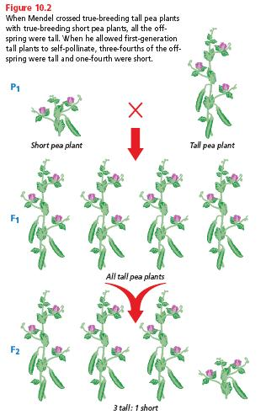

The rule of unit factors
- Each organism has two factors, or genes, that control each trait
  - One gene comes from mom, one gene comes from dad
- A single gene can exist in different forms called alleles
  - Example: Blue, brown, and green are alleles for the eye color gene

The rule of dominance
- Dominant trait: “stronger” trait that shows up when the dominant allele is present
  - Represented by a capital letter; B is for brown eyes
- Recessive trait: “weaker” trait that shows up only when the dominant allele is not present
  - Represented by a lowercase letter; b is for blue eyes
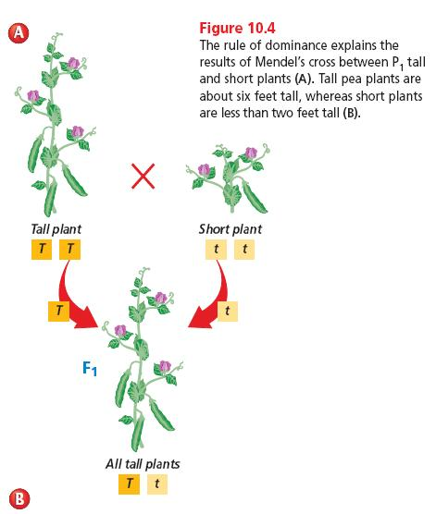

Mendel’s law of segregation
- Every organism has 2 alleles of each gene
- When gametes are made, each gamete receives only one of these alleles
- During fertilization, the offspring will receive one allele for each gene from each parent
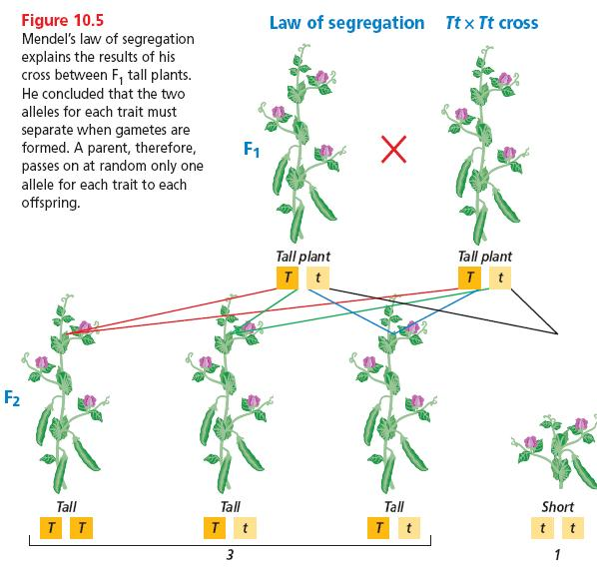

Phenotypes and genotypes
- Phenotype: the physical appearance of an organism
  - Brown eyes
- Genotype: genetic makeup of an organism
  - Alleles for eye color are Bb
- Homozygous: 2 alleles for a trait are the same
  - BB is homozygous dominant for brown eyes
  - Bb is homozygous recessive for blue eyes
- Heterozygous: 2 alleles for a trait are not the same
  - Bb is heterozygous

Dihybrid cross
- A cross between organisms that involves 2 traits
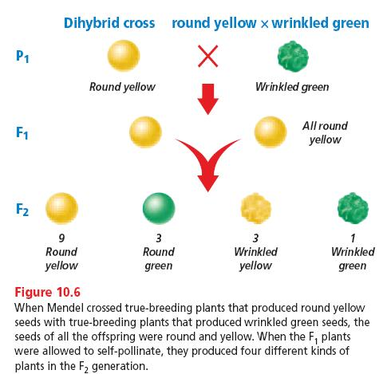

Mendel’s law of independent assortment
- Genes for different traits are inherited independently of each other
- Example: You have brown hair (Bb) and freckles (Ff)
  - You can pass on to your children one of the following combinations: B + F, B + f, b + F, b + f
Punnett Squares
- Shorthand way of determining the probability of having a certain type of offspring if you know the parents’ genotypes
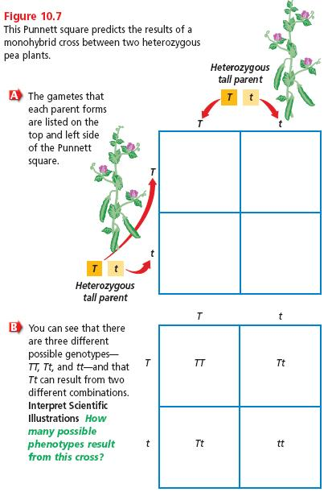

T: tall pea plant

t: short pea plant

Possible phenotypes
75% tall
25% short

Possible genotypes
25% TT
50% Tt
25% tt

R: round pea r: wrinkled pea
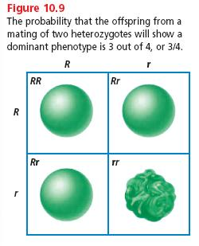
Possible phenotypes
75% round
25% wrinkled

Possible genotypes
25% RR
50% Rr
25% rr

Genes, Chromosomes, and Numbers
- Diploid cell: has 2 of each kind of chromosome
  - One came from mom, one came from dad
  - This is why we have 2 of each kind of gene
  - All body cells, except gametes, are diploid cells
- Haploid cell: has 1 of each kind of chromosome
  - Gametes are haploid cells
- Each type of organism has a specific number of chromosomes (humans have 46 chromosomes)
- Homologous chromosomes: 2 of the same type of chromosome in a diploid cell
  - Have genes for the same traits, but might have different alleles for the same gene
    - Ex: blue eye gene on 1 chromosome and brown eye gene on the other chromosome

Meiosis
- Cell division that produces gametes with half the number of chromosomes as a body cell
- Gametes that are produced are sperm cells for males and egg cells for females
- In humans, each sperm and egg cells has 23 chromosomes (which is half of 46, the normal number of chromosomes)
- Sexual reproduction: when haploid egg and sperm cells join together to form a diploid zygote
- Sperm (23) + Egg (23) = Zygote (46 chromosomes)
- Healthy zygotes cannot have more than 46 chromosomes
- Once formed, zygotes undergo mitosis to grow and develop

Before Meiosis
- Homologous chromosomes are attached to each other
  - Homologous chromosomes: 2 of the same type of chromosome
- Chromosomes copy themselves
- Tetrad: 4 chromosomes attached to each other
  - 2 homologous chromosomes plus 2 copies

A
A
Copies itself
A

A

A copy
A copy

Original homologous chromosomes
Tetrad

2 pairs of sister chromatids:
A chromosome and its copy

Meiosis I (2 new cells are formed)

Prophase I: *Tetrads condense
*Nuclear membrane disappears
* Centrosomes move to opposite ends of cell to form spindle fibers

Metaphase I: Tetrads line up in the middle of the cell

Anaphase I: Tetrads split and each set of sister chromatids moves to opposite ends of the cell

Telophase I: Cytokinesis (division of the cytoplasm) results in 2 new cells

Meiosis II (4 new cells are formed)

Prophase II: Centrosomes move to opposite ends of the cell to form spindle fibers
Metaphase II: Sister chromatids line up in the middle of the cell

Anaphase II: Sister chromatids separate and move to opposite ends of the cell

Telophase II: *Nuclear membrane forms around each set of chromosomes
*Cytokinesis
*4 new daughter cells

Steps of Meiosis

Mistakes in Meiosis
- Nondisjunction: when homologous chromosomes don’t separate from each other during meiosis
- so homologous chromosomes move together into a new gamete giving that gamete too many chromosomes, while the other new gamete is missing the chromosome
- organisms with extra chromosomes can survive
- organisms with too few chromosomes usually do not survive
- polyploidy: when organisms have more than the normal number of chromosome sets
  - instead of 46 chromosomes, they might have double or triple that number
  - lethal for animals but not plants

