Chapter 16: Primate Evolution

Primates
- Group of mammals that have
  - Rounded heads and flattened faces
  - Large, complex brains
  - Opposable thumb: thumb can cross the palm to meet the other fingertips
  - Binocular vision: see an object through both eyes at the same time, which helps to perceive depth
  - Arm movement in many directions
  - Flexible joints
- Primates evolved from the same ancestor

Anthropoids: humanlike primates
  - Include hominoids, Old and New World monkeys, apes, humans
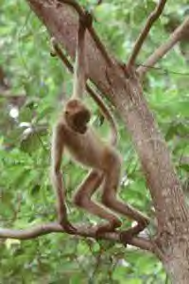
  - New World monkeys
    - live in the rain forests of South and Central America
    - include marmosets and spider monkeys
    - live in trees (arboreal)
    - long, muscular prehensile tail (tail is used to grasp and wrap around branches like another arm or leg)
    - oldest New World monkey fossils are 30-35 million years old
Figure 1. Spider monkey

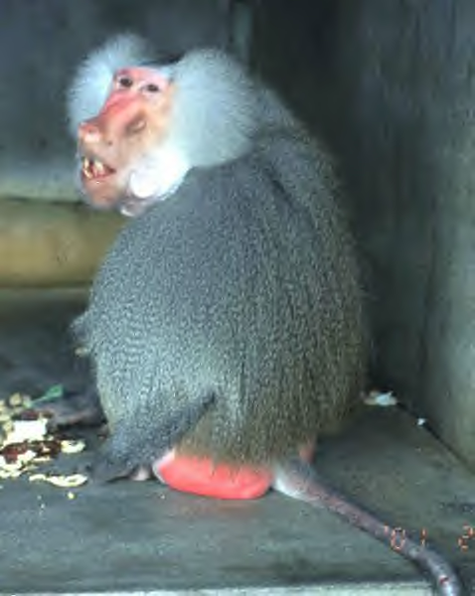
  - Old World monkeys
Figure 2. Baboon
    - Found in hot, dry environments (Africa) and cold environments (Japan)
    - Arboreal and live on the ground
    - Colobus monkeys, guenons, baboons, macaques
    - Do not have prehensile tails
    - Oldest Old World monkey fossils are 20-22 million years old

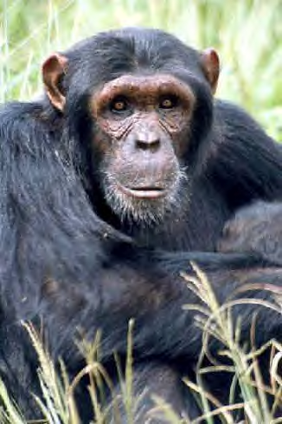
  - Hominoids: apes or humans
Figure 3. Chimpanzee
    - Apes include orangutans, gibbons, chimpanzees, bonobos, and gorillas
    - Lack tails
    - Long, muscled arms and legs for climbing and walking
    - Can be arboreal or live on the ground
    - Capable of social interaction (which comes from a large brain)
    - Chimpanzees are the most closely related hominoid to humans

Hominoids
- Primates that walk upright on 2 legs and include gorillas, chimpanzees, bonobos, and humans
- Between 5-8 million years ago in Africa, a population of hominoids diverged into 2 lines that eventually became chimpanzees and humans
  - There are no fossils to support this, but the DNA of humans and chimpanzees is very similar
  - The hominoid population diverged into 2 lines perhaps because there was an environmental change that caused some hominoids to leave the trees and move to the ground to find food
  - In order to move efficiently on the ground while avoiding predators, the hominoids evolved to be bipedal (walk on 2 legs)
  - Hominids: bipedal primates that include modern day humans and their direct ancestors
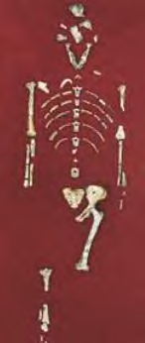
Figure 4. Lucy skeleton
The oldest primate skeletons found so far have been named australopithecines
  - Australopithecine: early hominid that lived in Africa and possessed both apelike and humanlike characteristics
  - “Lucy” is one of the most complete australopithecine skeletons found so far and is 3.2 million years old
  - scientists think that australopithecines lived in small family groups, slept and ate in trees, but traveled by walking on the ground, and rarely lived past 25 years old
  - Australopithecines became extinct 2-2.5 million years ago and are thought to be ancestors of modern humans

Bipedalism evolved before a large brain
- Scientists have found skeletons that show that the ability to walk on 2 legs (bipedalism) appeared before large skulls (large brains)

When did hominids evolve large brains?

- Homo habilis: The oldest hominid to have a large skull (large brain) and use stone tools (found buried near stone tools) is 1.5-2.5 million years old
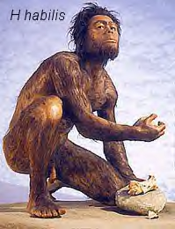

Figure 5. Homo habilis

- Homo erectus: Hominid with large brain and humanlike face that may have hunted, used fire, and lived 1.5-1.8 million years ago
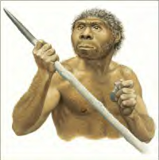

Figure 6. Homo erectus

- Homo neanderthalensis (Neandertals): Hominids that lived 35,000-100,000 years ago in Europe, Asia, and the Middle East with brains as large as modern humans. They used tools and possibly had a religion and spoken language
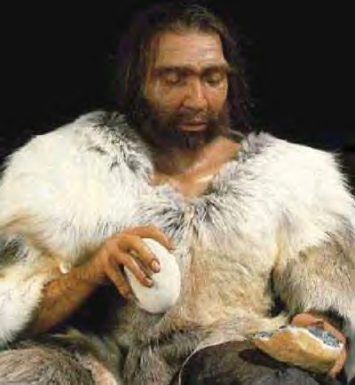

Figure 7. Homo neanderthalensis

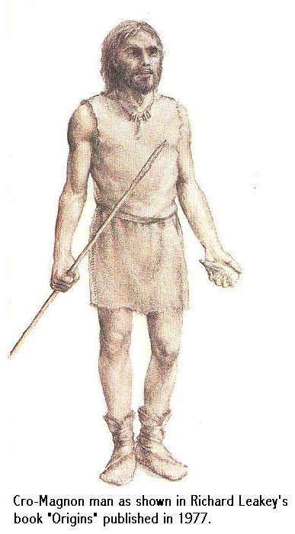
- Homo sapiens: Modern day humans that appeared in South Africa and the Middle East about 100,000-200,000 years ago
Figure 8. Cro-magnon
  - Cro-Magnon: Type of Homo sapien that lived in Europe 35,000-40,000 years ago and was identical to modern humans in height, skull and tooth structure, and brain size. They were probably toolmakers and artists and used spoken language.
  - Modern humans have not changed much in their body structures over the last 200,000 years
  - Modern humans spread through Africa, Europe, and Asia then crossed by sea or a land bridge into North America
  - By about 8000 to 10,000 years ago, Native Americans in North America had build settlements and were farming

