Chapter 18: Viruses and Bacteria

Viruses
- Composed of nucleic acids in a protein coat
  - Nucleic acid can be DNA or RNA and only contains information on how to reproduce the virus
  - Capsid: outer protein coat
  - Sometimes has an envelope on the outside made up of phospholipids
- 4 different shapes
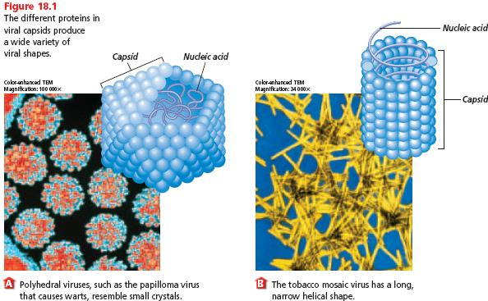
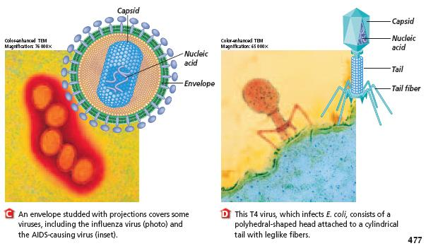

- Smaller than bacteria
- Considered nonliving because they don’t have all the characteristics of life
  - Don’t carry out respiration, grow, or develop
  - Can’t reproduce on their own
- Bacteriophage: virus that infects a bacteria
Lytic cycle: the cycle by which viruses reproduce themselves
- Viruses don’t have all the tools needed to reproduce on their own
- So they have to invade other cells and use the tools in the other cells to reproduce
- Host cell: An animal, plant, or bacterial cell that is invaded by a virus
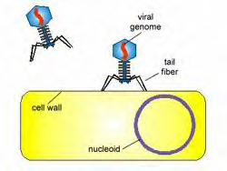
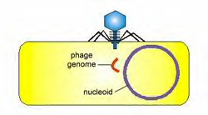
Chromosome
Virus

Host cell
1. Virus attaches to a host cell
2. Virus injects its chromosome into the host cell

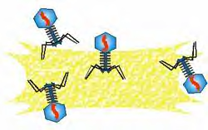
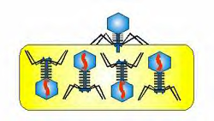
3. The virus chromosome uses tools in the host cell to make more viruses
4. New viruses bust out of the host cell, killing the host cell

Lysogenic cycle: a reproduction cycle in which the virus’s nucleic acid is placed into the host cell’s chromosome
Chromosome
Virus

Host cell

1. Virus attaches to a host cell
2. Virus injects its chromosome into the host cell

4. When the cell reproduces, the provirus is copied as part of the chromosome
3. The virus chromosome is placed into the host cell’s chromosome.

Provirus: viral DNA that is placed into the host cell’s chromosome

Switch from lysogenic cycle to lytic cycle

Releasing viruses from the cell
- Lysis: bursting of a cell

Sugar
Host Cell
Step 3
Step 1
Step 2
- Exocytosis: the virus is packaged in small pieces of plasma membrane that fuse with the host cell’s plasma membrane, releasing viruses

Lytic viruses vs. lysogenic viruses
- Lytic viruses usually cause symptoms very quickly in an infected organism because new viruses are made and spread to other cells right away
- Lysogenic viruses inject their DNA into a host cell, which gets placed into the host cell’s chromosome
  - The viral DNA can just sit in the host cell’s chromosome up to many years and the organism will have no symptoms
  - Once the DNA leaves the chromosome and directs the production of new viruses, the organism will have symptoms

Retroviruses
- Viruses that contain RNA and have complex reproduction cycles
- Retroviruses are lysogenic viruses
- The virus injects its RNA and a special enzyme (reverse transcriptase) into the cell
- This special enzymes makes DNA from the viral RNA
- The viral DNA then gets placed into the host cell’s chromosome, which is made up of DNA
- Example: HIV virus that causes AIDS
  - HIV virus infects white blood cells
  - Because the HIV virus is lysogenic, a person may not appear sick but is still able to transmit the disease to others in bodily fluids

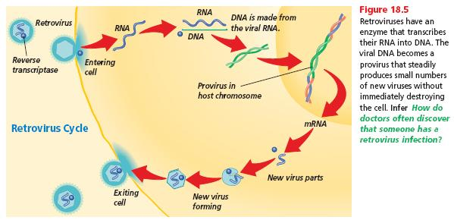

Prokaryotes
- Bacteria
- Divided into 2 kingdoms
  - Archaebacteria: live in extreme environments
  - Eubacteria: common bacteria

Archaebacteria
- Live in extreme environments
1. bacteria that live in oxygen-free environments, such as digestive systems and lake sediments, and produce methane gas
2. bacteria that live in very salty water, such as Utah’s Great Salt Lake and the Middle East’s Dead Sea
3. bacteria that live in the hot, acidic waters of sulfur springs

Eubacteria
- Live almost everywhere and use organic molecules for food
- Some are photosynthetic autotrophs
  - use sunlight to carry out photosynthesis and make their own food
- Some are chemosynthetic autotrophs
  - Carry out chemosynthesis: process of breaking down and releasing energy of inorganic compounds containing sulfur and nitrogen
  - They use this energy, rather than sunlight, to make their own food
  - These include the nitrogen-fixing bacteria in the nitrogen cycle

Structure of prokaryotic cells
- No nucleus
- Single, closed loop of DNA is free in cytoplasm
- Have a cell wall, cell membrane, cytoplasm and ribosomes
- No membrane-bound organelles
- Some have a capsule: shell covering the cell wall that helps to protect the cell
- Some have pili: short hairlike structures on the surface of the cell that helps to hold onto host cells
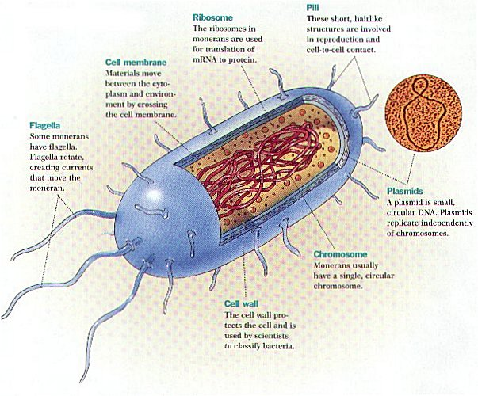
- Many have flagella: whiplike structure on the surface of the cell that helps in movement

Shapes of prokaryotic cells

- cocci: spherical cells

- bacilli: rod-shaped cells

- spirilla: spiral-shaped cells

How bacteria reproduce
- cannot reproduce by mitosis or meiosis because bacteria have no nucleus and no paired chromosomes
- bacteria only have a single closed loop of DNA
- bacteria can reproduce asexually (only 1 bacterial cell is needed) or sexually (2 bacterial cells are needed)

- binary fission: asexual type of reproduction in which one bacterial cell
- copies its closed loop of DNA
- the one cell grows larger
- a wall forms in the middle to split the cell in two, with each new cell receiving a closed loop of DNA
- the 2 new bacterial cells are identical to each other
- some bacteria reproduce every 20 minutes, producing enormous numbers of bacteria very quickly

- conjugation: sexual type of reproduction in which
- one bacterial cell forms a pilus (hairlike structure) that connects it to another bacterial cell
- the first bacterial cell uses the pilus to transfer all or part of its DNA to the second bacterial cell
- the second bacterial cell will have a different genetic makeup than the first cell, so they are not identical to each other

Bacteria and oxygen
- obligate aerobes: bacteria that require oxygen for cellular respiration
  - bacteria that causes tuberculosis in the lungs
- obligate anaerobes: bacteria that are killed by oxygen
  - bacteria that cause syphilis (sexually transmitted disease) and botulism (type of food poisoning)

Endospores
- tiny structure that contains a bacterial cell’s DNA and some of its cytoplasm surrounded by a tough outer covering
- bacteria form endospores when the environment becomes harsh
- endospores will not dry out and will not be destroyed in very hot or very cold temperatures or with harsh chemicals
- endospores do not reproduce and just protect the DNA and cytoplasm for up to thousands of years
- when environmental conditions improve, the endospores will become bacterial cells that reproduce
- bacteria that cause botulism and anthrax form endospores
- the only way to kill endospores is to heat them under high pressure to achieve a very high temperature (water boils above 100°C under high pressure)

Helpful bacteria
- some bacteria in the soil are nitrogen-fixing
  - convert free nitrogen in the atmosphere to nitrogen compounds useful to plants
  - important in the nitrogen cycle
- some bacteria feed on dead organisms and waste
  - this recycles nutrients back to the environment
- photosynthetic bacteria release oxygen back into the atmosphere
- specific bacteria are used to make vinegar, cheese, sauerkraut, and antibiotics
- bacteria in our digestive system help us to digest food

Harmful bacteria
- some bacteria cause diseases in plants and animals
- some bacteria cause human diseases by entering the body through the mouth, nose, eyes, or open wounds
  - strep throat, tuberculosis, tentanus, lyme disease, dental cavities, pneumonia
- in 1900, the average person lived only to be 47 years old
  - due partly to many bacterial diseases that people did not know how to treat
- in 2000, the average person lived to be 75 years old
  - due partly to new medical treatments for bacterial diseases

