Chapter 4: Population Biology

Population
- Group of organisms, all of the same species, that live in a specific area
- Populations do not increase in a straight line; they increase in a J-shaped curve
  - Increase is slow at first because there are only a few reproducing individuals, then faster because there are more reproducing individuals
  - This type of curve shows exponential growth: as a population gets larger, it also grows at a faster rate

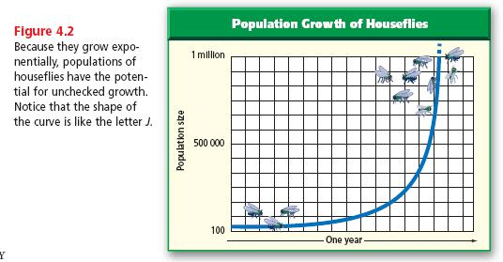
- Populations do not increase forever
- Eventually populations level out due to a limited food supply, disease, predators, or lack of space
- This leads to an S-shaped curve for population growth

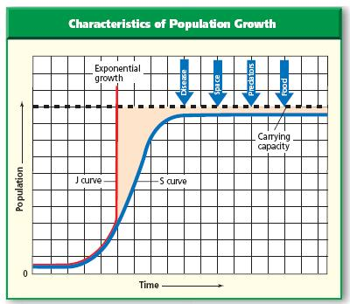 | 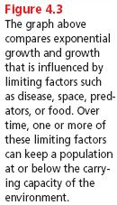

Carrying capacity
- The number of organisms of one species that an environment can support indefinitely
- When a population is developing in an environment, there are more births than deaths and the population increases until the carrying capacity is reached or passed
- When the carrying capacity is passed, there are not enough resources for all the individuals of a population so there are more deaths than births until the population falls below the carrying capacity again

Life-history pattern
- An organism’s reproductive pattern
- Rapid life-history pattern: an organism has many offspring in a short period of time
  - Organisms tend to be small and have short lives
  - Reproduce rapidly forming large populations than most die out when environmental conditions change
  - Example: mosquitoes
- Slow life-history pattern: an organism has few offspring over a long period of time
  - Organisms tend to be large and have long lives
  - Reproduce slowly forming populations that stay at or near carrying capacity
  - Examples: humans, trees, elephants, bears

What affects population density (population size)?
- Population density: the number of individuals in a given area
  - Density-dependent factors: environmental factors that affect the size of a population and depend on the size of that population
- disease
- competition for food, water, and space
- predators
- parasites
- limited food or water supply
- stress from overcrowding (aggression, decrease in parental care, decreased reproduction, and increased disease)
  - density-independent factors: environmental factors that affect the size of a population but do not depend on the size of that population
- volcanic eruptions
- temperature
- storms
- floods
- droughts
- chemical pesticides

Demography
- the study of human population size, density and distribution, movement, and its birth and death rates
- since the 1930’s, the human population has grown rapidly
- there are more than 6 billion people in the world today
- the human population is growing at a rate of more than 80 million people per year

What affects the growth of the human population?
- Human population growth is different from other species because humans can change their environment when other species cannot
- So the human population keeps growing due to
  - Medical treatments for diseases
  - Increased food production
  - Technology to increase the amount of clean water

Calculating growth rate
- Birthrate: the number of live births per 1000 population in a given year
- Death rate: the number of deaths per 1000 population in a given year
- Population growth rate (PGR) = Birthrate – death rate
- If PGR = 0, then individuals are being born at the rate as other individuals are dying off (stable population)
- If PGR > 0, more individuals are being born than dying off (growing population)
- If PGR < 0, less individuals are being born than dying off (decreasing population)

Doubling time
- The time needed for a population to double in size
- A rapid growth rate means that a population will double in a short time
- A slow growth rate means that a population will double over a long time

Age structure
- The proportions of the population that are in different age levels
