The Chemistry of Life
By Mrs. Rebello
www.geocities.com/rebelloscience

Elements
- Pure substance that makes up everything
- Names of elements are abbreviated using symbols
- 6 most common elements in living things are
  - Sulfur (S)
  - Phosphorus (P)
  - Oxygen (O)
  - Nitrogen (N)
  - Carbon (C)
  - Hydrogen (H)

Atoms
- atom: smallest particle of an element that has the characteristics of that element
- basic building blocks of all matter
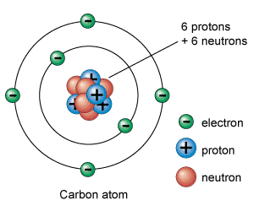
- contain a nucleus that holds positively charged protons and neutral neutrons
- around the nucleus are the energy levels where negatively electrons spin around the nucleus
  - first energy level holds up to 2 electrons
  - second energy level holds up to 8 electrons
  - third energy level holds up to 18 electrons
- atoms of different elements have different numbers of protons
- isotopes: atoms of the same element with different numbers of neutrons
  - some isotopes are radioactive and are useful in experiments
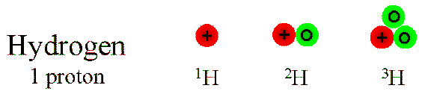

Compound
- Substance made up of 2 or more elements chemically combined
  - Table salt is made up of chlorine and sodium

Chemical Bonds
- Atoms combine with each other in order to fill up their outermost energy level with electrons, which makes the atom stable
- Atoms are held together through chemical bonds
- Two types of chemical bonds
  - Ionic bond: formed when one atom donates electrons to another atom
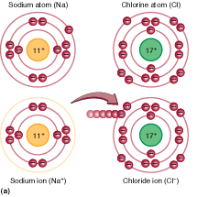
  - Covalent bond: formed when two atoms share electrons
    - Molecule: compound held together by covalent bonds

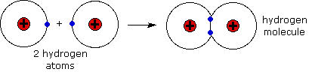
Chemical reactions
- chemical reactions occur when bonds are broken or formed between atoms, changing one substance into another
- Metabolism: all the chemical reactions that occur in an organism

Water
- Water (H₂O) is a molecule that contains covalent bonds
- Water is polar, which means there is a positive end and a negative end
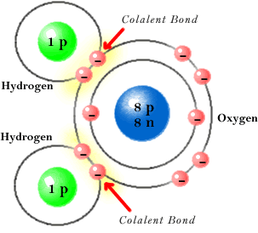
Positive end
Negative end
- Water heats up and cools down very slowly
  - Helps cells maintain homeostasis
- Water expands when it freezes
  - So ice is less dense than liquid water and ice floats

Diffusion
- Brownian motion: random motion of atoms and molecules
- Brownian motion causes diffusion
- Diffusion: the movement of particles from an area of high concentration to an area of lower concentration
  - Example: Smell of cookies moves from the kitchen (high concentration) to the rest of the house (low concentration)
  - Example: materials diffuse into and out of cells
  - particles will continue to move until they have reached equilibrium (are evenly spread out)

Organic compounds
- Compounds that contain carbon atoms bonded to each other
- Found in all living things
- Carbon is important because it can bond to other atoms in so many ways
- Four different types of organic compounds
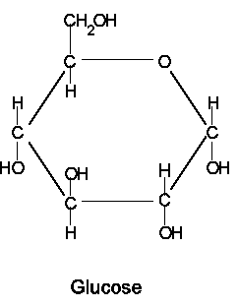
  - carbohydrates
    - made up of carbon, hydrogen, and oxygen
    - sugars
    - used by organisms for short term energy
    - monosaccaride: 1 sugar molecule, such as glucose
    - disaccharide: 2 sugar molecules linked together, such as sucrose (table sugar)
    - polysaccharides: many sugar molecules linked together, such as starch

  - lipids
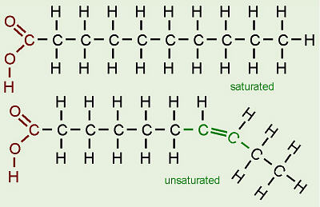
    - made up of carbon and hydrogen mostly
    - fats, oils, waxes, steroids
    - used by organisms for long term energy, insulation, and protective coatings
    - fatty acid: a simple lipid molecule
    - fatty acids are linked together to make bigger lipid molecules

  - proteins
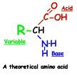
    - made up of carbon, hydrogen, oxygen, nitrogen, and sometimes sulfur
    - 20 different amino acids are used to build proteins
    - used for construction of organisms (hair, nails, muscles) and for speeding up chemical reactions in an organism (enzymes)
      - enzyme: protein that increases the speed of a chemical reaction that would otherwise be too slow
      - used to digest food

  - nucleic acids
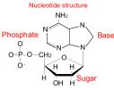
    - made up of carbon, hydrogen, oxygen, nitrogen, and phosphorus
    - store genetic information (DNA, RNA)
    - nucleotides are used to build nucleic acids

Home

