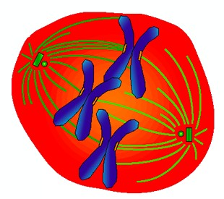 | Cellular Transport and the Cell Cycle

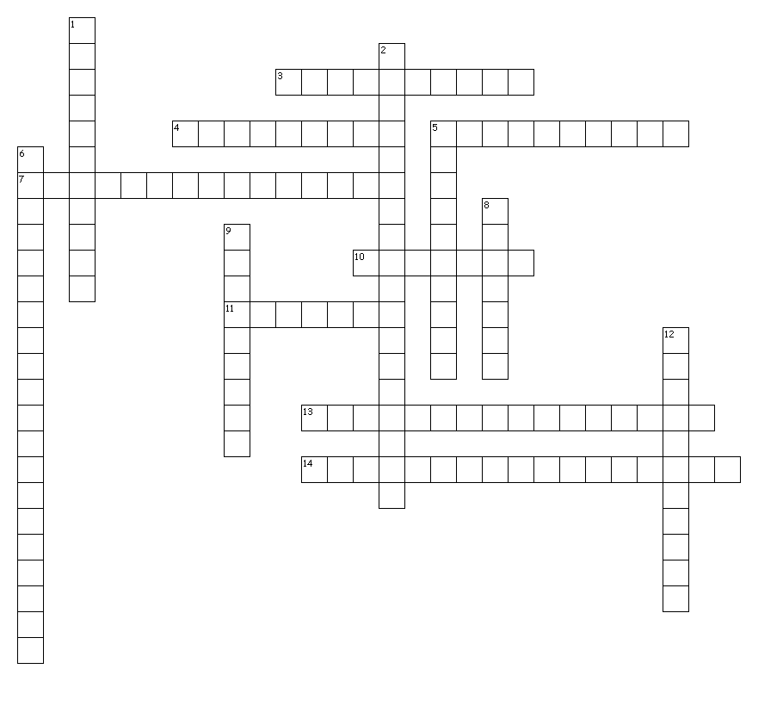
Across
3. Active transport process by which materials are excreted or expelled from the cell.
4. Continuous sequence of growth (interphase) and division (mitosis) in a cell.
5. In animal cells, a pair of small cylindrical structures composed of microtubules that duplicate during interphase and move to opposite ends of the cell during prophase.
7. Energy expending process by which cells transport materials across the cell membrane against a concentration gradient.
10. Period of nuclear cell division in which two daughter cells are formed, each containing a complete set of chromosomes.
11. Diffusion of water across a selectively permeable membrane depending on the concentration of solutes on either side of the membrane.
13. In cells, solution in which the concentration of dissolved substances in the solution is the same as the concentration of dissolved substances inside the cell.
14. In cells, solution in which the concentration of dissolved substances is lower in the solution outside the cell than the concentration inside the cell; causes the cell to swell and possibly burst as water enters the cell.

Down
1. Active transport process where a cell engulfs materials with a portion of the cell's plasma membrane and releases the contents inside of the cell.
2. In cells, solution in which the concentration of dissolved substances outside the cell is higher than the concentration inside the cell; causes the cell to shrink as water leaves the cell.
5. Cell structure that joins two sister chromatids of a chromosome.
6. Passive transport of materials across a plasma membrane by transport proteins embedded in the plasma membrane.
8. Cell structure composed microtubule fibers; forms between the centrioles during prophase and shorten during anaphase, pulling apart sister chromatids.
9. Long strands of DNA found in the eukaryotic cell nucleus; condense to form chromosomes.
12. Cell process following mitosis or meiosis in which the cell's cytoplasm divides and separates into new cells.

