Chapter 8

Cellular Transport and the Cell Cycle

Types of transport across the plasma membrane
- Passive transport: requires no energy
    - Simple diffusion: materials move from high to low concentration
    - Facilitated diffusion: materials move from high to low concentration using transport proteins
    - Osmosis: diffusion of water
Cell
Cell

- Active transport: requires energy
    - Carrier proteins: Act like a swinging door to move a small substance into or out of the cell
    - Endocytosis: Cell brings large substances into itself by swallowing them up
Sugar
Cell
Step 1
Step 3
Step 2

    - Exocytosis: Cell exports large substances out of itself by spitting them out
Sugar
Cell
Step 3
Step 1
Step 2

Osmosis
- diffusion of water across a selectively permeable membrane
- important for maintaining homeostasis
- water will move from where there’s more of it to where there’s less of it

What controls osmosis?
isotonic solution
- concentration of water is the same inside and outside the cell
- no net movement of water into or out of the cell
hypotonic solution  - there is more water outside the cell than inside  - water moves into the cell  - cell swells up | Water
hypertonic solution  - there is more water inside the cell than outside  - water moves out of the cell  - cell shrivels up | Water
Cells stay small because
- diffusion of water, oxygen, etc. is slow over large distances
- proteins needed for cell survival are made only so fast
- surface area-to-volume ratio
  - a cell’s volume increases faster than its surface area
  - as a cell gets bigger, you reach a point where its surface area (plasma membrane) cannot take in enough food or get rid of waste fast enough to support the large volume (cytoplasm)

Chromosomes
- DNA in the nucleus of the cell
- contains all of the directions that a cell needs to survive
- for most of a cell’s life, chromosomes exist as chromatin
  - chromatin: long strands of DNA wrapped around proteins

The Cell Cycle
- sequence of growth and division of a cell
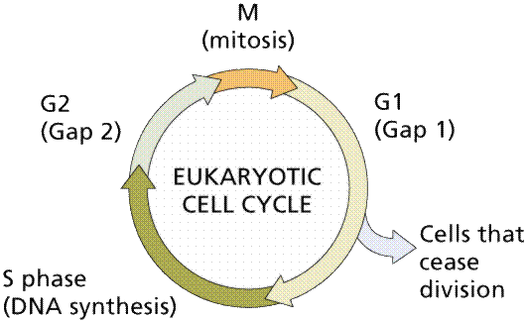
- Interphase
    - G1 phase: cell grows
    - S phase: Chromosomes copy themselves and form sister chromatids (so that each new cell will have all the chromosomes the original cell had)
    - G2 phase: cell grows
- M phase: mitosis, or cell division, occurs

Mitosis
- cell division that produces 2 daughter cells that are identical to the original cell
- Prophase
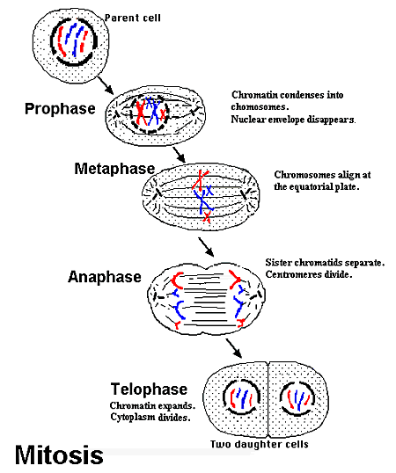
    - Nuclear membrane falls apart
    - chromasomes condense
    - centrioles move to opposite sides of the cell and start to form spindle fibers
- Metaphase
    - sister chromatids line up along the spindle fibers in the middle of the cell
- Anaphase
    - sister chromatids separate as the spindle fibers pull them apart to opposite ends of the cell
- Telophase
    - chromosomes decondense
    - spindle fibers break down
    - new nuclear membrane forms around each set of chromosomes
    - Cytokinesis: cytoplasm divides, forming 2 new cells

Mitosis is used to create multicellular organisms
- Cell --> Tissue --> Organ --> Organ system --> Organism
- Example:
muscle cell --> muscle tissue --> stomach --> digestive system --> animal

Control of the Cell Cycle
- controlled by proteins called cyclins and enzymes that attach to the cyclins
- Cancer: malignant growth resulting from uncontrolled cell division
  - enzymes that attach to cyclins are not working properly due to a mutations in the genes for these enzymes
  - cell keeps dividing because the cell cycle is not working
    - forms a tumor: mass of cells that keep dividing
  - second leading cause of death in the US (second to heart disease)
  - genetics and environment can cause cancer
    - environmental causes: cigarette smoke, air and water pollution, UV radiation from sun
  - eating a low-fat, high-fiber diet can reduce your risk of cancer

