Chemical Quantities
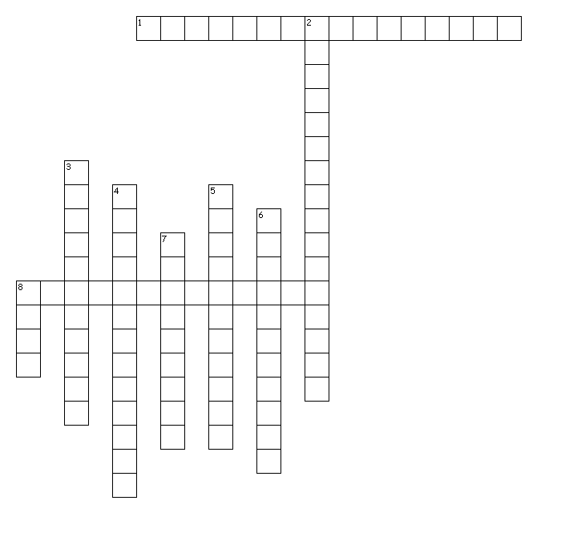
Across
1. The formula of a compound having the smallest whole-number ratio of atoms in the compound.
8. The mass in atomic mass units of one molecule of a covalent compound.

Down
2. The number of things in one mole of a substance, specifically 6.02 x 10²³.
3. The mass in atomic mass units of one formula unit of an ionic compound.
4. The study of relationships between measurable quantities, such as mass and volume, and the number of atoms in chemical reactions.
5. The volume that a mole of gas occupies at a pressure of one atmosphere and a temperature of 0.00 degrees Celsius.
6. The equation that expresses exactly how pressure, volume, temperature, and the number of particles of a gas are related.
7. The mass of one mole of a pure substance.
8. The unit used to count numbers of atoms, molecules, or formula units of a substance.

