Constructing a Cladogram

Directions:
1. Use the times in the descriptions of the insect species below to make a list of species from most ancient to most recent.

2. Place the species on the cladogram outline in order from most ancient to most recent using your list above. Use your notes in the table to help you.

3. Use the species’ descriptions to determine features that are shared among the insects. These are synapomorphies. Make your notes in the table below.

Feature (Synapomorphy) | Shared by the following species

4. Use the species’ descriptions to determine features that are unique to one insect. These are called automorphies. Make your notes in the table below.
Feature (Automorphy) | Unique to this species

5. Use the synapomorphies and automorphies you listed to determine which would best fit on your cladogram. Write them into your cladogram. Use your notes to help you.

Description of Insect Species | Insect Picture
Species 1 - Fossils of this species date back to 30,000 years ago. The organism has a single antenna that is branched (like a Y). It has two eyes positioned on top of the head a non segmented body | 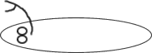
Species 2 - Fossils of this species date back to 8,000 years ago. This organism has branched antennae, 3 body segments, the middle segment has fleshy appendages with a bendable joint. | 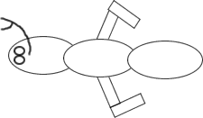
Species 3 - Fossils of this species date back to 25,000 years ago. The organism has a branched antenna (like a Y), body is divided into 2 segments, and eyes positioned on the top of the head. In addition, the last segment of the body has a long curly tail. | 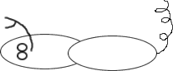
Species 4 - Fossils of this species date back to 10,000 years ago. This organism has branched antennae, 2 body segments, eyes positioned on the top of the head, fleshy appendages on the last segment have a bendable joint. | 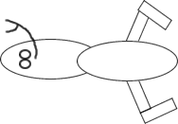
Species 5 - Fossils of this species date back to 50,000 years ago. The organism has a single antennae, two eyes positioned on top of a head and a non segmented body. | 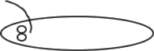
Species 6 - Fossils of this species date back to 20,000 years ago. This organism has branched antennae, 2 body segments, eyes positioned on the top of the head, and small flesh appendages on the last segment. This organism also has a ridge of spines on the last segment. | 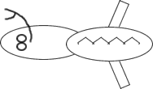
Species 7 - Fossils of this species date back to 31,000 years ago. The organism has a single branched antennae (like a Y) and a club like structure at the end of the branches of the antennae. It has two eyes positioned on top of the head and a non segmented body. | 