BIOLOGY LAB

Lab: Modeling Crossing Over Names:
Adapted from Glencoe’s Biology: The Dynamics of Life

Problem: How does crossing over affect the genes passed down to the daughter cells?

Hypothesis:

Experiment:

Materials:
Modeling clay
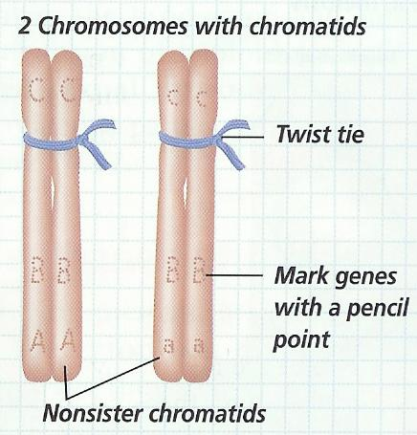
2 twist ties
Procedure:
- Roll out four long strands of clay at least 10 cm long to represent two chromosomes, each with two chromatids.
- Use the figure to the right as a guide in joining and labeling these model chromatids. Although there are four chromatids, assume that they started out as a single pair of homologous chromosomes prior to replication. The figure shows tetrad formation during prophase I of meiosis.
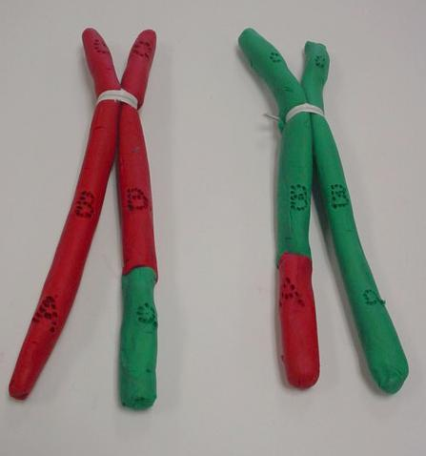
- First, assume that no crossing over takes place. Model the appearance of the four gamete cells that will result at the end of meiosis. Record your model’s appearance by drawing the gametes’ chromosomes and their genes in the data table.
- Next, repeat steps 1-3, however, assume that crossing over occurs between genes B and C. See the picture at the right as an example.

Data:

No Crossing Over | Crossing Over
Appearance of Gamete Cells | Appearance of Gamete Cells

Conclusions:
- Define crossing over and explain when it occurs.

- Compare any differences in the appearance of genes on chromosomes in gamete cells when crossing over occurs and when it does not occur.

- Crossing over has been compared to “shuffling the deck” in cards. Explain what this means.

- What would be accomplished if crossing over occurred between sister chromatids? Explain your answer.

Home

