Chapter 11: DNA: The Molecule of Heredity

DNA
- Deoxyribonucleic acid
- Is a type of nucleic acid
- What chromosomes (and genes) are made of
- Made up of repeating nucleotide subunits
- 1 nucleotide looks like:
Phosphate Group
Deoxyribose Sugar
Nitrogenous
Base

4 types: Adenine (A)
Guanine (G)
Cytosine (C)
Thymine (T)

- 2 strands so bases can pair up
  - A binds T only
  - C binds G only
Remember

DNA is like an Oreo
Phophates + sugars = cookies
Bases = cream filling
Strand 1
Strand 2
Phosphates + sugars on the outside
Bases on the inside (Bases fit like puzzle pieces)

P
P

S
S
A
T

P
P

S
S
C
G

- Shape is a double helix
  - Double helix: 2 spirals wound around each other
  - Rosalind Franklin took an X-ray photo of DNA
  - James Watson and Francis Crick interpreted the photo and discovered the double helix structure (They won the Nobel Prize)
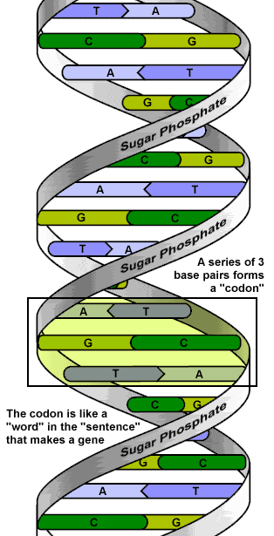

Codon: Group of 3 bases

- Genes: stretch of DNA that codes for a trait
  - The code is the order of the bases (letters)
  - Genes are hundreds or thousands of bases long

Eye color gene

Dimples gene
Hair color gene

Chargaff’s Rule
- In DNA, the amount of A = the amount of T
the amount of C = the amount of G

DNA is complementary
- Complementary: bases on one strand match up with the bases on the other strand (A-T and G-C)
- Example: Strand 1- ATG GGC CTA
Strand 2- TAC CCG GAT

Replication
- Process by which DNA copies itself
- Happens when chromosomes copy themselves before mitosis and meiosis
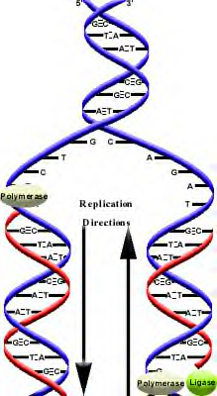
- Semiconservative replication: Each new piece of DNA is made up of 1 old strand and 1 new strand
Original DNA

DNA unzips

Each original strand grows a new strand

DNA never ever leaves the nucleus
- DNA is the master copy of the directions a cell needs to live so it needs to be protected
DNA in the nucleus is safe
But DNA in the cytoplasm can be destroyed

RNA is a copy of DNA that goes out into the cytoplasm to tell the cell what to do in order to stay alive
- RNA: ribonucleic acid
- You can always make more RNA so it’s ok if it gets destroyed (You can’t make more DNA!!!)
 | DNA | RNA
How many strands? | 2 | 1
Nucleotide subunit | Phos-phate Group  Deoxyribose  Sugar  Nitro-gen  Base  Deoxyribose sugar | Phos-phate Group  Ribose Sugar  Nitro-gen  Base  Ribose sugar
Bases | Thymine (T)  T – A  G – C  Adenine (A)  Guanine (G)  Cytosine (C) | Uracil (U)  U – A  G – C  Adenine (A)  Guanine (G)  Cytosine (C)
Transcription
- Definition: RNA is made from 1 gene in DNA
- The type of RNA made is called mRNA (messenger RNA) because it sends a message from DNA to the cytoplasm

Uses mRNA
To send a message to the cytoplasm
DNA safe in the nucleus

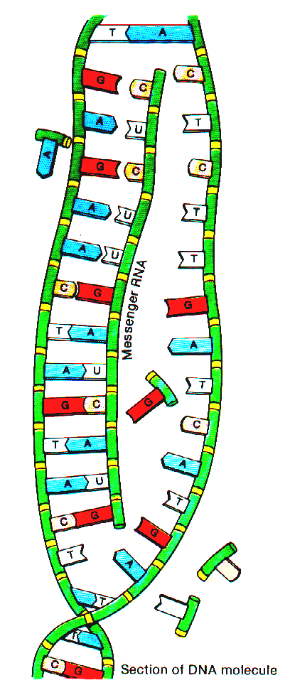
- Transcription
  - Unzip one gene in DNA
  - Match up bases to one side of a gene in DNA
  - mRNA detaches from the DNA
  - mRNA moves out of the nucleus and into the cytoplasm

DNA: GAG AAC TAG TAC
RNA: CUC UUG AUC AUG

For figuring out RNA:
A binds U
C binds G

Transcription happens in the nucleus. An RNA copy of a gene is made.
Then the mRNA that has been made moves out of the nucleus into the cytoplasm
Once in the cytoplasm, the mRNA is used to make a protein
Cytoplasm of cell
Nucleus
DNA
mRNA
mRNA

How does mRNA tell the cell what to do?
- mRNA is a message that codes for a protein
- Proteins are made in the cytoplasm and then work to keep the cell alive
- Translation (protein synthesis): Process of making a protein
- Proteins are made up of amino acids (small building blocks)
- There are 20 different types of amino acids

Protein

Amino Acids

Process of Translation
Nucleus

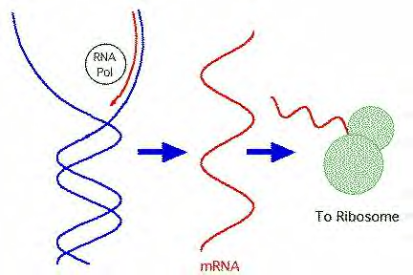
- mRNA moves out of nucleus and into cytoplasm

Cytoplasm

- mRNA attaches to a ribosome

Ribosome
- Transfer RNA (tRNA) decodes the mRNA and brings amino acids to build up the protein

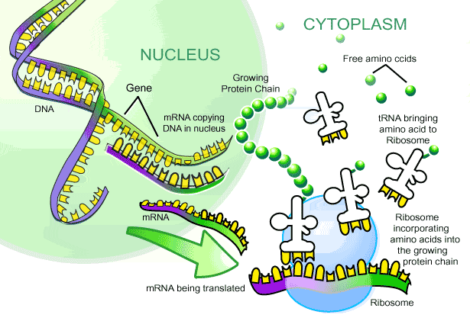
tRNA
Amino acid

Anticodon (3 bases on tRNA): Matches up to codons on mRNA

- Protein (chain of amino acids) detaches from ribosome and goes off to work in the cell

Genetic Code
- Code that matches codons in mRNA to amino acids on tRNAs
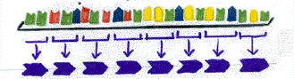
mRNA
codons
(3 bases)

Amino acids

Stop codon – codes for the end of the mRNA (no amino acid added)

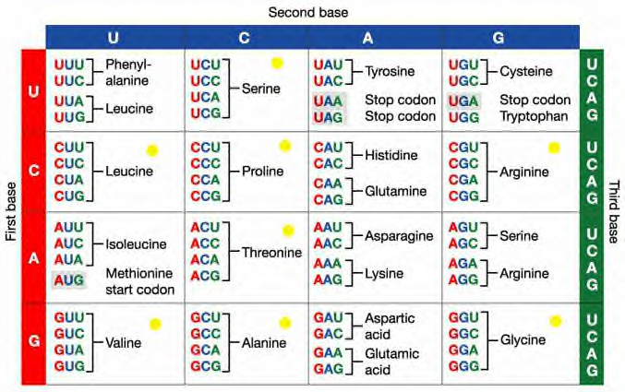
1. Read your mRNA codon → ACU
- Find 1st base on the left, 2nd base on the top, 3rd base on the right. Find where they all cross in the chart.
- Read your amino acid. → Threonine

Different codons code for different amino acids!!!

Central dogma of molecular biology
Transcription
Translation

DNA

RNA

Protein

Directions to make proteins are safely stored in the nucleus
Carries the directions to the cytoplasm
Work to keep the cell alive

Mutation
- a change in the DNA sequence
- It’s a mistake that’s made during replication or transcription
- can be harmful: diseases or deformities
helpful: organism is better able to survive
neutral: organism is unaffected
- if a mutation occurs in a sperm or egg cell, that mutation is passed onto offspring
- if a mutation occurs in a body cell, that mutation affects only the organism and is not passed onto offspring

Types of mutations
- Point mutations: Bases are mismatched
- Harmful when: a mistake in DNA is carried into mRNA and results in the wrong amino acid

Correct DNA Correct mRNA Correct amino acid

GAG
CTC CUC Leucine

Point mutation in DNA Mutated mRNA Wrong amino acid

GCG
CTC CGC Arginine

A should pair with T, but instead C is mismatched to T

- Not harmful when: a mistake in DNA is carried into mRNA but still results in the correct amino acid

- Frameshift mutations: bases are inserted or deleted
- Are usually harmful because a mistake in DNA is carried into mRNA and results in many wrong amino acids

Correct DNA: ATA CCG TGA

TAT GGC ACT

Correct mRNA: UAU GGC ACU

Correct amino acids: Tyrosine Glycine Threonine

Extra inserted base shifts how we read the codons (3 bases), which changes the amino acids

Frameshift mutation ATG ACC GTG A
in DNA: TAC TGG CAC T

Mutated mRNA: UAC UGG CAC U

Wrong amino acids: Tyrosine Tryptophan Histadine

- Chromosomal mutations
- chromosomes break or are lost during mitosis or meiosis
- broken chromosomes may rejoin incorrectly
- almost always lethal when it occurs in a zygote

Causes of mutations
- mutagens: anything that causes a change in DNA
- examples: X rays, UV light, nuclear radiation, asbestos, cigarette smoke

