Disappearing ink from http://www.chemsoc.org/networks/learnnet/Word_files/Kev31-40.doc

Introduction
A blue liquid is made. This liquid is tested on a white page; it leaves a blue ink spot. In a few seconds, the blue spot disappears.

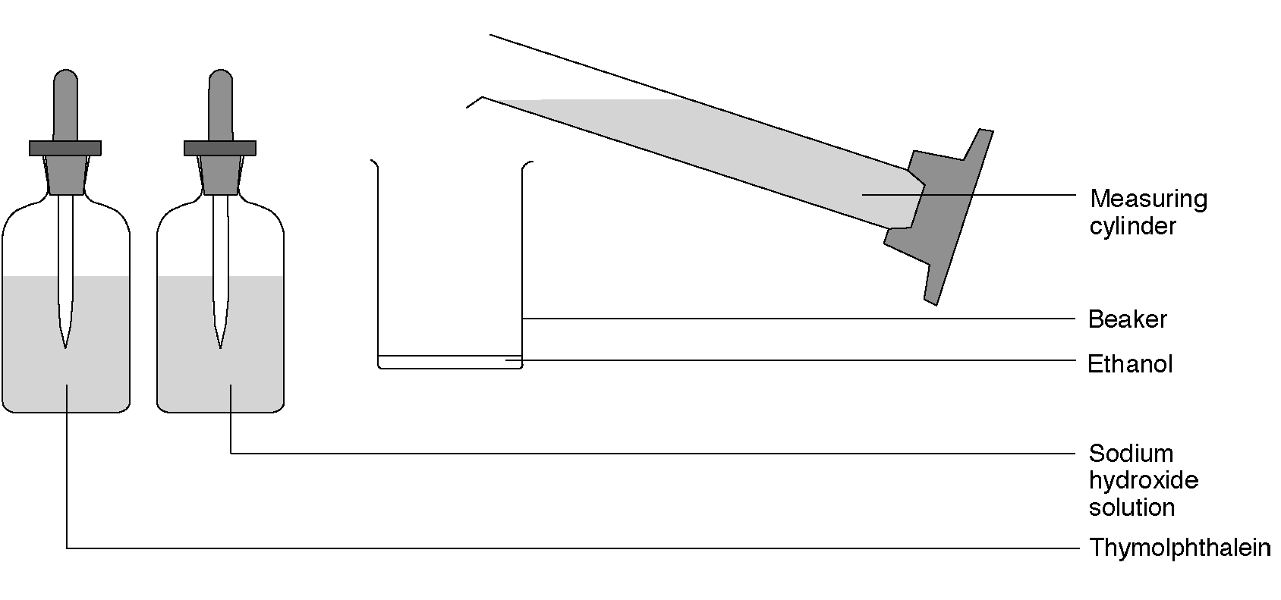

What to do
1. Place 10 cm³ of ethanol (Highly flammable) in a small beaker.
2. Add a few drops of thymolphthalein (Highly flammable) indicator solution.
3. Add just enough NaOH solution (Irritant); drop wise, to produce a deep blue color in the solution.
4. Using a small paintbrush test the ‘disappearing ink’ on a white page.

Safety
Wear eye protection. Care with teat pipettes that contain sodium hydroxide.

Questions
The color change occurs because sodium hydroxide reacts with a gas in the air.

1. Which gas in the air causes this color change?

2. Write a word equation for the reaction.

3. Write a formula equation for the reaction.

Home

