Edmunds Central Chemistry _____ % Name _____________________

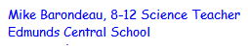
Contributed by:

Open the “Elements1” Excel file. To answer the questions you may want to use the Sort and Hide features of Excel.

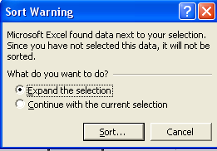
Sort Columns

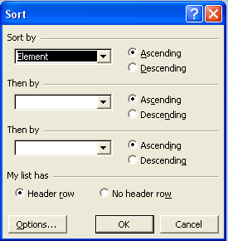
Select the entire column you would like to sort, then click on the Data menu. Now click on the Sort feature and the window to the right should pop up. May sure the radio button for Expand the selection is selected, otherwise your sort will not carry all of the elements information with the sort. When you click the Sort button the second window below should appear with the column you selected in the first Sort by field and the Ascending radio button on.

You will probably want to select a second field criteria during your sort. More than likely you will want the second sort criteria to be the field “Atomic #.” You may also choose a third sort criteria field if you need to.

Hide a row or column
Another handy feature that may help you analyze the data is the Hide feature. This allows you to hide rows or columns that you do not need to see at the moment. You can always unhide them for the next sort.
Select the rows or columns you wish to hide. On the Format menu, point to either Row or Column, and then click Hide.

To see all of the data again repeat the procedure and select unhide.

Another thing that may help your sorts is the Split feature under the Window menu.

Use these features of Excel to answer the questions on the following sheet:
Edmunds Central Chemistry _____ % Name _____________________

- How many elements are solids?
- How many elements are liquids?
- How many elements are gases?
- Why does the total for questions 1-3 not add up to 109 like your periodic charts?
- How do the sizes of atoms vary within a group (family) and explain why. (Hint: Use atomic radius for size.)

- How do the sizes of atoms vary within a row (period)? Explain why.

- What happens to the physical state of atoms as you move across a row (period)?

- What happens to the physical state of atoms as you move down a group (family)?

- What happens to the electronegativity as you move down a group (family)? Explain why.

- What happens to the electronegativity as you move across a row (period)? Explain why.

- Which element has the highest melting point? How do melting points vary within a family?
- Which element has the lowest melting point? How do melting points vary within a period?
- Determine a trend you want to study and explain it and how it varies?

