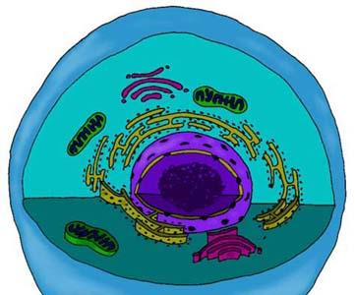 | Energy in a Cell

C | I | R | L | C | T | I | P | Y | O | T | N | N | O | I | T | C | A | E | R | K | R | A | D | F
P | S | S | N | O | I | T | C | A | E | R | T | H | G | I | L | D | T | G | N | I | O | R | N | E
H | P | I | I | H | Y | D | I | L | C | L | L | Y | H | P | O | R | O | L | H | C | N | O | R | R
O | I | A | R | T | A | F | E | R | M | E | N | T | A | T | I | O | N | C | C | B | L | V | I | M
T | G | M | Z | N | O | I | T | A | R | I | P | S | E | R | R | A | L | U | L | L | E | C | A | E
O | M | T | A | O | T | A | M | N | P | T | A | E | L | C | Y | C | N | I | V | L | A | C | L | N
L | E | R | P | N | G | L | I | D | I | C | A | C | I | T | C | A | L | O | N | O | P | C | N | T
Y | N | H | A | D | E | N | O | S | I | N | E | D | I | P | H | O | S | P | H | A | T | E | L | A
S | T | I | T | R | O | P | S | N | A | R | T | N | O | R | T | C | E | L | E | P | D | A | N | T
I | S | N | Y | I | P | H | O | T | O | S | Y | N | T | H | E | S | I | S | E | C | N | I | R | I
S | O | A | D | E | N | D | O | S | I | N | E | T | R | I | P | H | O | S | P | H | A | T | E | O
L | Y | I | I | Y | S | O | G | L | Y | C | O | L | Y | S | I | S | B | I | C | E | V | S | A | N
S | A | A | N | I | O | C | I | T | R | I | C | A | C | I | D | C | Y | C | L | E | E | I | E | T
I | A | N | A | E | R | O | B | I | C | R | E | S | P | I | R | A | T | I | O | N | E | D | E | A
A | E | R | O | B | I | C | R | E | S | P | I | R | A | T | I | O | N | F | T | S | A | T | C | G

WORD LIST
ADENOSINE DIPHOSPHATE |  | ADENDOSINE TRIPHOSPHATE |  | AEROBIC RESPIRATION
ANAEROBIC RESPIRATION |  | CALVIN CYCLE |  | CELLULAR RESPIRATION
CHLOROPHYLL |  | CITRIC ACID CYCLE |  | DARK REACTION
ELECTRON TRANSPORT |  | FERMENTATION |  | GLYCOLYSIS
LACTICACID |  | LIGHT REACTIONS |  | NADP
PHOTOLYSIS |  | PHOTOSYNTHESIS |  | PIGMENTS
FERMENTATION

Clipart provided by  AwesomeClipartforKids.com | This worksheet was created with  "Worksheet Maker" by Chris Small  of The Small Homeschool Pages

Worksheet ID#K8P345

