Name_________________________________________ Period_____ Date____________

Flame Test Demonstration

- Before the demonstration begins, record the atomic number of each element listed below.
- During the demonstration, record the color of each flame.
- After the demonstration, find the approximate wavelength of the light of the flame using the chart.
- Use the speed of light to calculate the frequency. Be sure to convert the wavelength to meters before you put it in the equation.
- Use the frequency and Planck’s constant to calculate the energy of the light.
- Answer the discussion questions in detail.

Metal Ion Tested | Atomic Number | Color of Flame | Wavelength (nm) | Frequency (1/s) | Energy (J)
Lithium
Copper
Calcium
Sodium
Barium
Strontium
Potassium
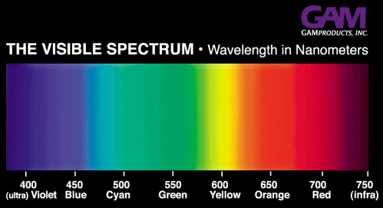

Discussion Questions:

- Why did some flames appear the wrong color at various times during the tests?

- What are some of the problems with using flame tests as a way to identify substances?

- Explain how the colors are created by the atoms.

- How are wavelength and frequency related? Wavelength and energy? Frequency and energy?

- What practical uses are there for this phenomenon?

