Forensic Science

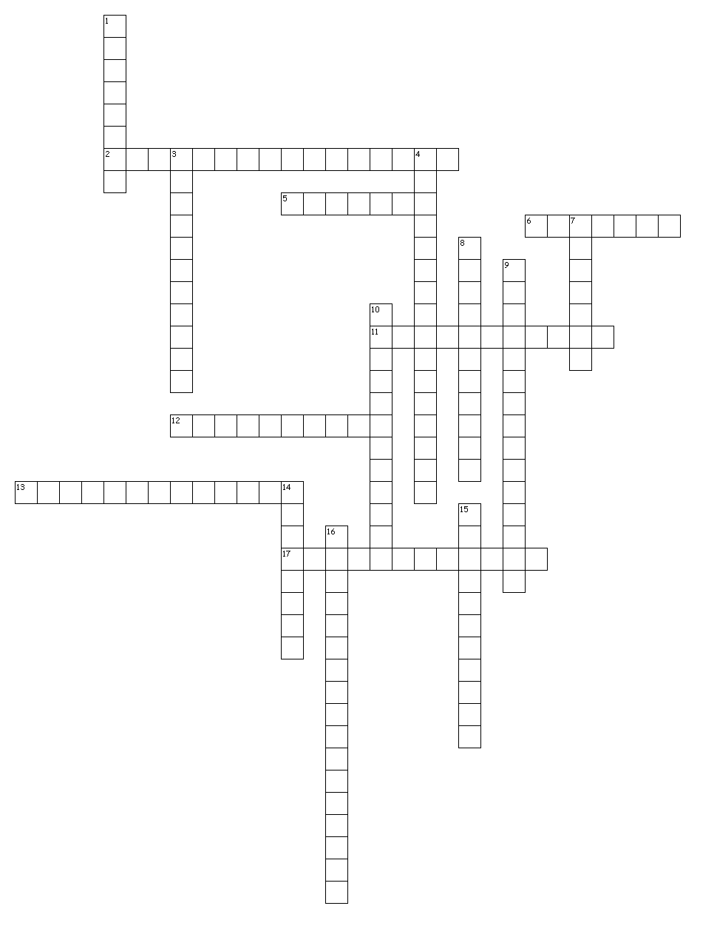

Across
2. A forensic tool used to identify the chemical makeup of substances used in the commission of crimes.
5. The internal and external examination of a body after death.
6. The diameter of the bore of a rifled firearm, usually expressed in hundredths of an inch or in millimeters.
11. Also known as a "Polygraph," a machine that charts how respiration and other bodily functions change as questions are asked of the person being tested.
12. The study of the motion of bullets and their examination for distinctive characteristics after being fired.
13. Material deposited at a crime or accident scene that can only be detected through a deliberate processing procedure.
17. The process of testing to identify DNA patterns or types. In forensic science this testing is used to indicate parentage or to exclude or include individuals as possible sources of bodily fluid stains or other biological evidence.

Down
1. A technology dealing with the properties and actions of serums in blood; also known as blood analysis.
3. The study of criminal activity and how it is dealt with by the law.
4. Any object that can help explain an event under investigation.
7. A chemical that is capable of detecting bloodstains diluted up to 10,000 times.
8. The unique patterns created by skin ridges found on the palm sides of fingers and thumbs.
9. Techniques used to develop latent fingerprints on non-porous surfaces.
10. The pattern of blood that has struck a surface. This pattern can provide vital information about the source of the blood.
14. Anything that has been used, left, removed, altered, or contaminated during the commission of a crime or other event under investigation.
15. The path of a bullet or projectile as it passes through matter, such as a body or a wall.
16. A fingerprint made by deposits of oils and/or perspiration, not usually visible to the human eye.

Home

