Finding the formula of an oxide of copper

From Royal Society of Chemistry Student Sheets—Classic Chemistry Experiments

Introduction
The chemical formula gives the types of atom in the substance. It also gives the relative number of each type. From the mass of each element in a sample, the number of moles can be calculated. The lowest whole number ratio provides the simplest chemical formula.

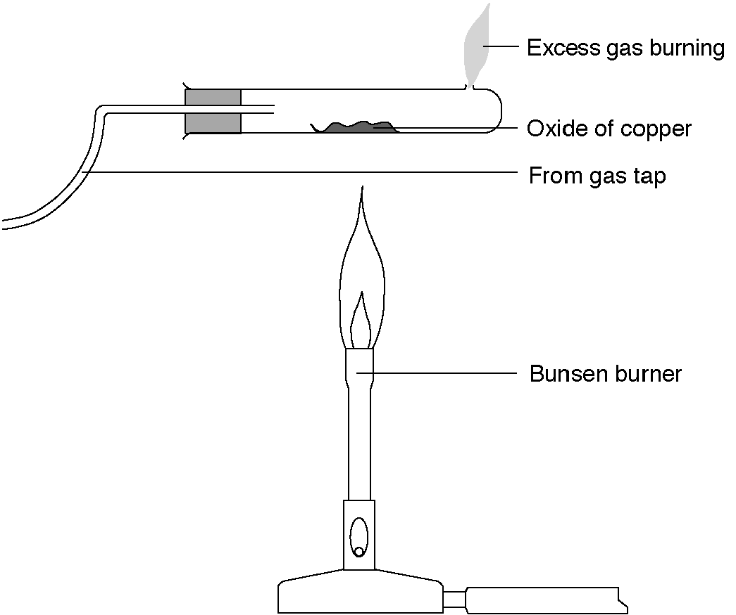

What to record
Weight of test-tube + bung.
Weight of test-tube + bung + copper(II) oxide.
Weight of test-tube + bung + copper.

What to do
1. Weigh the test-tube + bung.
2. Place two spatulas of dry black copper(II) oxide in the centre of the tube. Try to spread it out.
3. Weigh the tube + bung + copper(II) oxide.
4. Assemble the apparatus as shown in the diagram.
5. Pass a gentle stream of gas through the tube without lighting it. This will flush out the air. After a few seconds set light to the gas and adjust the height of the flame coming out of the test tube to about 3 cm. Keep your head well back.
6. Heat the copper(II) oxide strongly and move the flame slowly to and fro. Continue to heat for five min after the solid has turned a brownish pink colour.
7. Stop heating the tube but keep the gas flowing through the test-tube and burning at the end. This prevents re-oxidation of the copper.
8. Let the test-tube cool, turn off the gas and reweigh the tube + bung + copper.

Safety
Wear eye protection
Copper(II) oxide is harmful.

Questions
1. What is the mass of copper(II) oxide used?

2. What is the mass of copper formed?

3. What is the mass of oxygen lost?

4. How many moles of copper were formed?

5. How many moles of oxygen were combined with this number of moles of copper?

6. What is the simplest whole number ratio of moles of copper to moles of oxygen?

7. What is the formula of copper(II) oxide?
http://www.chemsoc.org/networks/learnnet/Word_files/Kev81-90.doc

