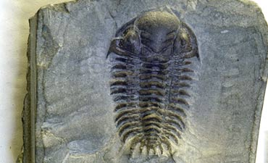 | The History of Life


Across
5. Chemosynthetic prokaryotes that live in harsh environments, such as deep-sea vents and hot springs.
Down
1. Large, ordered structure, enclosed by a membrane that carries out some life activities, such as growth and division.
2. Mistaken idea that life can arise from nonliving materials.
3. Physical evidence of an organism that lived long ago that scientists use to study the past; evidence may appear in rocks, amber, or ice.
4. Geological explanation for the movement of continents over Earth's thick, liquid interior.
6. Idea that living organisms come only from living organisms.

