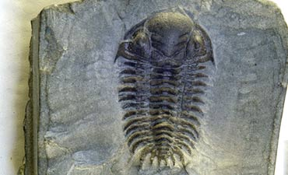 | The History of Life

I | J | D | Z | I | D | Y | P | R | O | T | O | C | E | L | L | C | S | R | I | S | A | N | C | T
C | U | D | S | P | N | P | L | A | T | E | T | E | C | T | O | N | I | C | S | O | B | N | N | D
P | R | O | S | H | A | P | R | I | M | O | R | D | I | A | L | S | O | U | P | S | O | R | I | O
R | A | I | C | D | E | S | E | P | E | S | T | I | N | S | I | S | E | N | E | G | O | I | B | I
E | S | R | T | E | E | E | D | O | I | R | E | P | S | U | O | E | C | A | T | E | R | C | A | R
C | S | E | I | C | P | R | P | V | E | O | B | A | R | E | C | I | O | Z | O | N | E | C | E | E
A | I | P | O | N | E | A | T | D | O | I | R | E | P | N | A | I | R | U | L | I | S | A | C | P
M | C | C | V | I | C | A | S | F | A | E | A | N | O | N | R | A | E | F | O | S | S | I | L | N
B | P | I | E | S | M | S | A | T | I | A | R | E | C | I | O | Z | O | E | L | A | P | S | A | A
R | E | S | A | I | Z | S | O | A | E | D | O | I | R | E | P | N | A | I | N | O | V | E | D | I
I | R | S | N | F | C | I | R | U | C | U | M | E | N | P | E | R | E | E | T | S | E | S | E | M
A | I | A | A | A | E | M | I | T | I | G | R | I | A | R | E | C | I | O | Z | O | S | E | M | R
N | O | I | S | P | O | N | T | A | N | E | O | U | S | G | E | N | E | R | A | T | I | O | N | E
C | D | R | E | I | O | N | O | I | T | C | N | I | T | X | E | S | S | A | M | S | U | T | E | P
A | T | T | I | A | I | R | E | T | C | A | B | E | A | H | C | R | A | T | I | J | C | R | L | E

WORD LIST
FOSSIL |  | PLATETECTONICS |  | ARCHAEBACTERIA
BIOGENESIS |  | PROTOCELL |  | SPONTANEOUSGENERATION
PRIMORDIALSOUP |  | PASTEUR |  | CENOZOICERA
MASSEXTINCTION |  | MESOZOICERA |  | PALEOZOICERA
TRIASSICPERIOD |  | JURASSICPERIOD |  | CRETACEOUSPERIOD
PRECAMBRIAN |  | DEVONIANPERIOD |  | SILURIANPERIOD
PERMIANPERIOD

Clipart provided by  AwesomeClipartforKids.com | This worksheet was created with  "Worksheet Maker" by Chris Small  of The Small Homeschool Pages

Worksheet ID#C13K382

