Puzzle-Piece Ionic Compounds

You have had a couple of days experience balancing ionic-compound formulas, getting the cations and ions properly balanced. To get a visual feel for how to combine ions, let's use ion puzzle pieces to make ionic compounds. One has to cut them out and glue them together. For example, Sodium Chloride when completed and labeled will look like this:
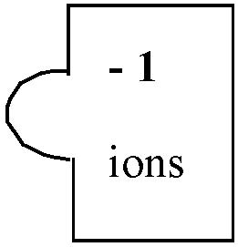
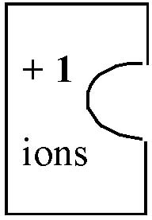
Na⁺
Cl⁻

Finished formula of ionic compound: no charges shown, subscripts where appropriated, and ( ) if necessary.

Label each ion
piece correctly
NaCl

The charges add up to zero and a neutral balanced formula is written below. Use the ion table provided. Construct the following ionic compounds using puzzle pieces that you will cut out:

Copper (I)* chloride
Label all ion puzzle pieces. See above.
Add up ions to get formulas.
The number of atoms or polyatomic ions must be subscripted: Ag₂CO₃
If element symbol has two letters, second must be lowercase.
Don't forget to put polyatomic ions in parentheses if more than one and subscript the number: Al(OH)₃
Copper (II)* iodide
Magnesium oxide
Gold (III) Nitrate
Sodium Sulfate
Lead (II)* Hydroxide
Aluminum Carbonate
Iron (III)* Phosphate
Ammonium Dichromate

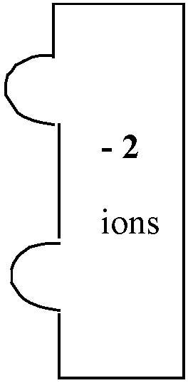
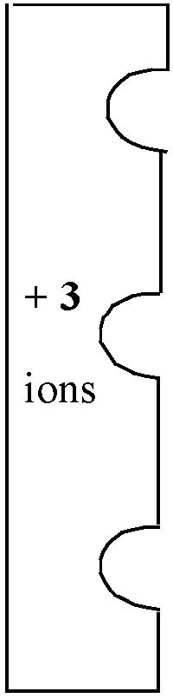
Cut out the appropriate ion puzzle pieces. Do not cut out all the pieces on a sheet. You will not need them all. Save time. You do need to cut around the tab of the anions. You do not need to cut out the semicircle of the cations. Just glue the anions over the cations. Glue ion pieces onto pieces of recycled (scrap) paper to make the puzzle-piece compound. Label each ion piece with the ion that it is. The ion puzzles are complete if their bottoms line up. Look at the NaCl example above. Some of the puzzle pieces are tricky. Notice that this piece immediately to the right is incomplete. The ion puzzle requires more -2 and -3 pieces. Stagger them until the bottoms align. Adding a -1 piece would be incorrect!!!! That would be mixing anions which is not allowed. Mixing cations is also not allowed. Your puzzles must be 100% correct for any credit.

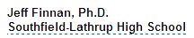
Count up the puzzle pieces (ions on each side) to get the correct formula. Write the formula of the ionic compound with proper subscripts as needed below the puzzle-piece compound. Don’t forget your name. Seek teacher assistance as necessary. Please, don't discard unused pieces from the sheets. We can use them again. Provided by

