A compound from two elements

Introduction
A mixture of iron and sulfur can easily be separated. This is because there are no chemical bonds between the sulfur and the iron. The iron is magnetic and is therefore easily removed from the sulfur. In this experiment, a mixture of iron and sulfur are heated to make a new compound.

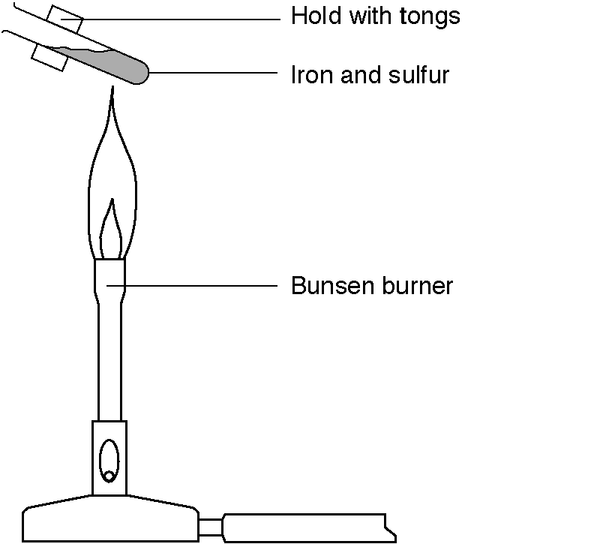

What to do
1. Examine the plastic bag of sulfur, the bag of iron and the bag containing a mixture of the two.
2. Run a magnet over each of the bags.
3. Set up the apparatus as shown in the diagram.
4. Light a Bunsen burner and half open the air-hole to give a medium flame.
5. Place a mixture of the iron and sulfur in a test tube
6. Heat the very end of the tube strongly. When the mixture starts to glow, move the Bunsen burner to one side.
7. Watch the mixture in the tube. (If the glow just goes out, heat the tube again.)
8. Let the tube cool down completely.
9. The substance from the tube is a new compound called iron sulfide.
10. Test the iron sulfide with a magnet. Does the magnet pick it up?

Safety
Wear eye protection. Do not get too close to the fumes.

Questions
1. Write a word equation for this reaction.

2. What has happened to the iron and the sulfur in forming iron sulfide?

3. What is the chemical formula for iron sulfide?

Home

