BIOLOGY LAB

Lab: Making a Dichotomous Key Names: _____________________________
_____________________________
_____________________________
_____________________________

Problem: How can laboratory equipment be classified?

Hypothesis:

Experiment:

Materials:
- Lab sheet
- Pen or pencil
- Brain in gear

Procedure:

- Use the diagram of laboratory equipment on page 3 to separate the types of equipment into 2 groups.
- Record the characteristics used to separate the groups on the diagram handout.
- Continue to form subgroups within your two groups based on different characteristics and record them on your diagram until you have only one piece of equipment in each group.
- Using the diagram you have made, make a dichotomous key for the laboratory equipment. Remember each numbered step should contain two choices for classification. Begin with 1A and 1B.
- Exchange your key with another group and see if they can use it to identify the laboratory equipment.

Data: Record your groups on chart handout and compose your dichotomous key on page 2. You do not have to use all of the blanks!

Conclusions:
- What two main groups did you divide the equipment into? _________________________ ________________________________________ Are there other ways to divide the equipment? ________ Explain. ______________________________________________ _______________________________________________________________________

2. Did the group you exchanged with find it easy to identify the equipment from your key? _ ________ Why or why not? ________________________________________________ ________________________________________________________________________ ________________________________________________________________________

Laboratory Equipment Key

1. A. _____________________________________________________________________
B. _____________________________________________________________________

2. A. _____________________________________________________________________
B. _____________________________________________________________________

3. A. _____________________________________________________________________
B. _____________________________________________________________________

4. A. _____________________________________________________________________
B. _____________________________________________________________________

5. A. _____________________________________________________________________
B. _____________________________________________________________________

6. A. _____________________________________________________________________
B. _____________________________________________________________________

7. A. _____________________________________________________________________
B. _____________________________________________________________________

8. A. _____________________________________________________________________
B. _____________________________________________________________________

9. A. _____________________________________________________________________
B. _____________________________________________________________________

10. A. _____________________________________________________________________
B. _____________________________________________________________________

11. A. _____________________________________________________________________
B. _____________________________________________________________________

12. A. _____________________________________________________________________
B. _____________________________________________________________________

13. A. _____________________________________________________________________
B. _____________________________________________________________________

14. A. _____________________________________________________________________
B. _____________________________________________________________________

15. A. _____________________________________________________________________
B. _____________________________________________________________________

16. A. _____________________________________________________________________
B. _____________________________________________________________________

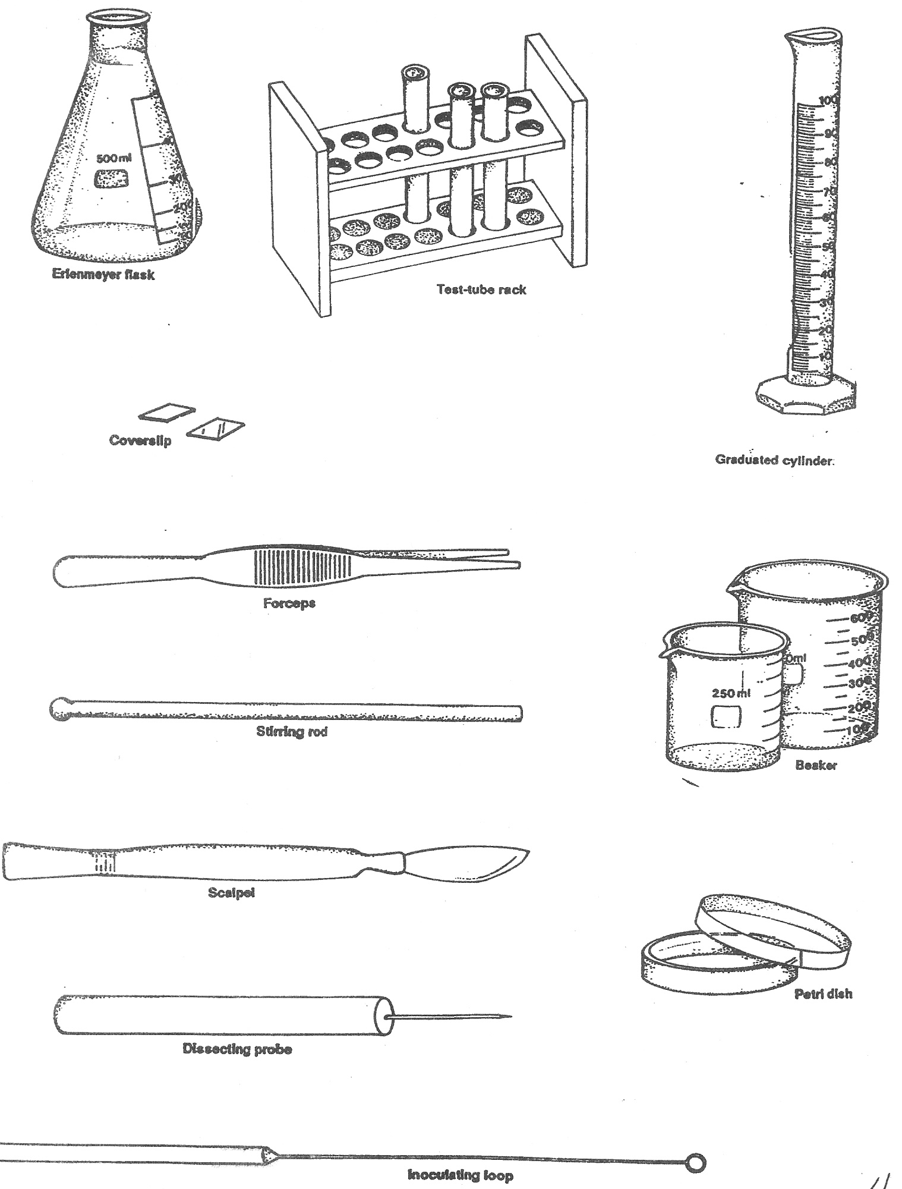

Home

