Making a pH indicator from http://www.chemsoc.org/networks/learnnet/Word_files/Kev31-40.doc

Introduction
A pH indicator is a substance that has a different color when added to acid or alkali. In this experiment a pH indicator is made from red cabbage.

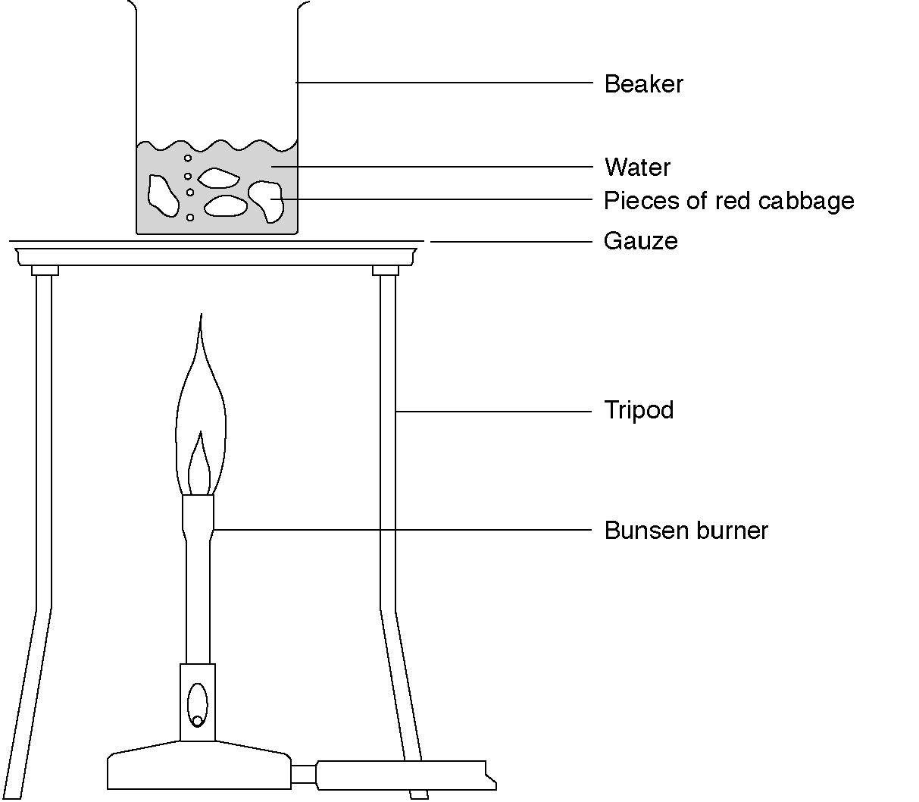

What to record
Record the color of the cabbage indicator in the three solutions.

What to do
1. Boil about 100 cm³ of tap water in a beaker.
2. Add three to four pieces of red cabbage to the boiling water.
3. Boil for about 5 min. The water should have turned blue or green.
4. Turn off the Bunsen burner and allow the beaker to cool for a few minutes.
5. Place three test tubes in a rack. Half fill one with alkali, one with acid and one with deionised water.
6. Decant approximately 2–3 cm height of cabbage solution into each test-tube.

Safety
Wear eye protection.

Questions
1. What color is the cabbage indicator when neutral?

2. What color is the cabbage indicator when alkali?

3. What color is the cabbage indicator when acid?

Home

