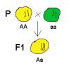 | Mendel and Meiosis | 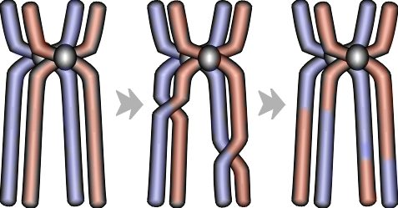

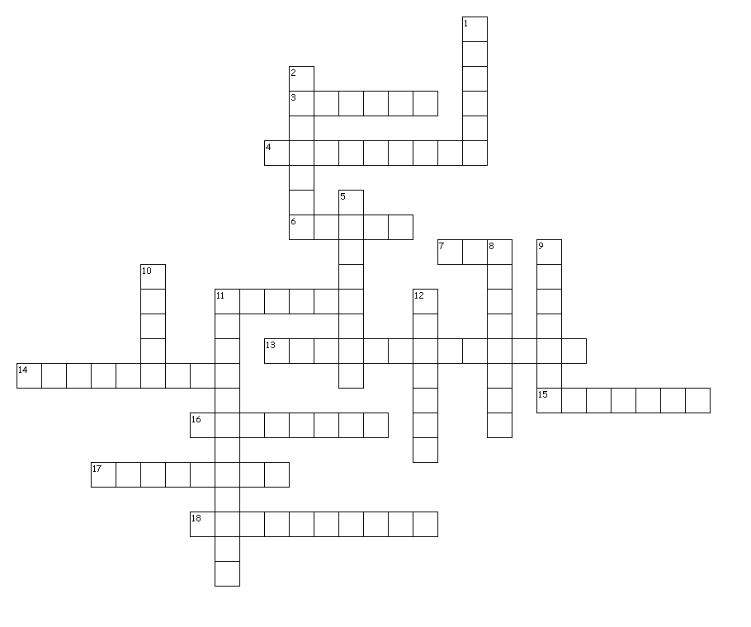
Across
3. Alternative forms of a gene for each variation of a trait of an organism.
4. Trait of an organism that can be masked by the dominant form of a trait.
6. Haploid male sex cells produced by meiosis.
7. Haploid female sex cell produced by meiosis.
11. Offspring formed by parents having different forms of a trait.
13. Fusion of male and female gametes.
14. Outward appearance of an organism, regardless of its genes.
15. Cell with two of each kind of chromosome; is said to contain a diploid, or 2n, number of chromosomes.
16. Observed trait of an organism that masks the recessive form of a trait.
17. Combination of genes in an organism.
18. When there are two identical alleles for a trait.

Down
1. Diploid cell formed when a sperm fertilizes an egg.
2. Male and female sex cells; sperm and eggs.
5. Passing on of characteristics from parents to offspring.
8. Branch of biology that studies heredity.
9. Cell with one of each kind of chromosome; is said to contain a haploid, or n, number of chromosomes.
10. Characteristic that is inherited; can be either dominant or recessive.
11. When there are two different alleles for a trait.
12. Type of cell division where one body cell produces four gametes, each containing half the number of chromosomes as a parent's body cell.

