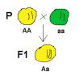 | Mendel and Meiosis | 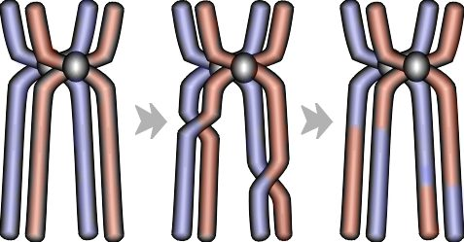

I | T | I | I | E | D | I | O | L | P | A | H | I | D | W | I | M | E | G | H | J | X | T | E | P
E | C | O | Y | E | O | O | N | D | G | T | S | F | D | S | T | E | H | E | M | E | S | O | G | N
L | R | Z | Y | L | O | R | G | S | I | G | I | E | H | J | O | Y | H | N | G | T | I | S | F | O
K | O | X | H | P | O | E | P | A | E | F | N | R | O | L | O | E | E | O | Y | P | S | E | H | I
O | S | R | I | H | T | E | R | N | S | V | K | T | Y | E | B | F | T | T | G | H | O | T | E | T
E | S | E | E | E | R | T | E | C | G | O | T | I | H | R | E | N | E | Y | O | E | I | O | R | A
P | I | N | M | M | S | T | E | Z | O | Y | E | L | E | L | L | A | R | P | P | N | E | G | E | N
R | N | A | E | I | I | I | R | O | G | N | N | I | O | X | R | T | O | E | A | O | M | Y | D | I
F | G | E | G | C | E | R | T | H | R | B | E | Z | P | N | N | E | Z | N | O | T | E | Z | I | L
E | O | O | S | M | E | T | I | Y | T | G | R | A | A | A | L | R | Y | O | R | Y | O | A | T | L
I | V | L | L | G | L | O | U | B | G | M | L | T | N | E | N | R | G | Y | L | P | R | R | Y | O
Y | E | S | O | N | O | Z | E | R | O | P | O | I | I | I | I | O | O | D | N | E | L | A | Y | P
S | R | R | E | C | E | S | S | I | V | E | M | O | G | I | H | O | U | E | M | B | I | G | E | L
T | T | Y | Y | T | I | H | D | D | M | O | H | N | O | E | U | E | S | E | E | G | E | H | V | P
H | M | D | I | P | L | O | I | D | D | V | W | S | U | O | G | Y | Z | O | M | O | H | I | R | D

WORD LIST
ALLELE |  | DOMINANT |  | FERTILIZATION
GAMETE |  | GENETICS |  | GENOTYPE
HEREDITY |  | HETEROZYGOUS |  | HOMOZYGOUS
HYBRID |  | PHENOTYPE |  | POLLINATION
RECESSIVE |  | TRAIT |  | ZYGOTE
CROSSING OVER |  | DIPLOID |  | EGG
HAPLOID |  | MEIOSIS |  | SPERM

Clipart provided by  AwesomeClipartforKids.com | This worksheet was created with  "Worksheet Maker" by Chris Small  of The Small Homeschool Pages

Worksheet ID#C9O124

