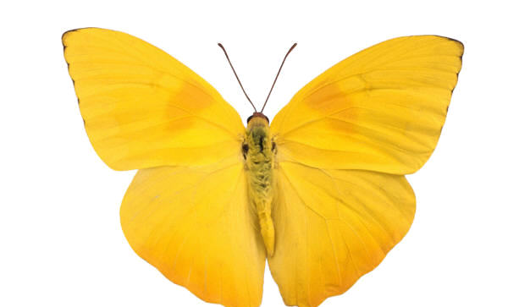
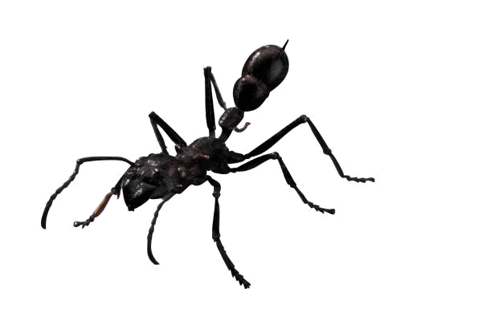
Video: Microcosmos

Name: ___________________________________________ Date: __________ Block: __________

Organisms that appear in the film:

ladybird with seven spots
swallow-tail butterfly
climbing caterpillar
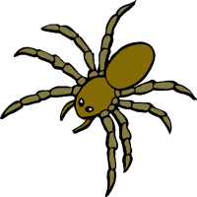
bee
sage flower
long tailed blue caterpillar
snails
spider
ants
wasps
sacred beetle
pheasant
a bee in love with an orchid
an insect-eating plant
dung beetles
great peacock moth
wriggler as it changes into a mosquito

1. What is happening as the bee seeks nectar from the purple flower?

2. The bee and the flower have a symbiotic relationship called ____________.
- mutualism

- commensalism
- parasitism

3. Who wins the fight between the ant and the lady bug?

4. Describe lady bug mating (G rated, please).

5. Describe the hatching of the orange caterpillar

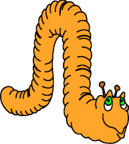
6. What does the orange caterpillar do immediately after hatching?

7. What is the purpose of the spider’s web?

8. What does the spider do after it has caught something, but before eating it?

9. What type of evolution has occurred between the bee and the long pink flower?
- divergent evolution
- convergent evolution
- coevolution

10. In what type of formation do the processionary caterpillars move?

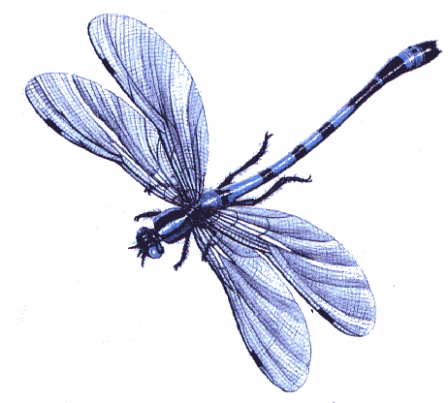
11. What do the ants do with all of the seeds they collect?

12. a. Describe the hatching bees.

- What do they do once they get out?

13. a. Estimate how many times larger the dung ball is than the dung beetle: _________.

- How much does something weigh that is that many times larger than you: _________.

- Do you think you could push or roll an object of that size?

14. What insect is eaten by the pheasant (the bird with the red “eye shadow”)?

15. What property of water allows insects to stand and walk on water?

16. Compare the size of a raindrop to the size of most of the insects.

17. a. Describe the insect-eating plant.
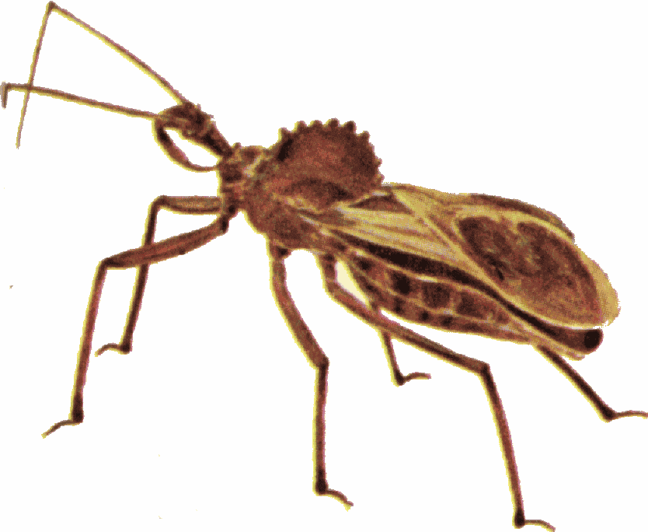

- Why do you think the plant does this?

18. What might the two horned beetles be fighting over?

19. What do caterpillars eat?

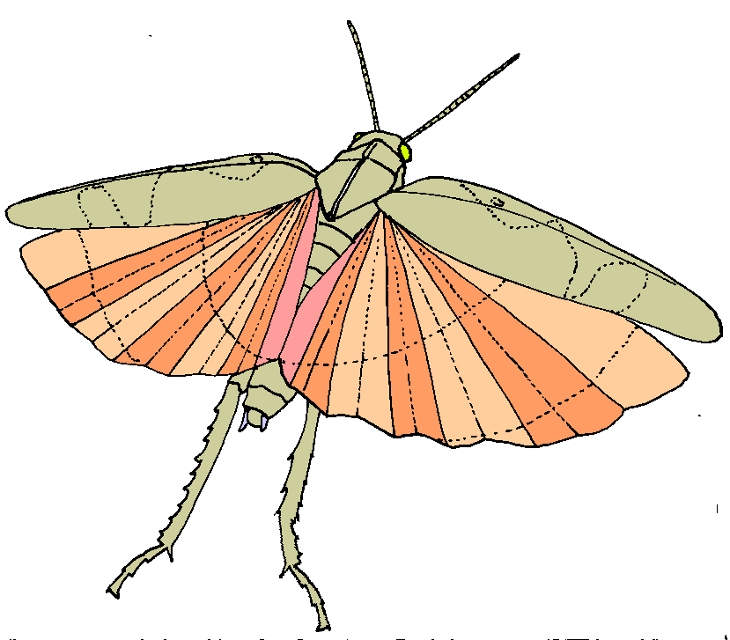
20. What type of flying insects come out at night?

21. What time of year do you think this film was made?

22. Did you enjoy the film?

23. Describe one thing you learned from the video that you didn’t already know.

