The volume of 1 mole of hydrogen gas

From Royal Society of Chemistry Student Sheets—Classic Chemistry Experiments

Introduction
One mole of any gas occupies the same volume when measured under the same conditions of temperature and pressure. In this experiment, the volume of one mole of hydrogen is calculated at room temperature and pressure.

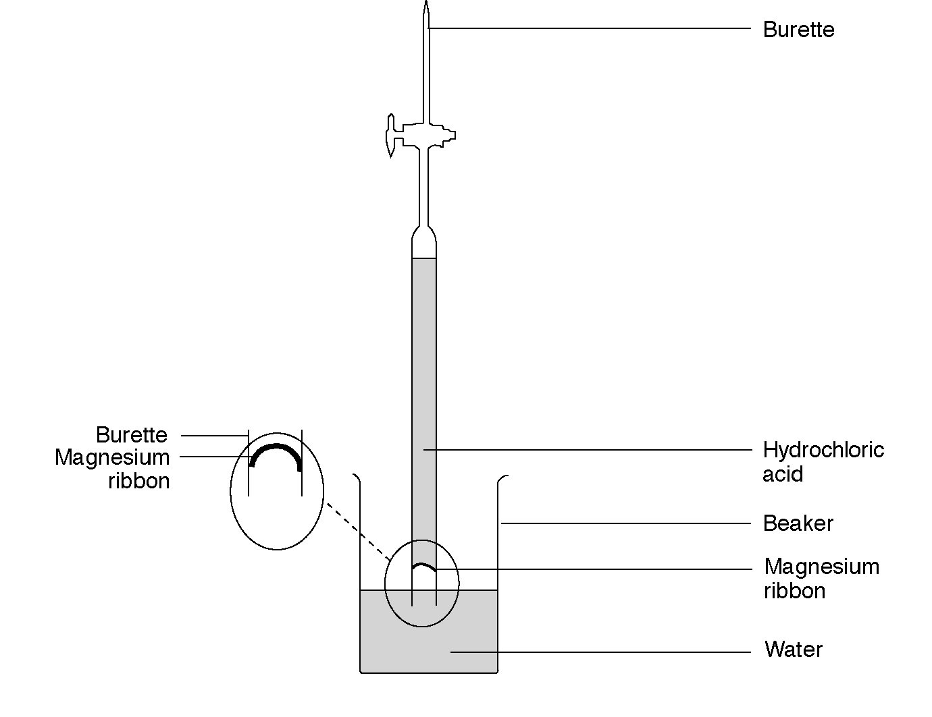

What to record
What was done.
The mass of magnesium used and the volume of hydrogen produced.

What to do
1. Clean a piece of magnesium ribbon about 3.5 cm long and weigh accurately. (This should weigh between 0.02 and 0.04 g; if not adjust the amount used.)
2. Measure 25 cm³ of dilute hydrochloric acid (Irritant) into the burette. Carefully add 25 cm³ of water on top of this.
3. Push the magnesium into the end of the burette so it will stay in position with its own tension.
4. Add 50 cm³ of water to a 250 cm³ beaker.
5. Quickly invert the burette into the water. If this is done quickly and carefully very little is lost. It is important that the liquid level in the burette starts on the graduated scale. If it is not on the scale; momentarily open the tap, this allows the level to drop). Clamp the burette vertically.
6. Take the burette reading (care: it is upside down!)
7. Observe the magnesium react as the acid diffuses downwards, wait until all the magnesium has reacted.
8. Note the new volume on the burette (care: it is upside down).
9. Record your results.

Safety
Wear eye protection.

Questions
The equation for the reaction is
Mg +2HCl → MgCl₂ + H₂
The relative atomic mass of magnesium is 24.

1. Copy out and fill in the gaps:
____ g Magnesium has produced ____cm³ hydrogen
____ /24 moles magnesium produces _____ cm³ hydrogen.
1 mole magnesium produces ________cm³ hydrogen which is the volume of one mole of hydrogen gas.
http://www.chemsoc.org/networks/learnnet/Word_files/Kev61-70.doc

