NAME: __________________________ DATE: ___________ PERIOD/SECT________

Partner:______________________
NASA ANIMATED GAS LAB
From Paul Bizot
GOALS
- Students will become familiar with the implications of the ideal gas law, generating curves for pairs of variables, including demonstration of Boyle’s law, Charle’s law.
- Students will manipulate the ideal gas law into variables and “lumped constant” for each case studied, to show why the graph for each case has the appearance it does.
- Students will obtain a more intuitive feeling for the effect of gas variables on molecular density (e.g. number of molecules per given volume of gas)

OBJECTIVES
- Students will perform animations of five pairings of the ideal gas law variables, including those demonstrating
  - Boyle’s law (number of moles and temperature held constant)
- For each such pairing of ideal gas variables, students will provide a sketch of the two variables (plotted against each other)
- For each pairing of plotted ideal gas variables, students will algebraically manipulate the ideal gas law to show why the graph has the form it does.
- Students may answer other questions as posed in the following

PROCEDURE
- Use Internet Explorer or NETSCAPE or other web browser to go to http://www.grc.nasa.gov/WWW/K-12/airplane/Animation/frglab2.html
Which includes something which looks like:

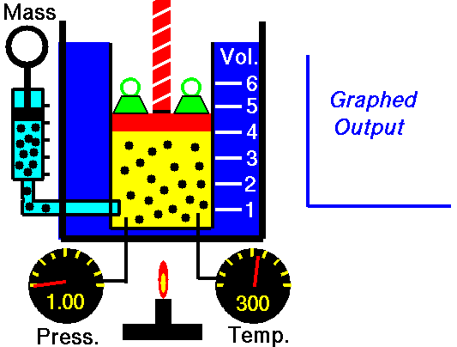
- Read the 2 introductory paragraphs. Manipulation of the variables is by the dialog box to the left, not from clicking on the image itself.
- In the dialog box to the left which is labeled “Freeze one variable”, left-click the mouse on “Mass” The “Freeze one variable” will be replaced with “Freeze another” and the mass variable will say “Mass frozen”. Left-click the mouse on “Temperature”. You will now have a choice of being able to see the effect of volume on pressure or the effect of pressure on volume.
- Choose the upper option “Effect of changing volume on pressure” by left-clicking the mouse on that option.
When the volume is “4” what is the value of pressure?
When the volume is “2” what is the value of pressure?
What is happening to the density of the gas (molecules per unit volume) as the volume goes down?

(Bonus) What do you think the theoretical value of pressure would be when the volume is 3? (Don’t waste your time trying to read the animation this closely, just think about Boyle’s Law)
Draw a copy of the completed curve/graph, with the axes labeled.
|
|
|
|
|
|_______________

(Bonus) Do you know the name for, and the generic formula for the above type of figure?

Example:
Starting from the Ideal Gas Law, PV = nRT, manipulate the law into the variables (P and V) with all of the “constants” lumped together

P V = n R T

P = ( n R T) x 1/V
Mass, gas constant,
Temperature all
“constant” for
this case (do not try
to use any values for
n, R, or T in this)

(Bonus) What do you think the theoretical value of pressure would be when the volume is 3? (Don’t waste your time trying to read the animation this closely, just think about Boyle’s Law)
5. Left-click with the mouse on “Effect of changing pressure on volume” in the dialog box to the left.

What do the changing weights on top of the piston signify?

At what pressure are the number of weights highest?

What is the volume when the pressure is highest?

What is the volume when the pressure is lowest?

Draw a copy of the completed curve/graph, with the axes labeled.
|
|
|
|
|
|_______________

Manipulate the ideal gas law, similar to #4, above

The above completes the “Boyle’s law” cases. Attached is a page from your text dealing with Charle’s Law. What two variables need to be held constant for Charle’s Law?

6. Pick the Charle’s Law case of “The effect of changing temperature on volume” (The other case doesn’t make much sense; certainly could not be done easily, and probably could not be done as NASA illustrated it.

What happens to the molecular density as the volume and temperature increase?

What is the volume, when the temperature is 250? What is the volume, when the temperature is 450?

From the graph, the volume scale, and the temperature scale, what do you think the volume would be at a temperature of zero?

What temperature, in Kelvin, do you think this would correspond to?

What does the ideal gas law predict as the product of Pressure and Volume, at 0K ?

Draw a copy of the completed curve/graph, with the axes labeled.
|
|
|
|
|
|_______________

Manipulate the ideal gas law, similar to #4, above

7. Pick the case of changing mass on pressure. For the animation of increasing “mass”, what is increasing in the ideal gas law?

What is happening to the molecular density, as the mass is increased

Draw a copy of the completed curve/graph, with the axes labeled.
|
|
|
|
|
|_______________

Manipulate the ideal gas law, similar to #4, above

8. Pick the case of changing mass on volume. For the animation of increasing “mass”, what is increasing in the ideal gas law?

What is happening to the molecular density, if the temperature and pressure are held constant?

How is the illustrated in the animation?

Draw a copy of the completed curve/graph, with the axes labeled.
|
|
|
|
|
|_______________

Manipulate the ideal gas law, similar to #4, above

9. Pick any other case which you have not already done, provide the graph, and manipulate the ideal gas law to show why the graph looks like it does. Discuss what happens to the density while the two variables selected are changed.

10. What insights, if any, has this lab provided you with on the ideal gas law (not more than 2-3 sentences)

11. Did you enjoy this lab? Why or why not?

