Paper Pets

The Paper Pet (species Papyrus domesticus) has 4 distinct traits as shown in the chart.

Trait | Variations
Eyes |   RR or Rr rr
Nose | 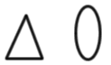  NN or Nn nn
Teeth |   TT or Tt tt
Hair |   HH Hh hh

THE PARENTS

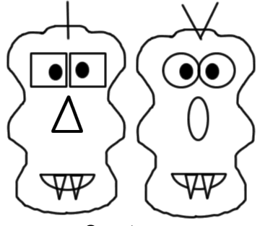
Genotype

Male

Rr
Nn
Tt
HH

Genotype

Female

rr
nn
Tt
hh

Show how you would use a punnet square to determine the possibilities of the offspring.

1. Rr x rr 2. Nn x nn 3. Tt x Tt 4. HH x hh

Making Your Parents

What if both parents were heterozygous for all traits:
RrNnTtHh x RrNnTtHh

Draw the new parents:

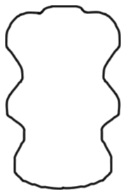

Making Your Offspring

Now, your parents will mate to create four offspring. To simulate mating, use a penny to flip. Heads represents a dominant allele, tails a recessive. Ex. For the first baby, you flip heads and then tails. Your baby has the genotype Hh. Two heads would have been HH and two tails would have been hh. You’ll repeat this for each trait.

Name of Pet 1  __________________ | Name of Pet 2  __________________ | Name of Pet 3  __________________ | Name of Pet 4  __________________
Genotype | Genotype | Genotype | Genotype

