The Ultimate Pedigree Challenge
Possible Answer

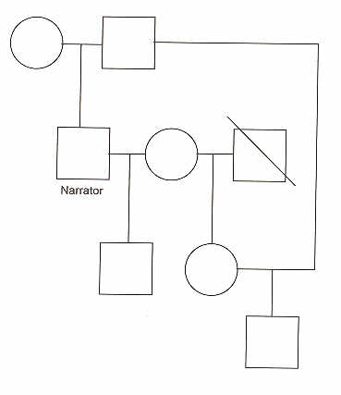
Widow
Widow’s
daughter
Narrator’s
Father

Son of narrator & widow
Widow’s deceased husband
Widow’s
daughter

Son of widow’s daughter and father of narrator

