Cutting Out the Chromosomes

Step #1  Cut out each pair of chromosomes on the solid line that surrounds each pair. | 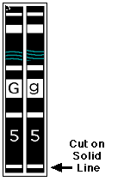 | Step #2  Fold along the dotted line between the pair of chromosomes. | 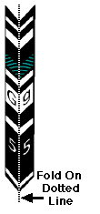
Step #3  Glue/tape the folded pair together, press until they are perfectly flat. Watch for undried glue squeezing out from between the chromosomes; they may stick with other chromosomes! | 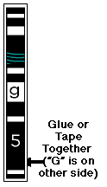 | Step #4  Bring your chromosomes to school in an envelope stored in one of your books.... keep your paired chromosomes flat! | 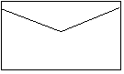

Genotype to Phenotype
Simulation Booklet
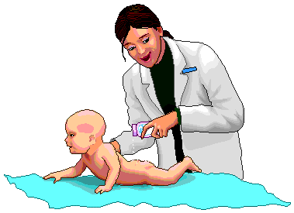

Combining germ cells to create
a new baby human

Name: ______________________________ Period: ____

Making A Face: Genetic Simulation Assessment
Please assess your own work and fill in your scores on this sheet. This sheet must be attached to your work when you turn it in.

Task | Outstanding | Good | Poor
Data Sheet | 20: Complete, fully filled in, neat | 10: Partially filled in; sloppy | 0: Blank or missing
Questions | 25: Complete, thoughtful answers, correct | 15: Fully answered; answers short, inaccurate, and/or incomplete | 0: Blank or missing
Drawing of Face | 35: Complete, accurate, in color, neatly done, creative | 20: Mostly complete, mostly accurate, in color, some creativity | 0-15: Incomplete, partially inaccurate, not in color
Cooperation  And Focus | 10: Worked diligently, cooperatively with partner | 5: Lack of focus, not working cooperatively all the time | 0: disruptive, distracted, and/or did not work cooper-atively with partner
Grade Sheet | 10: Filled in and totaled by student | 3: Partially filled in, not totaled | 0: not done

Total Score (100 possible): _________

Comments:

11. After looking at the pictures of all the “children” in your class, how is there so much variation in the way they look if they come from the same parents? ______________________________________________________

______________________________________________________________

______________________________________________________________

______________________________________________________________

______________________________________________________________

______________________________________________________________

______________________________________________________________

______________________________________________________________

______________________________________________________________

______________________________________________________________

Extra Credit
12. Explain why people that had the genotype "ll" had to skip the rest of the chin characteristics. _________________________________________

______________________________________________________________

______________________________________________________________

______________________________________________________________

______________________________________________________________

______________________________________________________________

(25)

7. What does epistatis mean? Explain and give an example. _____________

______________________________________________________________

______________________________________________________________

- Hair color is polygenic. What does this mean? ____________________

______________________________________________________________

______________________________________________________________

______________________________________________________________

______________________________________________________________

- How is it that there are so many colors of skin? ____________________

______________________________________________________________

______________________________________________________________

10.This exercise was a simulation. How much like real human genetics do you think this was, and why? _____________________________________

______________________________________________________________

______________________________________________________________

______________________________________________________________

______________________________________________________________

______________________________________________________________

______________________________________________________________

______________________________________________________________

(24)
Making A Face:

A Genetic Simulation

Converting Genotype Into Phenotype by Simulating Meiosis and Fertilization

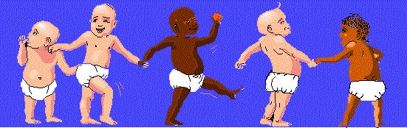
Congratulations, you are going to simulate creating a baby!
After this simulation, you should be able to answer the following questions:
- How many chromosome pairs does each human parent have?
- How many chromosomes does each parent "donate" to the next generation?
- Are some genes and gene characteristics expressed over others.... are dominant and recessive genes responsible for how a baby looks?
- What is the difference between Genotype and Phenotype?
- Do some traits require more than one gene to be fully expressed?
- What are sex-linked traits?
- How is there so much variation in the way children look even if they come from the same parents?
- What is epistasis?
- What is a polygenic inheritance?
You have been given a pink set of chromosomes if you are going to represent the mother, and a blue set of chromosomes if you are going to represent the father. We are asking the question... What would your baby look like if both
(1)
you and your classmate (who will simulate the other parent) have one dominant gene and one recessive gene for each of the facial features illustrated on the following pages? This, of course, is not the way it really is, but this is a simulation. Each of you will be heterozygous (hybrid) for each trait.
To determine the facial appearance of your child, you and your spouse will drop your 23 pair of chromosomes to the floor to simulate germ cell formation. This "dropping your chromosomes" will determine which one of the pair of chromosomes will enter the successful germ cell. Each parent, mom and dad, donate one and only one of each of their 23 pairs of chromosomes. Therefore, they each donate 23 chromosomes. Since genes ride in the DNA of the chromosomes, each child will end up with a pair of genes for each trait, one from the dad and one from the mom.
After you drop your own chromosomes and line them up according to size, then you will pair with your partner by pushing the chromosomes one at a time toward one another until they are side by side. This represents the establishment of pairs of chromosomes. When you are done you should have twenty three pairs of chromosomes again. The mathematics of sex is..... one of each pair from the mother.....Plus.... one of each pair from the father equals a pair of each kind for the baby! You essentially will supply one gene and the other parent will supply one gene for each characteristic. The resulting two genes that are paired up will produce the genotype.
Record the genetic contributions from each parent on the chart provided. Translate the genetic information into the phenotypic information (what will your baby look like). A mother and father will produce one child only. Then, each student will produce a drawing of his or her child 15 years later when he or she is in high school! Write your own name only on the back of your drawing -- we want to see if we can match the mother’s and father’s drawings of their children. Don't collaborate with your partner on the drawing assignment. In addition, answer the questions on the Question sheet.

(2)
Making A Face: Genetic Simulation Questions

- Why did you cut out the chromosomes in pairs? ____________________

______________________________________________________________

- When you folded the pair of chromosome and dropped them, what did that represent? ______________________________________________

______________________________________________________________

- What is the significance of only one of the pair of chromosomes ending its random journey facing up? __________________________________

_____________________________________________________________

______________________________________________________________

- What does this have to do with sex cell formation? _________________

______________________________________________________________

______________________________________________________________

- When you and your partner pushed the like pairs of chromosomes together, what was the number of chromosomes before and after you pushed them together? _______________________________________

______________________________________________________________

- What is it called when two genes are in a cell and one gene's phenotype is expressed and one is not? Explain and give an example of when this happened. _________________________________________________

______________________________________________________________

______________________________________________________________

(23)

Eyelashes Long Long Short
MM Mm mm

Mouth Size Wide Average Narrow
QQ Qq qq

Lips: Thickness Thick Thick Thin
JJ Jj jj

Dimples Dimples Dimples Absent
KK Kk kk

Nose Size Big Medium Small
NN Nn nn

Nose Shape Rounded Rounded Pointed
UU Uu uu

Earlobe Attachment Free Free Attached
ZZ Zz zz

Hairy Ears Present Present Absent
DD Dd dd

Freckles on Present Present Absent
Cheeks $$ $$ $$

Freckles on Present Present Absent
Forehead @@ @@ @@

(22)
Instructions

- Making the Chromosome Models
Follow the instructions to make the cut-out, folded chromosome models. Note that the two sides of each “chromosome” are different – each side carries a different version (allele) of each gene for this simulation.

- Meiosis: Creating the Germ Cells
Hold your set of chromosomes high in the air above your head. Drop them one at a time to the floor. If they don't twirl then drop them again. When they have all dropped to the floor carefully pick them up without turning them over and find a lab table where you can face each other, then organize them according to size. Your teacher will demonstrate how they should line up. Equal sizes should be across from each other as you face your partner. The sex chromosomes should be organized separately from the 22 other (autosomal) chromosomes. Keep in mind that you begin this exercise with the chromosome pair above your head, dropping them so that they twirl down to the floor and finally land. Only one of each chromosomal pair faces up. The upward facing one of the pair represents the chromosome that ended up in the successful germ cell that you have just produced. Yes, those 23 chromosomes that are all neatly lined up represent the contents your sperm or egg.

- Fertilization
Gently push the like-sized chromosomes toward each other at point halfway between you, pairing them up according to size and number. This represents the moment when a new human potential is reached. A totally unique human is conceived!

- Determination of Characteristics
Determination of child's sex. After conception, parents are always interested in determining the sex of their child. In this case the "father" has pushed either an "X" chromosome or a "Y" chromosome toward the middle (which ever dropped facing up) and matched it with the "mother's” "X" chromosome. If an "X", then you have a beautiful little girl, if a "Y", then a beautiful little boy! Record the information on your data sheet.

(3)
Determination of various genotypes. Carefully read the genes on all of the chromosomes and circle the resulting genotypes and phenotypes on your data sheet. These are the genes that make up the new baby’s genotype.
- Envisioning the New Person
Time passes, you get older, your baby is growing up! What does your child look like when he or she is a teenager of about 15 years of age? Make a full page, color drawing of your teenager's face using your best drawing ability. Color is necessary; some of the genes produce pigment!

- Envisioning the New Person
Time passes, you get older, your baby is growing up! What does your child look like when he or she is a teenager of about 15 years of age? Make a full page, color drawing of your teenager's face using your best drawing ability. Color is necessary; some of the genes produce pigment!

- Understanding the Process of Heredity
Answer the questions about the traits of “your” child on the question sheet. Use the descriptions of the genes and chromosomes to help you with your answers.

(4)
Eye Color Dark Brown Brown Brown Dark Dark Light
Brown Blue Blue Blue
FFBB FFBb FFbb FfBB FfBb Ffbb ffBB

Light Blue Pale Blue
FfBb ffbb

Red Hair Red Less Red No Red
Pigment Pigment Pigment
GG Gg gg

Hair Type Curly Wavy Straight
WW Ww ww

Widow’s Peak Present Present Absent
PP Pp pp

Eyebrow Thickness Thick Thick Thin
TT Tt tt

Eyebrow Placement Apart Apart Touching in Middle
EE Ee ee

Eye Distance Close Less Close Far Apart
Apart OO Oo oo
Eye Size Large Medium Small
II Ii ii

Eye Shape Almond Almond Round
VV Vv vv

(21)
Making A Face: Genetic Simulation
Data Sheet

Trait Genotype/Phenotype

Gender Female Male
XX XY

Face Shape Round Round Square
RR Rr rr

Chin Shape Very Prominent Very Prom. Not Prom.
LL Ll ll

Chin Shape Round Round Square
If LL or Ll only SS Ss ss

Cleft Chin Cleft Cleft No Cleft
If LL or Ll only CC Cc cc

Skin Color Very, Very Dark Med. Light Light Very
Polygenic Very Dark Brown Brown Brown Light Very
Dark Brown Brown Light
Brown Brown
AAA AAA AAA AAA AA A/a aaa
AAA AA/a A/aa /aaa /aaaa aaaa aaa

Hair Color Black Very Dark Brown Light Honey Blond
Polygenic Dark Brown Brown Blond
Brown
HHHH HHHH HHHH HHHH HHHH/ HHH/h HH/h
HHHH HHH/h HH/hh H/hhh hhhh hhhh hhhhh

Very VERY
Light light!
Blond Platinum
H/hh hhhh
hhhhh hhhh
(20)
Gender Determination

If your dropping of the genes resulted in two "XX" chromosomes turning face up, then you are the very lucky parents of a little girl.  The Mom contributed one "X" and the Dad the other "X". | 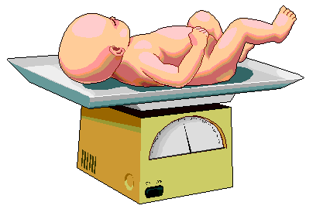  Its a Girl! | 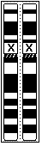
If your dropping of the genes resulted in an "Xy" combination of chromosomes turning face up, then you are the very lucky parents of a little boy.  The Mom contributed one "X" and the Dad the "y" chromosome. | Its a Boy!

(5)
Face and Chin Determination

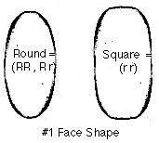  Chromosome #1 contains the genetic information in a gene we will call "R". This information determines the general shape of the face. Place your baby's genotype for face shape in the data table. | 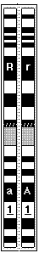

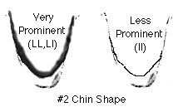  Chromosome #2 contains the chin shape gene "L." The genotype "ll" prevents the expression of the next two pairs of genes. Place your baby's genotype for chin shape in the data table. The control of one set of genes by another is called epistasis. If you landed the genotype "ll" then skip the next two and start on Skin Color. | 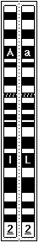

(6)
Freckle Determination

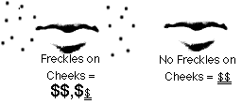

Chromosome #21 contains a gene, "$" which causes uneven pigment to form in the cheek region. If "$" is present then your child will have cheek freckles.  Place your baby's genotype for freckles in the data table. | 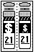
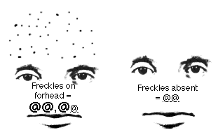
Finally on chromosome #9 there is data in the form of a gene "@". If your baby has "@" there will be freckles on the forehead! ("@@" underlined, represent the recessive genes)  Place your baby's genotype for freckles in the data table. | 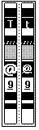

(19)

Nose and Ear Shape Determination
  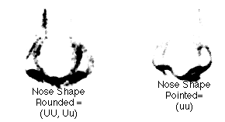
  Your baby's nose shape is determined by a gene on chromosome #14. The allele "U" imparts a rounded shape to the nose.
  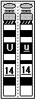
  Place your baby's genotype for nose shape in the data table

 | 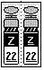
  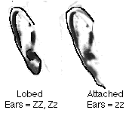 | Chromosome #22 carries the gene for free ears. The gene "Z" causes the earlobe to hang free at the side of the head.  Place your baby's genotype for earlobe attachment in the data table.

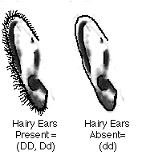 | Chromosome #20 contains DNA information encoded in a gene called "D". This information, if in its dominant form, causes the ear to grow a large amount of fuzzy hair.  Place your baby's genotype for hairy ears in the data table. | 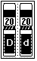

(18)
Chin Shape Determination

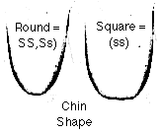 | Chromosome #3 contains the "S" gene. This gene controls the shape of the chin, round or square. These genes are activated only if the dominant "L" on chromosome #2 is present.  Place your baby's genotype for chin shape in the data table.  The control of one set of genes by another is called epistasis. | 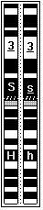
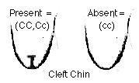 | Chromosome #5 carries the "C" gene. The "C" gene controls the development of the cleft chin phenotype.  Remember these "C" genes are activated only if the dominant "L" on chromosome #2 is present.  Place your baby's genotype for chin shape in the data table.  The control of one set of genes by another is called epistasis. | 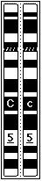

(7)
Skin Color Determination
Skin color is determined by three sets of genes on chromosomes #'s 1, 2, and 4. Since this trait is determined by several genes, it is known as polygenic inheritance. The dominant genetic code, gene "A" translates into a protein called melanin. This dark pigment is like a natural UV blocker. The greater the number of dominant genes one has, the greater the amount of melanin, the darker the skin, and the more UV protection a person has. These genes have been selected-for near the Earth's equator where the intense UV photons can cause a great deal of damage to lighter skin.  Count up the number of dominant and recessive genes and place your baby's genotype for skin color in the data table. | 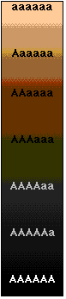
  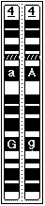
(8)
Dimples and Nose Determination

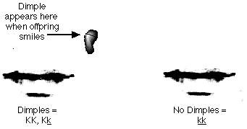
Chromosome #16 contains genetic information regarding the construction of dimples.  Place your baby's genotype for dimples in the data table. | 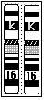

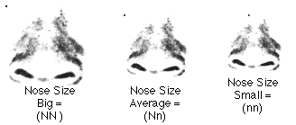
Chromosome #19 contains genetic information regarding the construction of nose size  Place your baby's genotype for nose size in the data table. | 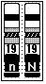

(17)
Mouth Size & Shape Determination

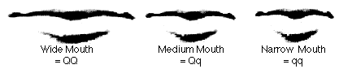
Chromosome #17's "Q" gene controls the width of the mouth. The dominant gene imparts width.  Place your baby's genotype for mouth width in the data table. | 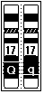

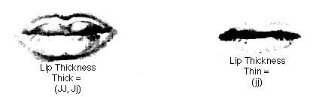
Chromosome #18's gene "J" adjusts the thickness of the lips.  Place your baby's genotype for fullness of lips in the data table. | 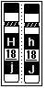

(16)
Hair Color Determination

The hair color gene, like skin color, is polygenic. The same genetic code is found on chromosome #'s 3, 6, 10 and 18. This code translates into pigment which is incorporated into the hair as it is growing. The greater the number of dominant alleles, the darker the hair. Hair color varies from black to white.  Count up the number of dominant and recessive genes and place your baby's genotype for hair color in the data table. | 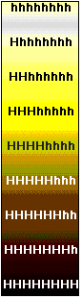
  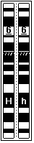
  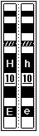

(9)
Eye Color Determination
Chromosomes #'s 11 and 12 contain Eye Color Genes: Darker eyes are produced in the presence of more active alleles. In this situation, the Capital letters (F or B) represent alleles which are active in depositing dark pigment. Lower case letters (f or b) represent alleles which deposit little pigment. To determine the color of the eyes, assume there are two gene pairs involved, one of which codes for depositing pigment in the front of the iris, and the other codes for depositing pigment in the back of the iris. Determine the genotype of the first pair (FF,Ff,ff). and then the second (BB,Bb,bb). If your genotype is in the first column then check your eye color in the second column. | Place your baby's genotype for eye color in the data table.
  Column #1 | Column #2
  Genotypes | Protein Phenotypes
  FFBB | Dark brown
  FFBb | Brown
  FFbb | Brown
  FfBB | Brown
  FfBb | Dark Blue
  Ffbb | Dark Blue
  ffBB | Light Blue
  ffBb | Light Blue
  ffbb | Pale blue
  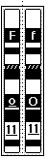 | 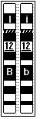
(10)
Eye Shape and Lash Determination

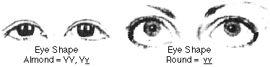
Chromosome #13 has the eye shape gene "V." Dominant genes code for almond shape and homozygous recessive is round.  Place your baby's genotype for eye shape in the data table. | 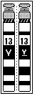

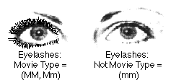
Movie star eyelashes are found on chromosome #15. Dominant "M" genes place your kid on the way to stardom!  Place your baby's genotype for eyelashes in the data table. | 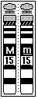

(15)
Eye Spacing & Measurement Determination

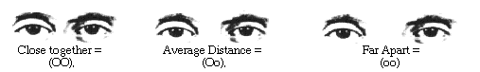
Chromosome #11 has the gene for eye placement. The dominant gene places the eyes close together, the recessive, far apart.
Place your "baby's" genotype for eye placement in the data table.

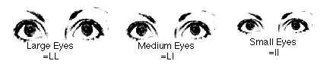
Chromosome #12, beside carrying one of the pigment genes for eye color, also carries the gene "I" for eye size.
Place your "baby's" genotype for eye size in the data table.

(14)
Red Hair Determination

Red Hair: Red hair is another gene for hair color present on a different chromosome. It blends its effect with other hair colors. Redness of the hair seems to be caused by a single gene pair with two alleles, red (G) or no red (g), and displays incomplete dominance. Thus, if a person has two genes for red (GG), the hair will be a more intense red than if they have a single gene (Gg). If a person has no genes for red (gg), then the hair does not show as red at all. Red hair is complicated by the fact that dark pigment, controlled by the many hair color genes, may mask or hide the red color. The darker the brown, the less the red shows through, although more shows with (GG) than with (Gg). As the hair becomes lighter in color, more red shows through. If your child is blond as evidenced by 3 Capitals or less above and (GG) lands facing up, then your child will probably have flaming red hair. Auburn might be (Gg) with the lighter shades of pigmentation.
  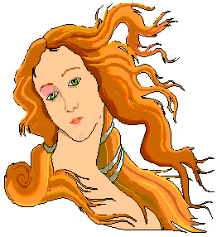
  GG = Heavy Red Pigment
  Gg = Medium Red Pigment
  rr = No Red Pigment

(11)
Hair Type Determination

 | 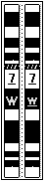
  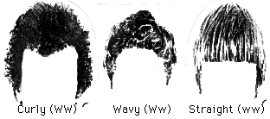
  Chromosome #7 contains the genetic code for hair type. The "W" hair-making DNA codes for amino acids which contain a sulfur atom which causes cross links between amino acids in the hair..... thus curly hair! Straight hair lacks the many sulfur amino acids and does not make as many cross links.
  Place your baby's genotype for hair type in the data table.

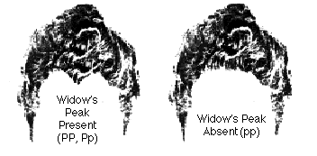Chromosome #8 contains the genetic code for Widow's Peak. If your baby has a dominant "P" then he or she will possess that trait. (Notice that there is a line through the recessive small " p " on the paper chromosome.)  Place your baby's genotype for Widow's Peak in the data table. | 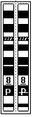

(12)
Eyebrow Shape Determination

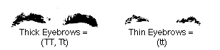
Chromosome #9 carries a gene for eyebrow thickness called "T". It works with complete dominance.

Place your baby's genotype for eyebrows in the data table.

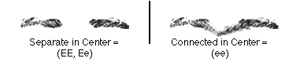
Chromosome #10 has the gene for eyebrow placement. "E" separates and lack of "E" causes connected eyebrows.
Place your baby's genotype for eyebrow placement in the data table.

(13)

