Biology – The Race to Discover DNA Review Sheet
Name: Period:

You may use the PowerPoint on your teacher’s website to help you answer the following questions.

- What is the Central Dogma of Molecular Biology?

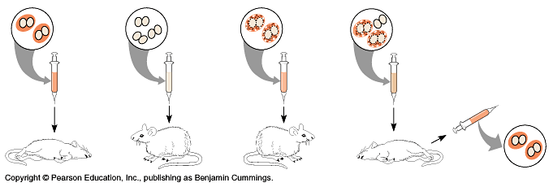
- For each of the images (I – IV) describe what this study proved to bacteriologist Frederick Griffith.
I.
II.
III.
IV.
- Briefly describe how Avery, McCarty and McLeod further developed Griffiths experiment.
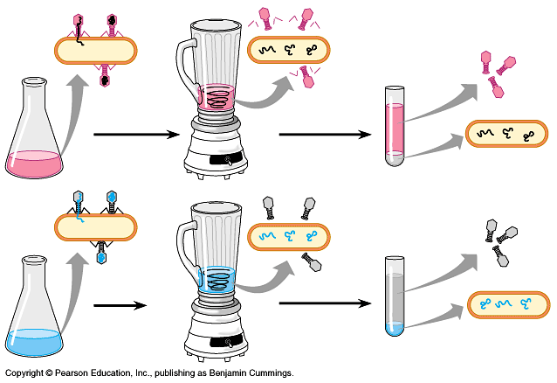
- Explain the experiment and the results of the Hershey-Chase experiment, which is visualized below.
- a. According to Chargaff’s rule, how do the bases of DNA pair with one another?
b. Why do they pair in this way?

- What about DNA did this image reveal?
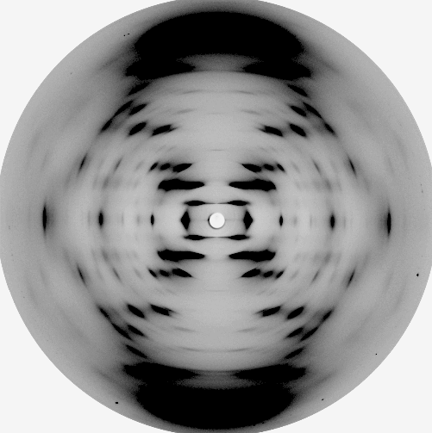
- Who won the race to discover DNA’s structure?
- a. What is the backbone of DNA made of?
b. What does this do to the overall charge of DNA?
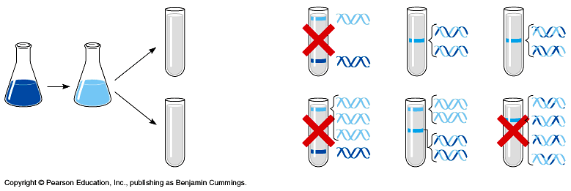
- Meselson and Stahl discovered the way that DNA replicates. Observe and label their overall experimental design, and interpret which hypothesis was proven correct from their experiment.
Hypothesis I.
Hypothesis II.
Hypothesis III.

- Knowing what you know about base-pairing rules, label the following nitrogenous bases.

