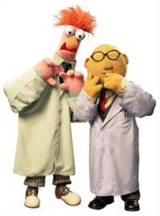
Names: _____________________________________________

Only You Can Help to Save Fred!
Contributed by Stacy Fox from NSTA ListServe
Fred has been spending his summer boating on the Great Lakes. But he’s not too bright (after all, the brains of worms are pretty small☺) He’s never learned how to swim and he never wears his life preserver. The worst has happened! His boat has capsized and he’s stuck! Fortunately, his life preserver is in the boat, but unfortunately he does not know how to reach it without falling off and drowning.

Problem: How can you and your partner save Fred using only 4 paper clips? You may not touch Fred, the boat, or the life preserver directly with your hands!

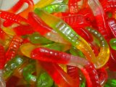
Materials:
- Gummy Worm
- Gummy life preserver
- 1 plastic cup
- 4 Paper Clips

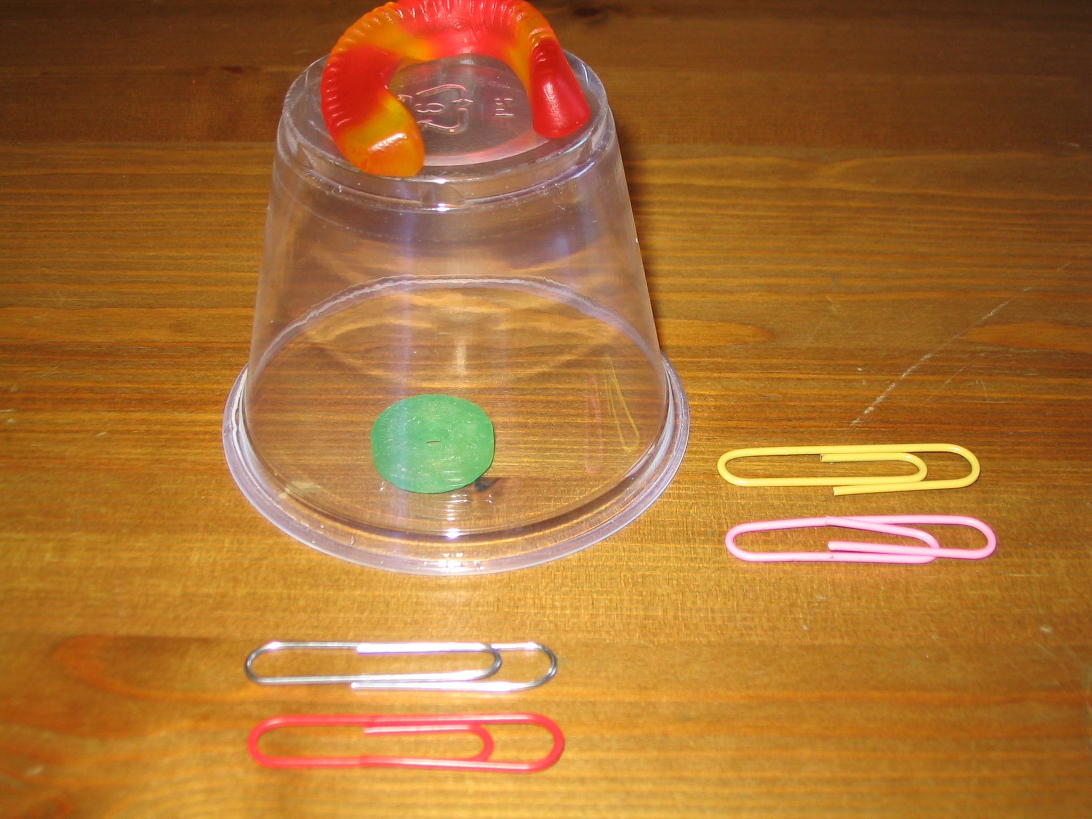
FRED
The Set-Up:
BOAT

LIFE PRESERVER

Procedure:
- Set up the challenge as shown in the picture above. Work with your partner and "Save Fred".

- Follow the rules. Fred, the boat, the life preserver can be touched only with the paper clips. NO HANDS.

- A flowchart is a diagram showing a sequence of operations. Fill in the flowchart on the back side of this page with diagrams showing step by step how your group completed the challenge. Be sure that you:
  - Produce neat and detailed pictures.
  - Label the major parts of your diagram.
  - Include a written description of each diagram using complete sentences.

- List any problems or challenges that your group encountered during the challenges.

- Answer the Post-Challenge Questions and rate this activity.
Flowchart of How you Saved Fred!

Description Picture
Problems and/or Challenges your group encountered!

Rate the difficulty of this activity from 1-5 by shading in the stars below. (1 = easy, 5 = hard)

Rate your enjoyment of this activity from 1-5 by shading in the stars below. (1 = no fun, 5 = too much fun)

Post-Challenge Questions
- Which problem that you encountered was the most difficult for your group? What did you do or how did you act to solve the problem?

- List one thing that you would do the same and one thing that you would change if you attempted this challenge again.
Keep the Same Change

