Scooby-Doo & the case of molarity mayhem
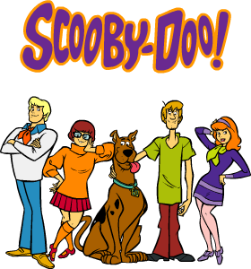
by Ms. Towle

Directions: Your job is to help Scooby and the Gang solve the case of molarity
mayhem. Read the case below, use the clues, and determine how to get the
10 molarity monsters into saturated solutions. You should show ALL WORK
on a separate piece of paper. The team of two who defeats the most molarity
monsters correctly gets 5 points added to any category for the third quarter,
the second place team gets 4 points, the third place team gets 3 points, the
fourth place team gets 2 points, and the fifth place team gets 1 point.

Scooby and the gang were in the mystery van cruising along Mudge Way in Bedford, Ma.
Daphne asked, “Where are we going Fred?”
“Ms. Towle asked us to watch her class while she’s at the NSTA convention,” answered Fred.
“Jinkies,” exclaimed Velma, “a science classroom is one of my favorite places! Plus, I heard the room is brand-spanking new.”
“Oh man,” groaned Shaggy, “I think I remember from high school that there is absolutely no eating in a science classroom.” Just then his stomach rumbled.
“Ro Reating?” asked Scooby, “Rat’s rorse ran rhosts!!”
“You’re right there Scoob,” replied Shaggy, “no eating, IS worse than ghosts.”
The gang made their way to Ms. Towle’s chemistry classroom and couldn’t believe what they saw. Ten monsters that looked like large Erlenmeyer flasks were wreaking havoc around the room.
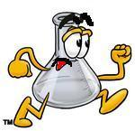
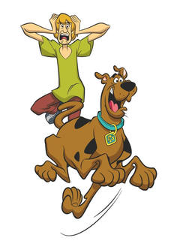
“Help!” yelled one of Ms. Towle’s awesome students. “We’re surrounded by these molar solutions that have gone crazy and we don’t know why.”
“Rikes rolar rolutions!” yelped Scooby.
“What’s a molar solution?” Shaggy asked Scooby.
“Ri ron’t row,” said Scooby “rit rounds rary.”
“True,” said Shaggy, “It does sound scary.”
“Oh you two,” said Velma. “Molar solutions aren’t scary
at all. They are just homogeneous mixtures of one or
more solutes dissolved in a solvent, a solution, with a certain number of
moles of solute per liter of solution.”
“Whatever, you say Velma, but we’re outta here,” said Shaggy. “We don’t want
any of these Molar Monsters hurting us.”
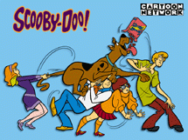
“Oh boys,” said Daphne. “Would you help us for some Scooby snacks?”
“Rou ret!!” exclaimed Scooby.
“You bet!!” exclaimed Shaggy.
“Why don’t I ever get Scooby snacks?” complained Fred.
“Okay, it’s time to investigate and search for clues. Shaggy, Scooby, and I will go this way,” said Velma, “and Daphne and Fred will go that way.”

Fred and Daphne gathered information from some of Ms. Towle’s students. They claimed when they walked in the room the back table was set up with 15 solutions. Five were set up in a tray labeled “unsaturated solutions: all 1L”, five were set up in a tray labeled “saturated solutions: all 1L”, and the remaining five were setup in a tray labeled “supersaturated solution: all 1L”. Then all at once the solutions in the unsaturated and supersaturated trays got up and starting running around the room and scaring the students.
“Hmmmmmmm,” concluded Fred, “it seems only saturated solutions do not turn into monsters. If only there was a way that we could turn the Molar Monsters into saturated solutions.”
Meanwhile, Velma, Shaggy, and Scooby were searching for clues. They noticed on the unsaturated sign on the tray that there was a blue sticker on it.
“Look,” said Shaggy, “there are blue stickers on five of those molar monsters.”
“Rith rumbers rand ra rapital retter rem,” said Scooby.
“Those numbers and that capital letter M tells as the molarity of that solution. And I’ll bet those blue labels mean they are unsaturated,” said Velma, “I wonder if the supersaturated solutions have stickers on them?”
“They do,” said Shaggy, “They have red stickers. Now I guess we should just record the molarities on all the monsters.”
“Already done,” said Velma as she showed a piece of paper to the boys, “here they are. Now let’s tell Fred and Daphne what we found.”


Blue A 1.5 M NaCl
Blue B 0.27 M KCl
Blue C 0.33 M KClO₃
Blue D 8.2 M NaNO₃
Blue E 3.7 M NH₄Cl
Red A 9.3 M NH₄Cl
Red B 0.65 M NaCl
Red C 1.6 M KClO₃
Red D 10.6 M NaNO₃
Red E 6.7 M KCl

Once the gang was all together, they came up with a plan that is listed below.
FYI: The room temperature is 25°C and the density of water is 1.0 g/ml.
Step 1: have Velma build two machines. One machine will dump the specified mass of solute into a solution as a molarity monster runs by. The second machine will zap a molarity monster as it runs by and heat it to the desired temperature.
Step 2: have Ms. Towle’s students pair up and determine how to get all those molarity monsters to saturated solutions (do you add solute, and if so how much, or do you heat it to a certain temperature, and if so what temperature?).
Step 3: have Shaggy and Scooby lure the molarity monsters by each machine so they can turn it into a saturated solution and no longer a molarity monster.

….A little while later, with the help of Ms. Towle’s students’ calculations all the molarity monsters were returned to saturated solutions. But just as the gang was about to leave, Scooby noticed that Velma was just someone wearing a mask. He pulled it off and realized it was MS. TOWLE!!!!!!! Her students told her she was supposed to be at the NSTA convention. She of course admitted,”I just can’t stay away from teaching my fabulous students, and I would’ve gotten away with it too if it weren’t for you meddling kids.”

THE END
