Sesame Street Characters

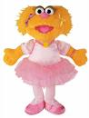  Zoe Ballerina | 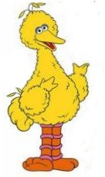  Big Bird |   Cookie Monster
  Grover |   Oscar the Grouch | 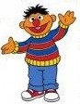  Ernie
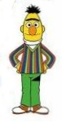  Bert | 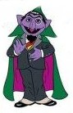  Count | 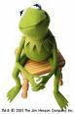  Kermit the Frog
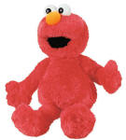  Elmo | 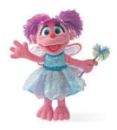  Abby Cadabby | 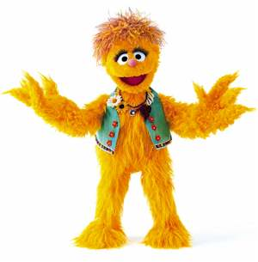  Kami

