Speed of Diffusion  Demo | 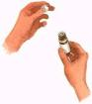 | 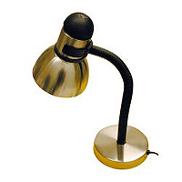
First, find out if any of your audience is "frangrance intolerant." If none are, place a 60 watt bulb on a lamp in one corner of the room. Use a tape measure to measure the distance from your lamp to the other corner of the room (you may estimate). place one student at regular intervals, such as two feet. Place one or two drops of a strong perfume on the light bulb, and when everyone is in place, turn the bulb on.
Ask each student to raise their hand when they smell the perfume.
Try to use a stop watch to measure how long it takes the perfume to reach the last student in the chain. Students will be actively engaged as they see a series of hands go up. They will look forward to participating in this game, once they understand the rules.
NOTE: If done in the summer time, make sure that there are no open windows or doors and no floor fans or a/c.
If the audience is old enough, you could graph the speed of the diffusion.

T i m e D e t e c t e d i n S e c o n d s

D
i
s
t
a
n
c
e

i
n

c
m

