Testing water hardness

From http://www.chemsoc.org/networks/learnnet/Word_files/Kev41-50.doc

Introduction
Tap water in some parts of the country is very pure and is said to be ‘soft’. It easily makes a lather with soap. Water from other parts may contain various dissolved impurities and is described as ‘hard’ water. Temporary hardness may be removed by boiling, but permanent hardness survives the boiling process. In this practical activity, water hardness can be measured by finding out the volume of soap solution required to form a permanent lather with a known volume of water.

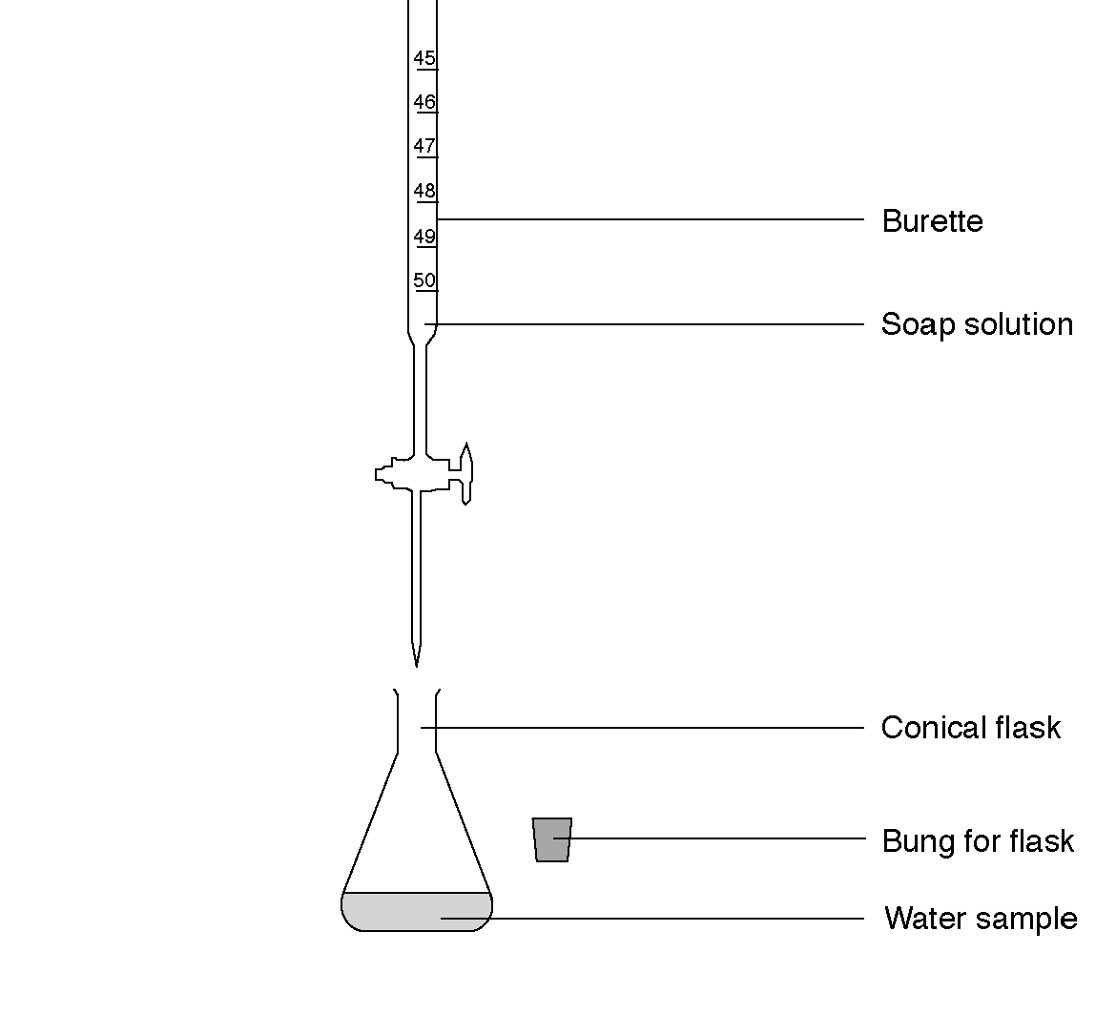

What to record
Record the volume of soap needed to produce a permanent lather with each type of water. Note any difference between the appearance of the samples after the addition of soap solution.

Water type | Volume of soap required to produce  a permanent lather /cm³
Rainwater
Seawater
Temporary hard water
Seawater, boiled then cooled (permanent hard water)
Temporary hard water, boiled then cooled

What to do
1. Collect a conical flask and bung. Check the bung is a good fit.
2. Measure 10 cm³ of water sample into a conical flask using a measuring cylinder.
3. Using the burette add 1 cm³ of soap solution to the water. Stopper the flask and shake vigorously. If no lather is produced, add another 1 cm³ of soap solution. Continue in this way until a permanent lather (one that lasts for 30 seconds) is obtained. Record the volume of soap solution needed to produce a permanent lather.
4. Repeat this procedure for the other water samples.

Safety
Wear eye protection.

Questions
1. Is the rainwater hard or soft?

2. Is seawater hard or soft?

3. Does seawater contain temporary hardness, permanent hardness or both?

Home

