Water and It's Solutions
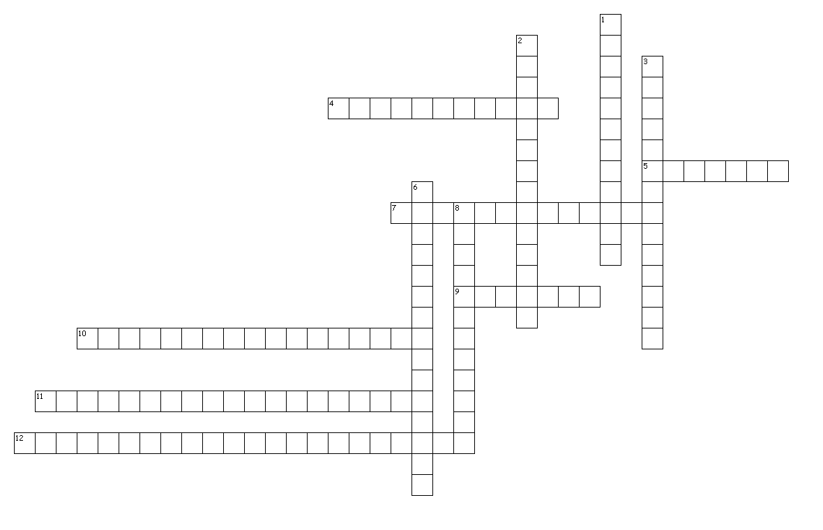
Across
4. The rising of a liquid in a narrow tube, sometimes called capillary action.
5. A mixture that contains particles that are evenly distributed through a dispersing medium and do not settle out over time.
7. The scattering effect caused when light passes through a colloid.
9. The flow of molecules through a selectively permeable membrane driven by concentration difference.
10. A solution that holds the maximum amount of solute under the given conditions.
11. A solution in which the amount of solute dissolved is less than the maximum that could be dissolved.
12. A solution containing more solute than the usual maximum; they are unstable.

Down
1. A measure of the amount of heat needed to raise the temperature of 1 gram of a substance 1 degree Celsius.
2. The heat taken in or released in the dissolving process.
3. The force needed to overcome intermolecular attractions and break through the surface of a liquid or spread the liequid out.
6. A connection between the hydrogen atoms on one molecule and a highly electronegative atom on another molecule, but not a full covalent bond.
8. The process by which the charged particles in an ionic solid separate from one another, primarily when going into solution.

Home

