inheritance patterns in zorks
Vanderbilt Student Volunteers for Science
vanderbilt.edu/vsvs

Winter 2007 (Revised 1/17/07)
Adapted from Reebops lesson, Girls and Science Camp

Purpose

Using the ideas and concepts introduced from ZORK GENETICS and MORE ZORK GENETICS, students will put those ideas into practice in this assignment and will give students a visual representation to aid in their understanding of basic Mendelian genetic principles. Both of the above assignments should be completed before doing this activity. Students will need to refer to the ZORK GENETICS activity table for a list of the alleles which will be needed for this activity.

Background

Interestingly, zorks make good tools for the investigation of meiosis. Students will “create” baby zorks given genotypes that they determine by selecting paper chromosomes.

Each cell in all living organisms contains hereditary information that is encoded by a molecule called DNA (deoxyribonucleic acid). (Show students the model of DNA) DNA is an extremely long molecule. When this long, skinny DNA molecule is all coiled up and bunched together it is called a chromosome. (Show students the picture of a chromosome) Each chromosome is a separate piece of DNA, so a cell with eight chromosomes has eight long pieces of DNA. A gene is a segment of the long DNA molecule. Different genes may be different lengths. Each gene is a code for how a certain molecule can be made. The molecules produced by the genes can generally be sorted into two different types: ones that run the chemical reactions in your body, and ones that will be the structural components of your body. How an organism looks and functions is a result of the cumulative effect of all the molecules. Any organism that has “parents” has an even number of chromosomes, because half of the chromosomes come from the “father” and the other half from the “mother.” For example, in plants, a pollen grain is the “father’s” contribution and an ovule is the “mother’s” contribution. These two cells combine to make a single cell, which will grow into a seed (the offspring).

Humans have 46 chromosomes. The chromosomes sort into 23 pairs. One chromosome in each of the 23 pairs is from the person’s father, the other from the person’s mother. Since chromosomes come in pairs, genes do too. One gene is located on one member of chromosome pair, the other gene is in the same location on the opposite chromosome. The gene “pair” is technically referred to as a gene, as both members of the pair code for the same trait. A gene can consist of a variety of different forms, but only two forms are ever present per gene (one from the mother, the other from the father). The two different gene forms on the pair of chromosomes may be identical or different. The different forms that comprise a gene are called alleles.

Materials (for 30 students)
- Colored pencils
- 15 sets of trait strips (20 strips in each set)
- “How to Draw Zork Parts” (in sheet protectors)
- 30 Zork Worksheets
- 1 DNA model
- 1 picture of chromosome
- Copy of each student’s ZORK GENETICS assignment
- Colored modeling clay (optional for extension activity)
Information
Each partner should each have a set of different colored chromosomes. (It does not matter who gets which color, as long as each person has a different color.)
Tell the students that:
- One set of strips represent the chromosomes from the mother (female) zork. The other set represents chromosomes from the father (male) zork.
- Each STRIP represents a CHROMOSOME. Each strip has a letter, – either uppercase or lowercase. The uppercase letters represent a DOMINANT form of the trait and the lowercase letters represent the RECESSIVE form.
- Each PAIR of letters codes for a TRAIT (or, scientifically, an ALLELE). A DOMINANT trait will be present if the UPPERCASE letter is present. A RECESSIVE trait occurs only when BOTH lowercase letters are chosen.
- The traits are sorted so that they are matched into same sized pairs and same letters of the alphabet. You should have 10 pairs of same size strips (chromosomes whose letters code for traits) for both the male and female.
- Students will need to have their ZORK GENETICS assignment for the table of alleles (traits).
Experiment
Tell the students to take the longest pair of one color of chromosomes (male) and the longest pair of the other color of chromosomes (female) and place them FACE DOWN on their desks so that they cannot see the letter. (Since the strips I added are not colored on both sides, have one student select males, and another females.)
WITHOUT TURNING THE CHROMOSOMES OVER, pick one chromosome of the longest size from one color, and pick one chromosome of the longest size of the other color. Put these in the middle as one new pair.
- Your partner will take the remaining pair for his/her zork baby.
- Continue doing this, taking one from each pair from longest to shortest. You and your partner should end up with ten new traits; each pair is one color chromosome and one of the other color chromosomes (strip).
- Turn over the chromosomes that remain on your table. These represent a new "baby" zork! On the DATASHEET, record the letter found on the first color of chromosomes in the Male Gene column. Record the letter found on the second color of chromosomes in the Female Gene column. Be sure you copy the letters exactly, uppercase or lower-case. THIS IS IMPORTANT!
- After filling out the DATA SHEET, return all chromosomes to their proper bags.
- Determine the GENOTYPE by combining the 2 letters.
  - Determine if the trait is dominant or recessive.
- Record the PHENOTYPE for each characteristic, using the KEY and TABLE from the ZORK GENETICS assignment. Record this on the Zork Worksheet.
- Now color and add parts to the baby zork.
- EXTENSION: You can get colored modeling clay from any hobby store or toy store. I have students make 3D models of their zorks and take pictures with a digital camera to display around the room. This may be used as an alternative for students who do feel comfortable drawing their zorks.
Zork Worksheet

Data Sheet
Male Gene (1st color) | Female Gene (2nd color)

Trait | Genotype | Phenotype
Tall/Short (T/t’s)
Hair (G/g’s)
Eyes (E/e’s)
Fangs (F/f’s)
Horns (H/h’s)
Lips (L/l’s)
Wings (W/w’s)

(D/d’s)
Legs (N/n’s)
Skin (R/r’s)
Eyebrows (B/b’s)

Analysis/Questions
- Compare your zork to other zorks around the room. What differences and similarities do you see?

- How do you explain all of the differences, even though the zorks all had the same set of parents?

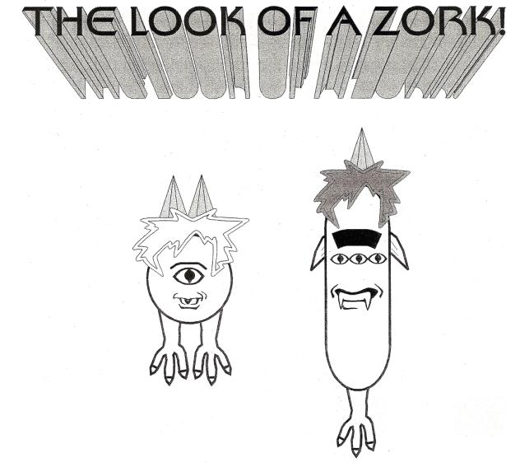

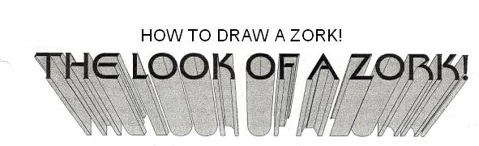
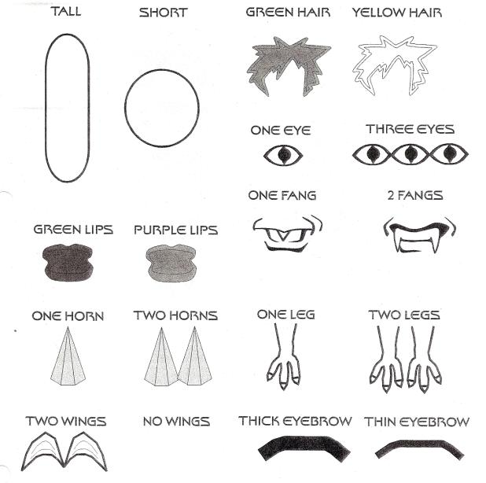

Chromosome Strips
For Father

T
T

g
g

E
e

F
f

h
h

L
l

W
W

N
n

R
r

B
b

Chromosome Strips
For Mother

T
t
G
G
e
e
F
f
H
H
l
l
W
w
n
n
R
r
B
b

