Pasta DNA Models

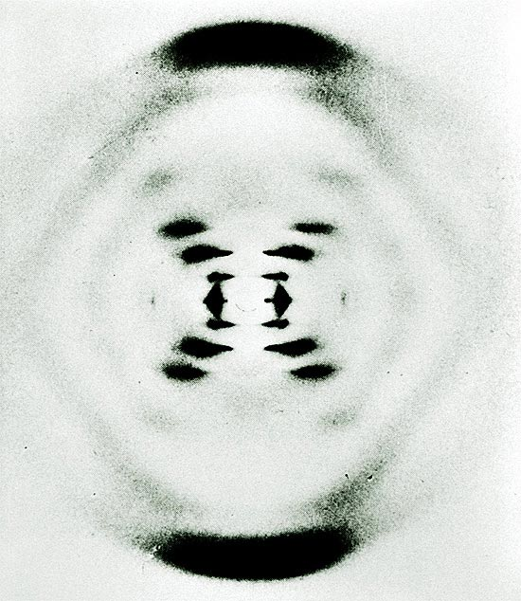
Introduction
James Watson and Francis Crick worked out the structure of DNA in the 1950’s. Several models of DNA had been proposed already, but they all had problems. So when Rosalind Franklin’s X-ray crystallography of DNA (see picture) fell into the hands of Watson & Crick (without Franklin’s knowledge or permission), they immediately realized its importance and finalized their model of DNA in large part thanks to Franklin’s unwitting contribution. They published their results in 1953, and later won the Nobel Prize for the discovery. Franklin died in 1958, never knowing that her work had contributed to one of the greatest insights in all of science.
In addition to working out the basic structure, Watson & Crick also wrote:
It has not escaped our notice that the specific pairing we have postulated immediately suggests a possible copying mechanism for the genetic material.
Their hypothesis, that the double strand unwinds, and each strand serves as a template for the formation of a new double strand, was NOT based on observation of a DNA molecule actually replicating, but on logical inference. It was confirmed experimentally by other scientists a few years later.
We have already discussed the basic structure of DNA in class. In this lab we will construct models of DNA to help us visualize both the basic structure and to demonstrate how DNA replicates.
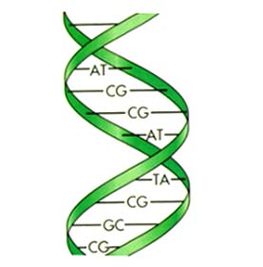
Recall that DNA is a polymer of 4 different nucleotides. A nucleotide consists of a sugar (deoxyribose), a phosphate group, and a nitrogenous base. There are 4 of these bases that make up the 4 different nucleotides: Adenine, Thymine, Cytosine, & Guanine. In a double strand of DNA, the A nucleotide always matches up with a T, while C always matches up with G. These pairs (A-T, C-G) are called complimentary base pairs. In this lab we will construct a segment of DNA and then unzip and replicate it.

Purpose
To model the structure of the DNA molecule
To understand the process of DNA replication

Materials

Dry fiori pasta (sugar)
Dry ziti pasta (phosphate group)
Different colored paperclips (bases)
String (chemical bonds)

Safety/Precautions
Don’t eat the pasta.

Procedures Part I (Structure)
- Tie one end of a string around a fiori pasta piece.
- Thread a piece of ziti on the string, resting on top of the fiori.
- Thread another piece of fiori on the string, resting on top of the ziti.
- Repeat steps 2-3 until you have about 6 fiori pieces and 5 pieces of ziti in between.
- Tie the final (6th) piece of fiori to the free end of the string.
- Attach one paperclip, in any color order, to each of the fiori. Each paper clip should face the same direction and be oriented perpendicular to the ziti. Use all 4 colors.
- Repeat steps 1-5 to create the backbone of the opposite strand.
- Attach paperclips to the fiori on the second strand that are complimentary to the paperclips on the first strand.
- Attach complimentary paperclips to each other to connect the two strands, forming a double-stranded DNA.

Analysis
Draw & label the following parts from your model:

1. Sugar 2. Phosphate Group 3. Bases (color coded)

5. Draw & label one nucleotide:

6. Draw your double stranded DNA model.

7. Discuss DNA and describe your model. Explain how your model differs from real DNA. Mention each component of your model and how it relates to the real thing.
__________________________________________________________________________________
__________________________________________________________________________________
__________________________________________________________________________________
__________________________________________________________________________________
__________________________________________________________________________________
__________________________________________________________________________________
__________________________________________________________________________________
__________________________________________________________________________________

Procedures Part II (Replication)
- Use a colored pencil to place a noticeable mark on each strand of your DNA model.
- “Unzip” your DNA strands.
- For EACH of the unzipped strands, construct a new, complimentary strand using the same procedure as part 1, steps 1-5 and 8-9.

Analysis
In the following drawings, simplify the model – use simple lines to represent phosphate group, bases, and a small circle to represent the sugar. Continue color-coding the bases.

1. Draw & label your original segment of DNA model:

2. Draw your DNA model in the process of “unzipping:”

3. Draw the replicated DNA. Indicate which strands are from the original DNA and which are new.

4. Write the sequences of bases on the original DNA segment.
Strand “A” _________________________________________________________________________
Strand “B” _________________________________________________________________________

5. How do these sequences compare with the newly replicated DNA?
__________________________________________________________________________________

6. How does your DNA model compare, in terms of base pair sequence, with the group sitting next to you? What does this suggest to you?
__________________________________________________________________________________
__________________________________________________________________________________
__________________________________________________________________________________
__________________________________________________________________________________

7. How does DNA “know” how to make a correct copy of itself? Is it “intelligent?”
__________________________________________________________________________________
__________________________________________________________________________________
__________________________________________________________________________________
__________________________________________________________________________________
8. Discuss how your model differs from what actually happens in a cell when DNA replicates. What in the cell corresponds to your hands, i.e., what actually brings these materials together in the cell?
__________________________________________________________________________________
__________________________________________________________________________________
__________________________________________________________________________________
__________________________________________________________________________________
__________________________________________________________________________________
__________________________________________________________________________________

Introduction adapted from various sources, some specifically cited below.
NOVA: Secret of Photo 51: http://www.pbs.org/wgbh/nova/photo51/about.html
Newton, G. (2003, January 3). The Crick papers: 1953 DNA replication. Retrieved April 7, 2007, from The Human Genome Web site: http://genome.wellcome.ac.uk/doc_WTD022318.html

