Testing the pH of oxides from http://www.chemsoc.org/networks/learnnet/Word_files/Kev21-30.doc

Introduction
In this experiment the pH of various oxides is tested.
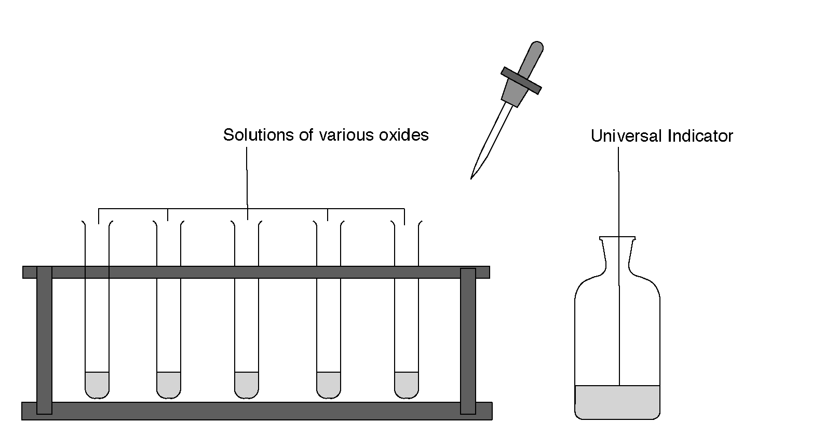

What to record

Name of oxide | Color of  Universal Indicator | pH value | Acid, alkali or neutral
Nitrogen oxide
Sodium oxide
Potassium oxide
Phosphorus(V) oxide
Calcium oxide

What to do
1. Using separate test-tubes, collect a sample (about 2 cm³) of each oxide in water.
2. Add three drops of Universal Indicator solution to each sample.
3. Record the results in a table showing the oxide, the colour of the Universal Indicator, the pH and whether the oxide is acidic, alkaline or neutral in water.

Safety
Wear eye protection

Questions
1. Which compounds in the table are metal oxides?

2. Comment on your results for the metal oxides?

3. Some metal oxides do not react with water. Predict the pH of these compounds.

Home

