The pH scale from http://www.chemsoc.org/networks/learnnet/Word_files/Kev1-10.doc

Introduction
The pH of a substance can be found by dissolving a small amount of the substance in deionised water and adding a few drops of Universal Indicator solution. The color produced is compared with a pH chart.
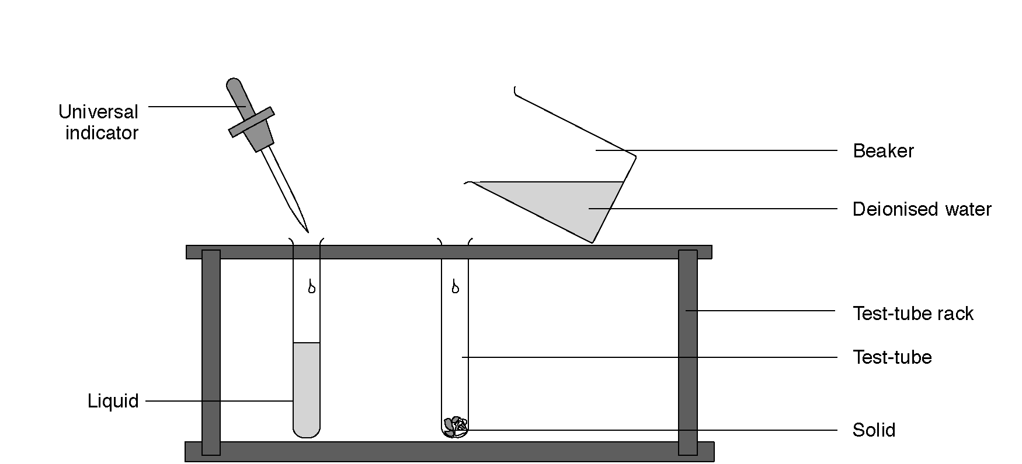

What to record
Prepare a table for your results

Solution | Color with Universal Indicator pH

What to do
1. Place one spatula measure of solid, or pour a few drops of liquid into a test-tube.
2. Half-fill the test-tube with deionised water from a small beaker, and shake to dissolve the solid or mix the liquid.
3. Add a few drops of Universal Indicator to the test-tube. Make a note of the color in the table. Compare it against the pH color chart and record the pH of the nearest color in the table.

Safety
Wear eye protection.

Questions
1. List the substances that were acidic, substances that were alkaline and substances that were neutral.

2. Why might a scientist prefer to use Universal Indicator rather than a different indicator like litmus?

3. What would happen if equal amounts of vinegar and limewater were mixed?

Home

