Protein Synthesis Simulation Lab

Part 1: Introduction
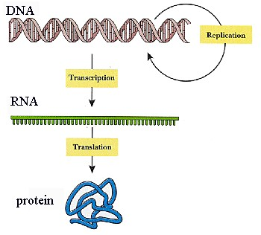
DNA is a very long, thin molecule located in the nucleus. The DNA in one chromosome has 10s of millions of base pairs and hundreds or thousands of genes. Yet an individual cell will only use a small portion of those genes in its lifetime. Imagine a mechanic who spends a lifetime fixing nothing but cars, but he or she is required nonetheless to carry around an entire library of repair manuals for everything from kitchen sinks to washing machines to light fixtures to computers and so on – all information the mechanic will never be able to use because s/he’s busy fixing cars.
Another peculiar thing about DNA is that it is located inside the nucleus, and pretty much stays inside the nucleus, yet the proteins that DNA helps to make are produced OUTSIDE of the nucleus. So how does the cell solve this problem? It sends a “messenger” from the nucleus to the ribosomes in the cytoplasm.
In a process called transcription, the DNA code is transcribed (copied) into mRNA, following rules similar to DNA replication we saw earlier (see below).
mRNA moves out of the nucleus into the cytoplasm where it links up with ribosomes and begins churning out proteins.
Recall that DNA consists of a sugar-phosphate backbone with a nitrogenous base. There are 4 different bases in DNA abbreviated with the letters A,T,C, & G. The code contained in DNA derives from these 4 bases. We can think of them as letters in an alphabet that will spell different words. In a real language, words can be anywhere from 1 letter long (a, I) to an upper limit of 10-15 letters for functional, non-compound words.
In DNA code, a “word” is always 3 letters long and is called a “codon.” Consider the following DNA segment:
A
G
T
C
C
A
A
A
T
C

T
C
A
G
G
T
T
T
A
G

“ATC” is a codon. “GTC” is a codon. “CAA” is a codon. Etc.

In transcription, the DNA code is transcribed (copied) into RNA code, following rules similar to DNA replication we saw earlier EXCEPT that:

DNA RNA
1. Transcribe the following DNA sequence into mRNA. Draw a line separating each codon:
A T C G T C C A A A ….
_________________________________

Matches with
A……………. U
T……………. A
C……………. G
G……………. C

Each mRNA codon corresponds to an amino acid that is transported to the RNA/ribosome complex by another special nucleic acid called tRNA. “T” stands for transfer. The ribosome essentially “reads” the RNA code and facilitates the linking of appropriate amino acids to make proteins. Summary diagram:
2. Transcribe the following DNA sequence into mRNA. Draw a line separating each codon::
T A G C A G G T T T ….
_________________________________

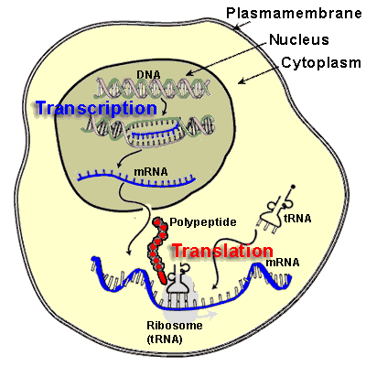
DNA (in nucleus) transcribed to mRNA

mRNA leaves nucleus

mRNA to cytoplasm

mRNA hooks up with ribosomes.

Ribosomes scroll through mRNA

tRNA delivers amino acids to mRNA/ribosome complex

Enzymes link amino acids together to form a protein

Activity: There are 4 letters of the mRNA code: U-A-C-G. How many possible combinations are there? In other words, how many “words” can you make with those 4 letters if any combination of letters is possible but all “words” are only 3 letters long? Hint – start with a single letter, how many codons can be produced that start with, for example, the letter “A?” You can infer the rest. I’ll get you started…
AAA
AAC
AAU
AAG
Part 2: Questions
1. At this point, you should have figured out that there are _____ possible codons using 4 letters with 3 letters per codon in any order. However, there are only 20 amino acids, and each codon “codes” for one amino acid – so what does this mean?

___________________________________________________________________________
The table below shows which amino acid corresponds with which codons.
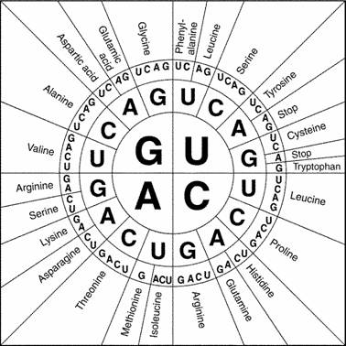
2. What does UAC code for?

________________________

3. CAG? ________________

4. AGG? ________________

5. GAU? ________________

6. UUU? ________________

7. List the codons for Valine:

________________________

8. Stop? _________________

9. Methionine is a “Start” signal. What is its codon?

________________________

Each amino acid is matched with one or more 3-letter “words.” The words are analogous to an amino acid. When the words are put together they make a sentence. The sentence is analogous to a protein. So, let’s break the following code.

10. Given the following DNA code, how would this segment be transcribed into mRNA?

T A C C C G A T A C T C C C T T C A A T T

________________________________________________

11. Give the 3-letter abbreviation (see p. 4) for the amino acids coded for in that sequence:

___________________________________________________________________________

12. What is the silly little sentence that this codes for (see p. 4)?
___________________________________________________________________________

Amino Acid – English word Table Abbreviation Table
MET  START | GLY  THE | ALA  SAD | VAL  RAT | ILE  MET
PHE  RAN | HIS  OLD | TRP  FOE | PRO  SLY | SER  CAT
THR  WHO | GLU  SAW | CYS  MAD | ARG  ATE | TYR  DOG
ASN  AND | GLN  HIS | ASP  FOR | LEU  DAY | LYS  BIG
STOP
.
NAME | CODE
Alanine | ALA
Cysteine | CYS
Aspartic Acid | ASP
Glutamic Acid | GLU
Phenylalanine | PHE
Glycine | GLY
Histidine | HIS
Isoleucine | ILE
Lysine | LYS
Leucine | LEU
Methionine | MET
Asparagine | ASN
Proline | PRO
Glutamine | GLN
Arginine | ARG
Serine | SER
Threonine | THR
Valine | VAL
Tryptophan | TRP
Tyrosine | TYR

In the remaining space, create your own messages and, working backwards, determine what the DNA sequence would be:

Your message: ______________________________________________________________

Amino acid (3 letter): ______________________________________________________________

mRNA sequence: ______________________________________________________________

DNA Sequence: ______________________________________________________________

Your message: ______________________________________________________________

Amino acid (3 letter): ______________________________________________________________

mRNA sequence: ______________________________________________________________

DNA Sequence: ______________________________________________________________

