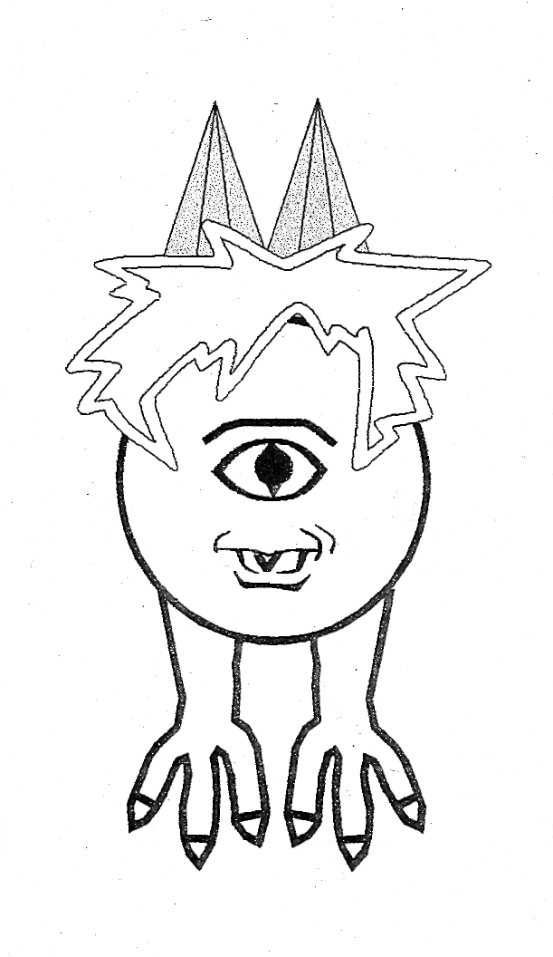
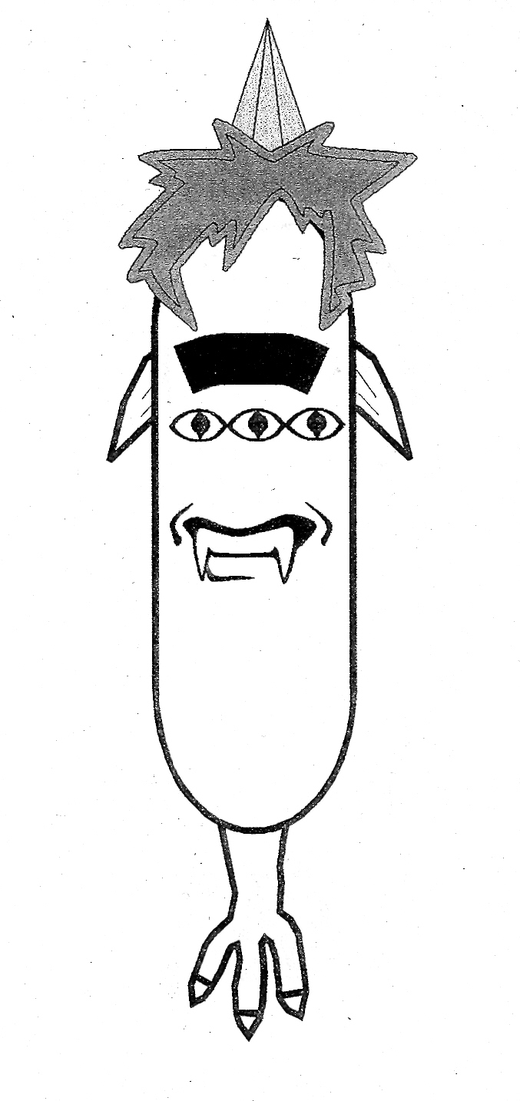
NAME:____________________________ PERIOD:___

BACKGROUND: A long time ago, in a galaxy far, far away, a great race of beings lived on a planet called ZORK. The inhabitants were known as Zorkonians. They are made up of 10 basic genes (unit) that code for their appearance. Each one of these genes is made up 2 alleles (traits). With this in mind, there are 1,024 different possible combinations for their appearance! This is called their phenotype or their physical appearance. If we look at their genes, there are 59,049 different combinations of the alleles! This is called the genotype or genetic makeup. Remember that we use letters for the alleles that control the genes and one letter or allele is inherited from each parent. You will be using Zorks, who use the same genetic principles as a pea plant, to see how genes are passed on and inherited. You will be using Punnett Squares to do this.

Here are some things to help you. You must understand these concepts and terms! I will use traits from the table on the next page as examples.

Phenotype: The physical appearance or what the gene makes an organism look like. Examples would be two eyes, yellow hair, and green lips from a zork.
1. Dominant: The trait that is shown the most. Example: Green hair is dominant over yellow hair.
2. Recessive: The trait that is hidden. In this example: yellow hair.

Genotype: The genetic makeup of an organism. We use letters for the genotype. Remember that you need to look at the genotype to see what the phenotype will be.

Example: There is a Gene or unit for hair color in a zork. The alleles or traits (individual genes) for hair color would be yellow and green. There are 2 alleles for each gene and we use letters for each allele. The capital letters are the dominant alleles and the lower case letters are the recessive alleles.

Gene Allele
Hair color 1. Green color = G
2. Yellow color = g

1. Heterozygous: The term used for different alleles. There is always one dominant and one recessive allele. Example: Gg. There is only one possibility for this!
2. Homozygous: The term used for having the same alleles. This will be either 2 dominant alleles or 2 recessive alleles. Example: GG or gg. There are 2 possibilities for this!

Please refer back to this to help you as you work through this assignment. You will use the table on the next page to complete the problems that follow. Everything you need is in the table! The following are the traits of a Zork, which we will use to study genetics. You will be studying one family. Be sure to read each problem carefully, because in each case the information is built upon the previous problem.
Allele | Trait | Dominant/Recessive | Genotype | Phenotype | Heterozygous | Homozygous
T | Tall | Dominant | TT,Tt | Tall | Tt | TT
t | Short | Recessive | tt | Short |  | tt
G | Green hair | Dominant | GG,Gg | Green  Hair | Gg | GG
g | Yellow hair | Recessive | gg | Yellow  Hair |  | gg
E | One Eye | Dominant | EE,Ee | One Eye | Ee | EE
e | Three Eyes | Recessive | ee | Three Eyes |  | ee
F | One Fang | Dominant | FF,Ft | One Fang | Ff | FF
f | Two Fangs | Recessive | ff | Two Fangs |  | ff
H | Two Horns | Dominant | HH,Hh | Two Horns | Hh | HH
h | One Horn | Recessive | hh | One Horn |  | hh
L | Purple Lips | Dominant | LL,Ll | Purple Lips | Ll | LL
l | Green Lips | Recessive | ll | Green Lips |  | ll
W | Two Wings | Dominant | WW,Ww | Two Wings | Ww | WW
w | No Wings | Recessive | ww | No Wings |  | ww
N | One Leg | Dominant | NN,Nn | One Leg | Nn | NN
n | Two Legs | Recessive | nn | Two Legs |  | nn
R | Green Skin | Dominant | RR,Rr | Green Skin | Rr | RR
r | Yellow Skin | Recessive | rr | Yellow Skin |  | rr
B | Thick Eyebrow | Dominant | BB,Bb | Thick Eyebrow | Bb | BB
b | Thin Eyebrow | Recessive | bb | Thin Eyebrow |  | bb

SINGLE CROSS PROBLEMS

1. Cross a heterozygous green skinned zork with a yellow skinned zork.

A. What do the possible offspring look
Like?

2. Cross a homozygous two horned zork with a heterozygous two horned zork.

A. What are the genotypes of the possible offspring?

3. Cross a heterozygous green haired zork with a heterozygous green haired zork.

A. What are the genotypes and phenotypes of the possible offspring?

4. Cross a green lipped zork with a heterozygous purple lipped zork.
A. What are the number of phenotypes and genotypes of the offspring? Hint: Count what is in the boxes!

5. Tork, who is homozygous for tall meets Vorkina, who is short.

A. What are the phenotypes and genotypes if they were to have offspring?

6. Tork and Vorkina have two children. One is a boy named Torky and the other is a girl named Vorki. Many years later, Torky meets and marries a girl named Morkalina who is short.

A. What are the possibilities for the height of their offspring?
Hint: Look at 5A for information on Torky.

7. Vorki the daughter meets a zork named Spork, who is heterozygous for tall.

A. How many will be tall? How many will be short? How many will be TT?

How many will be Tt? How many will be tt?

8. Torky has green hair and Morkalina has yellow hair. They have four children and all of them have green hair. What phenotype and genotype must Torky be?

9. Spork and Vorki both have three eyes.

A. What would their offspring look like?

10. Using problems 5-9, give the phenotypes and genotypes of Tork, Vorkina, Torky, Morkalina, Spork and Vorki based ONLY on the traits given in the problems.

